

Department of Engineering Technology

Web Technology I

Building and Maintaining Web Sites

**Table of Content**

TOPICS PAGE

1. Computer programming and coding 5

**1.1 Hardware and software** 5

**1.2 How Computers Store Data** 10

**1.3. Web Technology** 15

2. Working with text in HTML 19

**2.1. Web Technology** 19

**2.2. Working with *lists* in HTML** 24

**2.3. Tables** 26

**2.4. Managing images in HTML** 28

3. Introduction to CSS 37

**3.1. CSS Basics** 37

**3.2. Text in CSS** 40

4 – Layout in CSS, Icons and Social Medial Icons, Navigation bars 50

**4.1 Layout in CSS** 50

**4.2 CSS styling images** 55

**4.3 Navigation Bars** 60

5 – Color and images manipulation in CSS 69

***5.1. Colors*** 69

***5.2. CSS linear-grading*** 71

***5.3. Position Property*** 72

***5.4. Hero image*** 75

***5.5. Filter images*** 79

6. CSS Animation 86

**CSS transitions** 86

**Understanding CSS animation** 86

7 – Creating Slideshow using CSS 100

8 – Creating a modal window using HTML and CSS 107

8. Using Basic Styles in Bootstrap 4 123

***Installing Bootstrap 4*** 123

***Installation*** 123

**All together** 125

***Text/Typography*** 127

***Lists and blockquotes*** 129

*9 – Colors and Image Manipulation using Bootstrap 4* 131

***Colors*** 131

***Working with images*** 132

10. Mastering Layout with bootstrap 135

***Containers and rows*** 135

***Rows and columns*** 136

***Custom order*** 141

**Basic flex container** **Error! Bookmark not defined.**

4. Navigation bar 142

**Creating Navigation Bar using *nav*** 142

**Using navbar classes** 145

**Navbar brand and text** 146

**Dropdown** 146

**Create collapsible content** 147

5. Styling elements 149

**Creating buttons** 149

**Badges** 152

**Progress bars** **Error! Bookmark not defined.**

6. Predesign layout components 154

**Jumbotron** 154

**Table style** **Error! Bookmark not defined.**

**Cards** 155

**Card content classes** 156

7. Working with interactive components 163

**Popovers** **Error! Bookmark not defined.**

**Setting alerts** 163

**Dropdown** 164

**Add tooltips** **Error! Bookmark not defined.**

**Collapse Accordions** 167

**Carousels** 169

**Scrollspy** 171

**Modals** 166

Web Technology

# **1. Computer programming and coding**

(Gaddis, 2018) Think about some of the different ways that people use computers. The uses of computers are almost limitless in our everyday lives. Computers can perform such a wide variety of tasks because they can be programmed. This means that computers are not designed to do just one job, but to do any job that their programs tell them to do. A *program* is a set of instructions that a computer follows to perform a task.

Programs are commonly referred to as *software*. Software is essential to a computer because it controls everything the computer does. All of the software that we use to make our computers useful is created by individuals working as programmers or software developers. A *programmer,* or *software developer,* is a person with the training and skills necessary to design, create, and test computer programs. Computer programming is an exciting and rewarding career. Today, you will find programmers’ work used in business, medicine, government, law enforcement, agriculture, academics, entertainment, and many other fields.

## **1.1 Hardware and software**

### *Hardware*

The term *hardware* refers to all of the physical devices, or *components,* of which a computer is made. A computer is not one single device, but a system of devices that all work together. Like the different instruments in a symphony orchestra, each device in a computer plays its own part.

If you have ever shopped for a computer, you’ve probably seen sales literature listing components such as microprocessors, memory, disk drives, video displays, graphics cards, and so on. Unless you already know a lot about computers, or at least have a friend that does, understanding what these different components do might be challenging.

As shown in Figure 1-1, a typical computer system consists of the following major components:

* The central processing unit (CPU)
* Main memory
* Secondary storage devices
* Input devices
* Output devices

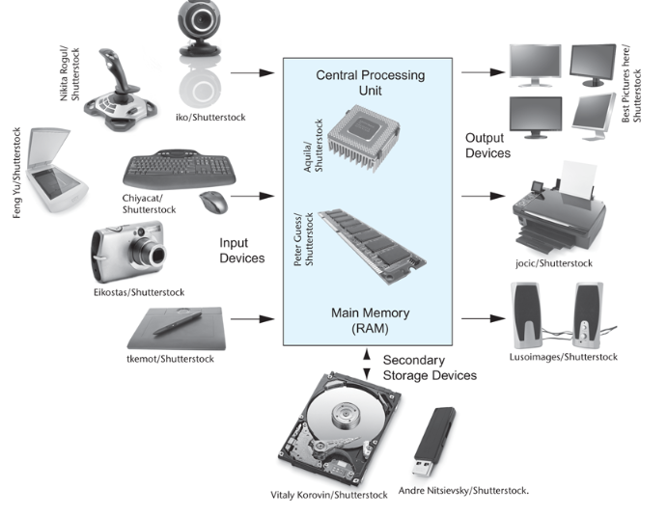

Figure 1-1 Typical components of a computer system

**The CPU**

When a computer is performing the tasks that a program tells it to do, we say that the computer is *running* or *executing* the program. The *central processing unit,* or *CPU,* is the part of a computer that actually runs programs. The CPU is the most important component in a computer because without it, the computer could not run software.

In the earliest computers, CPUs were huge devices made of electrical and mechanical components such as vacuum tubes and switches. **Figure 1-2** shows such a device. The two women in the photo are working with the historic ENIAC computer. The ENIAC, which is considered by many to be the world’s first programmable electronic computer, was built in 1945 to calculate artillery ballistic tables for the U.S. Army. This machine, which was primarily one big CPU, was 8 feet tall, 100 feet long, and weighed 30 tons.

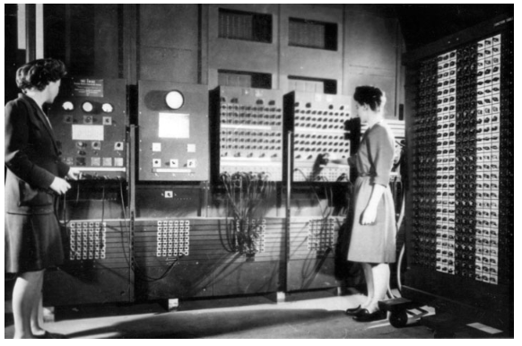

Figure 1-2 The ENIAC computer (*courtesy of U.S. Army Historic Computer Images)*

Today, CPUs are small chips known as *microprocessors*. [**Figure 1-3**](https://jigsaw.vitalsource.com/books/9780134484693/epub/OPS/xhtml/fileP700101398000000000000000000032C.xhtml#P7001013980000000000000000000354) shows a photo of a lab technician holding a modern microprocessor. In addition to being much smaller than the old electromechanical CPUs in early computers, microprocessors are also much more powerful.



Figure 1-3 A lab technician holds a modern microprocessor (*Creativa/Shutterstock)*

**Main Memory**

You can think of *main memory* as the computer’s work area. This is where the computer stores a program while the program is running, as well as the data that the program is working with. For example, suppose you are using a word processing program to write an essay for one of your classes. While you do this, both the word processing program and the essay are stored in main memory.

Main memory is commonly known as *random-access memory,* or *RAM*. It is called this because the CPU is able to quickly access data stored at any random location in RAM. RAM is usually a *volatile* type of memory that is used only for temporary storage while a program is running. When the computer is turned off, the contents of RAM are erased. Inside your computer, RAM is stored in chips, similar to the ones shown in **Figure 1-4**.

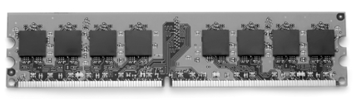

Figure 1-4 Memory chips (*Garsya/Shutterstock)*

**Secondary Storage Devices**

*Secondary storage* is a type of memory that can hold data for long periods of time, even when there is no power to the computer. Programs are normally stored in secondary memory and loaded into main memory as needed. Important data, such as word processing documents, payroll data, and inventory records, is saved to secondary storage as well.

The most common type of secondary storage device is the *disk drive*. A traditional disk drive stores data by magnetically encoding it onto a spinning circular disk. *Solid*-*state drives*, which store data in solid-state memory, are increasingly becoming popular. A solid-state drive has no moving parts and operates faster than a traditional disk drive. Most computers have some sort of secondary storage device, either a traditional disk drive or a solid-state drive, mounted inside their case. External storage devices, which connect to one of the computer’s communication ports, are also available. External storage devices can be used to create backup copies of important data or to move data to another computer.

In addition to external storage devices, many types of devices have been created for copying data and for moving it to other computers. For example, *USB drives* are small devices that plug into the computer’s USB (universal serial bus) port and appear to the system as a disk drive. These drives do not actually contain a disk, however. They store data in a special type of memory known as *flash memory*. USB drives, which are also known as *memory sticks* and *flash drives,* are inexpensive, reliable, and small enough to be carried in your pocket.

Optical devices such as the *CD* (compact disc) and the *DVD* (digital versatile disc) are also popular for data storage. Data is not recorded magnetically on an optical disc, but is encoded as a series of pits on the disc surface. CD and DVD drives use a laser to detect the pits and thus read the encoded data. Optical discs hold large amounts of data, and for that reason, recordable CD and DVD drives are commonly used for creating backup copies of data.

**Input Devices**

*Input* is any data the computer collects from people and from other devices. The component that collects the data and sends it to the computer is called an *input device*. Common input devices are the keyboard, mouse, touchscreen, scanner, microphone, and digital camera. Disk drives and optical drives can also be considered input devices, because programs and data are retrieved from them and loaded into the computer’s memory.

**Output Devices**

*Output* is any data the computer produces for people or for other devices. It might be a sales report, a list of names, or a graphic image. The data is sent to an *output device,* which formats and presents it. Common output devices are video displays and printers. Disk drives can also be considered output devices because the system sends data to them in order to be saved.

**Software**

If a computer is to function, software is not optional. Everything computer does, from the time you turn the power switch on until you shut the system down, is under the control of software. There are two general categories of software: system software and application software. Most computer programs clearly fit into one of these two categories. Let’s take a closer look at each.

**System Software**

The programs that control and manage the basic operations of a computer are generally referred to as *system software*. System software typically includes the following types of programs:

**Operating Systems**

An *operating system* is the most fundamental set of programs on a computer. The operating system controls the internal operations of the computer’s hardware, manages all of the devices connected to the computer, allows data to be saved to and retrieved from storage devices, and allows other programs to run on the computer. Popular operating systems for laptop and desktop computers include Windows, macOS, and Linux. Popular operating systems for mobile devices include Android and iOS.

**Utility Programs**

A *utility program* performs a specialized task that enhances the computer’s operation or safeguards data. Examples of utility programs are virus scanners, file compression programs, and data backup programs.

**Software Development Tools**

*Software development tools* are the programs that programmers use to create, modify, and test software. Assemblers, compilers, and interpreters are examples of programs that fall into this category.

**Application Software**

Programs that make a computer useful for everyday tasks are known as *application software*. These are the programs that people normally spend most of their time running on their computers. Two commonly used applications: Microsoft Word, a word processing program, and PowerPoint, a presentation program. Some other examples of application software are spreadsheet programs, email programs, web browsers, and game programs.

## **1.2 How Computers Store Data**

A computer’s memory is divided into tiny storage locations known as *bytes*. One byte is only enough memory to store a letter of the alphabet or a small number. In order to do anything meaningful, a computer has to have lots of bytes. Most computers today have millions, or even billions, of bytes of memory.

Each byte is divided into eight smaller storage locations known as bits. The term *bit* stands for *binary digit*. Computer scientists usually think of bits as tiny switches that can be either on or off. Bits aren’t actual “switches,” however, at least not in the conventional sense. In most computer systems, bits are tiny electrical components that can hold either a positive or a negative charge. Computer scientists think of a positive charge as a switch in the *on* position, and a negative charge as a switch in the *off* position. **Figure 1-5** shows the way that a computer scientist might think of a byte of memory: as a collection of switches that are each flipped to either the on or off position.

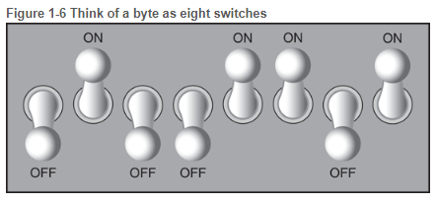

Figure 1-5 Think of a byte as eight switches

When a piece of data is stored in a byte, the computer sets the eight bits to an on/off pattern that represents the data. For example, the pattern on the left in [**Figure 1-6**](https://jigsaw.vitalsource.com/books/9780134484693/epub/OPS/xhtml/fileP70010139800000000000000000003A8.xhtml#P70010139800000000000000000003B5) shows how the number 77 would be stored in a byte, and the pattern on the right shows how the letter A would be stored in a byte. We explain below how these patterns are determined.

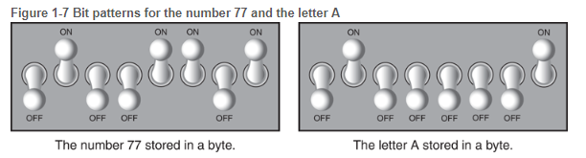

Figure 1-6 Bit patterns for the number 77 and the letter A

**Storing Numbers**

A bit can be used in a very limited way to represent numbers. Depending on whether the bit is turned on or off, it can represent one of two different values. In computer systems, a bit that is turned off represents the number 0, and a bit that is turned on represents the number 1. This corresponds perfectly to the *binary numbering system*. In the binary numbering system (or *binary*, as it is usually called), all numeric values are written as sequences of 0s and 1s. Here is an example of a number that is written in binary:

10011101

The position of each digit in a binary number has a value assigned to it. Starting with the rightmost digit and moving left, the position values are 20, 21, 22, 23, and so forth, as shown in **Figure 1-7**. **Figure 1-8** shows the same diagram with the position values calculated. Starting with the rightmost digit and moving left, the position values are 1, 2, 4, 8, and so forth.

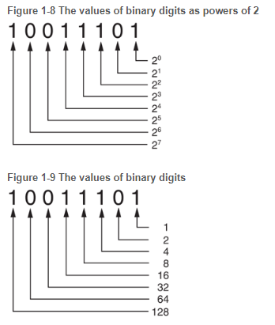

Figure 1-7 The values of binary digits as powers of 2 Figure 1-8 The values of binary digits

To determine the value of a binary number, you simply add up the position values of all the 1s. For example, in the binary number 10011101, the position values of the 1s are 1, 4, 8, 16, and 128. This is shown in **Figure 1-9**. The sum of all of these position values is 157. So, the value of the binary number 10011101 is 157.

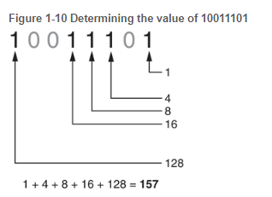

Figure 1-9 Determining the value of 10011101

**Figure 1-10** shows how you can picture the number 157 stored in a byte of memory. Each 1 is represented by a bit in the on position, and each 0 is represented by a bit in the off position.

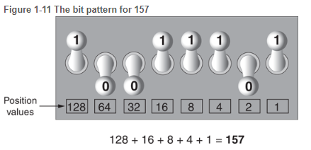

Figure 1-10 The bit pattern for 157

When all of the bits in a byte are set to 0 (turned off), then the value of the byte is 0. When all of the bits in a byte are set to 1 (turned on), then the byte holds the largest value that can be stored in it. The largest value that can be stored in a byte is 1 + 2 + 4 + 8 + 16 + 32 + 64 + 128 = 255. This limit exists because there are only eight bits in a byte.

What if you need to store a number larger than 255? The answer is simple: use more than one byte. For example, suppose we put two bytes together. That gives us 16 bits. The position values of those 16 bits would be 20, 21, 22, 23, and so forth, up through 215. As shown in **Figure 1-11**, the maximum value that can be stored in two bytes is 65,535. If you need to store a number larger than this, then more bytes are necessary.

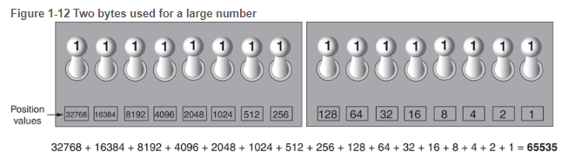

Figure 1-11 Two bytes used for a large number

**Storing Characters**

Any piece of data that is stored in a computer’s memory must be stored as a binary number. That includes characters, such as letters and punctuation marks. When a character is stored in memory, it is first converted to a numeric code. The numeric code is then stored in memory as a binary number.

Over the years, different coding schemes have been developed to represent characters in computer memory. Historically, the most important of these coding schemes is *ASCII,* which stands for the *American Standard Code for Information Interchange*. ASCII is a set of 128 numeric codes that represent the English letters, various punctuation marks, and other characters. For example, the ASCII code for the uppercase letter A is 65. When you type an uppercase A on your computer keyboard, the number 65 is stored in memory (as a binary number, of course). This is shown in **Figure 1-12**.

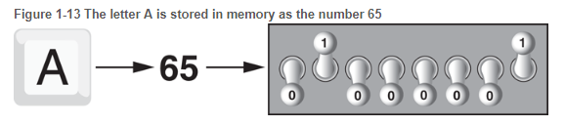

Figure 1-12 The letter A is stored in memory as the number 65

In case you are curious, the ASCII code for uppercase B is 66, for uppercase C is 67, and so forth. The ASCII character set was developed in the early 1960s and was eventually adopted by almost all computer manufacturers. ASCII is limited, however, because it defines codes for only 128 characters. To remedy this, the Unicode character set was developed in the early 1990s. *Unicode* is an extensive encoding scheme that is compatible with ASCII, but can also represent characters for many of the languages in the world. Today, Unicode is quickly becoming the standard character set used in the computer industry.

**Advanced Number Storage**

Earlier, you read about numbers and how they are stored in memory. While reading that section, perhaps it occurred to you that the binary numbering system can be used to represent only integer numbers, beginning with 0. Negative numbers and real numbers (such as 3.14159) cannot be represented using the simple binary numbering technique we discussed.

Computers are able to store negative numbers and real numbers in memory, but to do so they use encoding schemes along with the binary numbering system. Negative numbers are encoded using a technique known as *two’s complement,* and real numbers are encoded in *floating-point notation*. You don’t need to know how these encoding schemes work, only that they are used to convert negative numbers and real numbers to binary format.

**Other Types of Data**

Computers are often referred to as digital devices. The term *digital* can be used to describe anything that uses binary numbers. *Digital data* is data that is stored in binary format, and a *digital device* is any device that works with binary data. In this section, we have discussed how numbers and characters are stored in binary, but computers also work with many other types of digital data.

For example, consider the pictures that you take with your digital camera. These images are composed of tiny dots of color known as *pixels*. (The term pixel stands for *picture element*.) As shown in **Figure 1-13**, each pixel in an image is converted to a numeric code that represents the pixel’s color. The numeric code is stored in memory as a binary number.

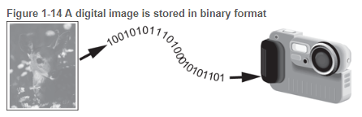

Figure 1.13 A digital image is stored in binary format

The music that you play on your CD player, iPod, or MP3 player is also digital. A digital song is broken into small pieces known as *samples*. Each sample is converted to a binary number, which can be stored in memory. The more samples that a song is divided into, the more it sounds like the original music when it is played back. A CD quality song is divided into more than 44,000 samples per second! (Gaddis, 2018)

## **1.3. Web Technology**

**The World Wide Web -www**

The World Wide Web (WWW) is a network of online content that is formatted in HTML and accessed via HTTP. The term refers to all the interlinked HTML pages that can be accessed over the Internet. The World Wide Web was originally designed in 1991 by Tim Berners-Lee while he was a contractor at CERN.

The World Wide Web is most often referred to simply as "the Web."

***The Internet***

The **Internet**, sometimes called simply "the Net," is a worldwide system of computer networks - a network of networks in which users at any one computer can, if they have permission, get information from any other computer (and sometimes talk directly to users at other computers).

Using the Internet, computers connect and communicate with each other, primarily using the TCP/IP (Transmission Control Protocol / Internet Protocol). Think of TCP/IP as a book of rules, a step-by-step guide that each computer uses to know how to talk to another computer.

***ISPs (Internet service providers)***

ISPs (Internet service providers), the companies that provide Internet service and connectivity, also follow these rules. The ISP provides a bridge between your computer and all the other computers in the world, which are all a part of the Internet. The ISP uses the TCP/IP protocols to make computer-to-computer connections possible and transmit data between them. When connected to an ISP, you are assigned an IP address, which is a unique address given to your computer or network and allows it to be found while on the Internet.

***URL (Uniform Resource Locator)***

Abbreviated as URL, a Uniform Resource Locator is a way of identifying the location of a file on the internet. They're what we use to open not only websites, but also to download images, videos, software programs, and other types of files that are hosted on a server.

Opening a local file on your computer is as simple as double-clicking it, but to open files on remote computers, like web servers, we must use URLs so that our web browser knows where to look. For example, opening the HTML file that represents the web page explained below, is done by entering it into the navigation bar at the top of the browser you're using.

Uniform Resource Locators are most commonly abbreviated as URLs but they're also called website addresses when they refer to URLs that use the HTTP or HTTPS protocol.

URL is usually pronounced with each letter spoken individually (i.e. u - r - l, not earl). It used to be an abbreviation for Universal Resource Locator before being changed to Uniform Resource Locator.

### **Examples of URLs**

You're probably used to entering in URL, like this one for accessing Google's website:

**https://www.google.com**

The entire address is called the URL. Another example is this website (first) and Microsoft's (second):

**https://lifewire.com**  
**https://www.microsoft.com**

***Web Server and Hosting***

Server hosting refers to the outsourcing of an organization's server placement and platform to a third-party Managed Hosting Provider (MSP). A client uses the Internet to connect to data and applications on a managed server and pays a recurring fee to the hosting provider. A MSP usually operates and manages large data centers with dozens, hundreds or thousands of hosted servers for two or more clients. This model is known as colocation or colocated hosting.

The server hosting model provides a best-of-all-worlds scenario by giving organizations access to server platforms to host their applications and data without shouldering attendant costs.

***HTML and CSS***

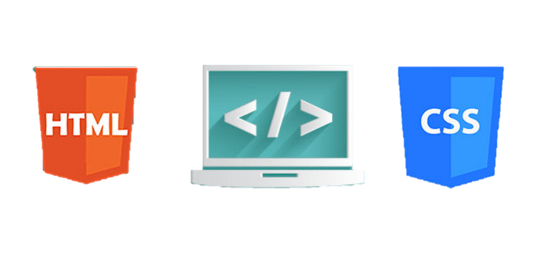

ML (the Hypertext Markup Language) and CSS (Cascading Style Sheets) are two of the core technologies for building Web pages. HTML provides the structure of the page, CSS the (visual and aural) layout, for a variety of devices. Along with graphics and scripting, HTML and CSS are the basis of building Web pages and Web Applications. Learn more below about:

***What is HTML?***

HTML is the language for describing the structure of Web pages. HTML gives authors the means to:

* Publish online documents with headings, text, tables, lists, photos, etc.
* Retrieve online information via hypertext links, at the click of a button.
* Design forms for conducting transactions with remote services, for use in searching for information, making reservations, ordering products, etc.
* Include spread-sheets, video clips, sound clips, and other applications directly in their documents.

With HTML, authors describe the structure of pages using markup. The elements of the language label pieces of content such as “paragraph,” “list,” “table,” and so on.

***What is XHTML?***

XHTML is a variant of HTML that uses the syntax of XML, the Extensible Markup Language. XHTML has all the same elements (for paragraphs, etc.) as the HTML variant, but the syntax is slightly different. Because XHTML is an XML application, you can use other XML tools with it (such as XSLT, a language for transforming XML content).

***What is CSS?***

CSS is the language for describing the presentation of Web pages, including colors, layout, and fonts. It allows one to adapt the presentation to different types of devices, such as large screens, small screens, or printers. CSS is independent of HTML and can be used with any XML-based markup language. The separation of HTML from CSS makes it easier to maintain sites, share style sheets across pages, and tailor pages to different environments. This is referred to as the separation of structure (or: content) from presentation.

***Text Editor***

A **text editor** is program that allows you to open, view, and edit plain **text** files. Unlike word processors, **text editors** do not add formatting to **text**, instead focusing on **editing** functions for plain **text**. **Text editors** are **used by** a wide variety of people, for a wide variety of purposes.

Editing HTML and CSS code can be done without any specific tools. In fact, if you have a simple text editor, you are good to go. However, just because you can do something doesn’t mean it is the best way to do it – and that applies to web development as well.

Web development IDE does all the things simple text editors do plus a number of more advanced stuff that you can’t do with text editors. For instance, while an editor such as Sublime or Atom can be used as an HTML CSS JavaScript editor, they only allow you to write code.

Of course, they come with a bunch of convenient features such as syntax highlighting, customizable interfaces, and extensive navigation tools, you will need additional features to make a functional app. For example, you will need a debugger and a compiler.

***Atom by GitHub***

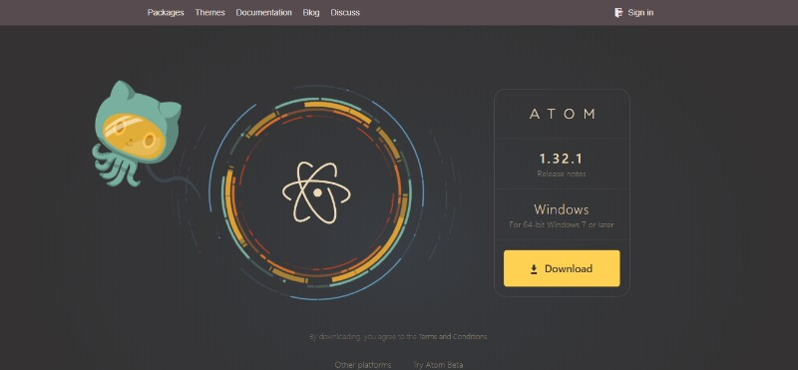

Atom by Github is the best editor for JavaScript if you are looking for something customizable and easy to use. It has a built-in package manager for installing new packages or start creating your own within this cool tool.

Atom comes pre-installed with four UI and eight syntax themes in a variety of colors. The rich and supportive community also creates cool themes for everybody to use so you might find what you’re looking for there.

Here are some of the Atom’s best features:

* It works across different operating systems such as OS X, Windows, or Linux
* Find, preview, and replace text as you type in a file or across all your projects.
* Easily browse and open a single file, a whole project, or multiple projects in one window.

Atom is a desktop app built with HTML, JavaScript, CSS, and Node.js integration. It runs on Electron, a framework for building cross-platform apps using web technologies. It is definitely a web development IDE worth checking out if you are looking for JavaScript development tools and best HTML IDE.

Hypertext Markup Language (HTML)

# **2. Working with text in HTML**

## **2.1. Web Technology**

### **Screen ClippingStructure**

Many webpages act like electronic versions of documents such as Newspapers.

Think about the stories you read in a newspaper: for each story, there will be a headline, some text, and possibly some images. If the article is a long piece, there may be subheadings that split the story into separate sections or quotes from those involved. Structure helps readers understand the stories in the newspaper.

**Structure** is a way to build a webpage to make it easier for the reader to understand what he is reading. HTML code describes the structure of webpages.

### **The HTML code**

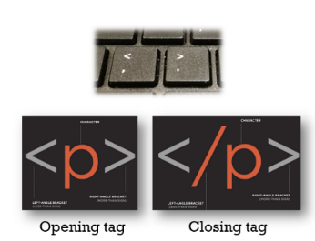The HTML code is made up of characters that live inside angled brackets which are called HTML **elements**. Elements are usually made up of two **tags:** an opening tag and a closing tag.

Each HTML element tells the browser something about the information that sits between its opening and closing tags.

### **Basic HTML elements**

The basics HTML elements are:

1. The opening **<html>** tag element indicates that anything between it and a closing **</html>** tag is HTML code
2. A **<head>** element contains information about the page such as title
3. The contents of the **<title>** element are either shown in the top of the browser, above where you usually type in the URL of the page you want to visit, or on the tab for that page (if your browser uses tabs to allow you to view multiple pages at the same time).
4. The **<body>** tag indicates that anything between it and the closing tag </body> should be inside the main browser window.
5. A paragraph of text appears between these **<p>** and **</p>** tags.

### **Headings elements**

HTML has six levels of headings:

* <h1>is used for main headings
* <h2> is used for subheadings.
* If there are further sections under the subheadings then the <h3>element is used, and so on...

**Exercises) Creating your first webpage**

Activity 1 we are going to create our first app view using HTML and check our code through google Chrome browser.

**Steps:**

1. We start by writing the HTML code using Atom.

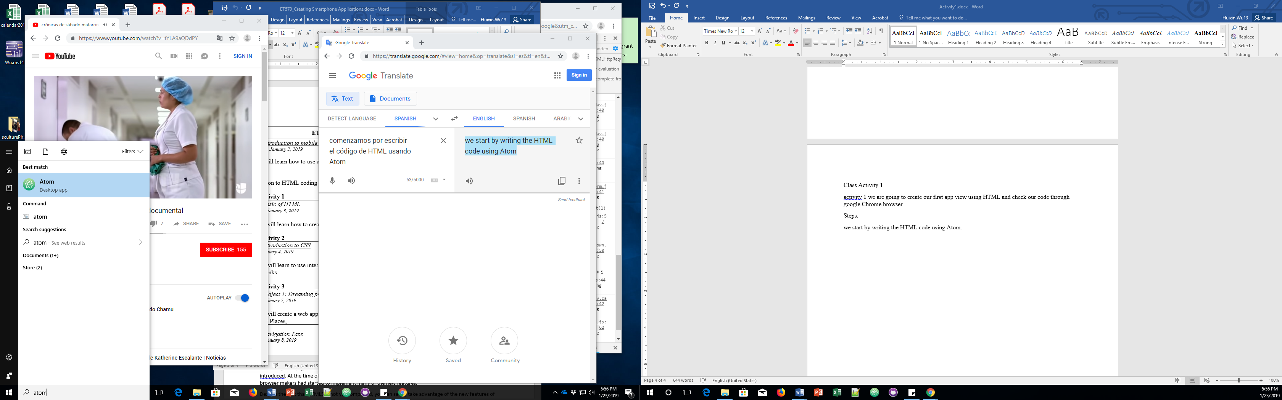

1. In Atom, open a new file and save it with your last name and the file extension .html. Make sure that you save the file in your local drive or computer Desktop.
2. The first line that we write in an html file is <html> tag to declare the html file. One of the great thing about Atom is that when you type a tag name, it will automatically build a basic code structure of the code. Write html and click enter and Atom will create the following code:

<!DOCTYPE html>

<html lang="en" dir="ltr">

<head>

<meta charset="utf-8">

<title></title>

</head>

<body>

</body>

</html>

The **<!DOCTYPE>** declaration must be the very first thing in your HTML document, before the <html> tag and it specifies the rules for the markup language, so that the browsers render the content correctly.

The attribute **lang** indicates the language and the value **en** means English. This line specifies that the html code is based in English.

The attribute **dir** indicates the direction of the text and the value **ltr** indicates that the text will be display from left-to-right.

Metadatais data (information) about data. The **<meta>** tag provides metadata about the HTML document. Metadata will not be displayed on the page, but will be machine parsable.

Meta elements are typically used to specify page description, keywords, author of the document, last modified and other metadata

**UTF-8** is the Unicode character sets from 1 to 4 bytes long. UTF-8 can represent any character in the Unicode standard. UTF-8 is backwards compatible with ASCII and the encoding for e-mail and web pages.

For app view development, it is an important to add the following line:

<meta name="viewport" content="width=device-width, initial-scale=1.0">

The **viewport** is the user's visible area of a web page. It varies with the device, and will be smaller on a mobile phone than on a computer screen. viewport element gives the browser instructions on how to control the page's dimensions and scaling.

The **width=device-width** part sets the width of the page to follow the screen-width of the device (which will vary depending on the device).

The **initial-scale=1.0** part sets the initial zoom level when the page is first loaded by the browser.

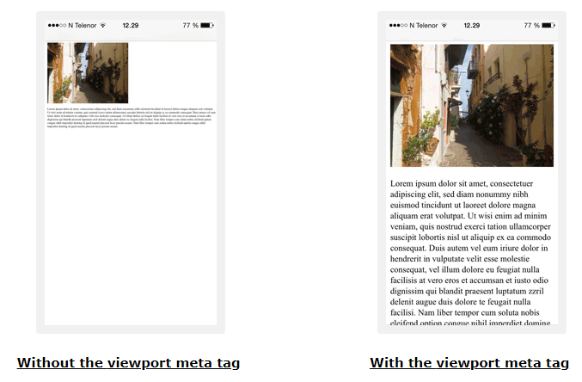

Once we have the **<head>** element sets, we can use some tags in the **<body>.** Most of the tags that we use in **<body>** are visible in the web app. We are try to add some heading the body.

HTML has six levels of headings:

* <h1>is used for main headings
* <h2> is used for subheadings.
* If there are further sections under the subheadings then the <h3>element is used, and so on...

<h1>Heading 1 size</h1>

<h2>Heading 2 size</h2>

<h3>Heading 3 size</h3>

<h4>Heading 4 size</h4>

<h5>Heading 5 size</h5>

<h6>Heading 6 size</h6>



To see the output of the html code, we can go to the location of our html file, and double click on html icon

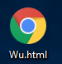

The html file will open in internet browser

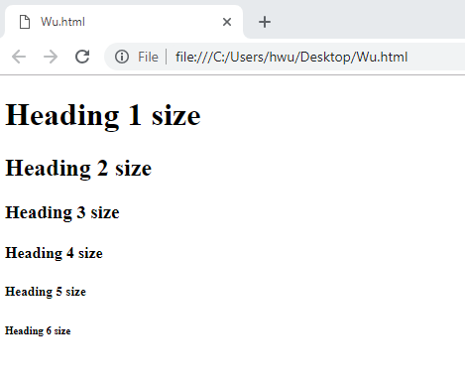

### **More elements**

***Paragraph***

The <**p**> **tag** specifies a paragraph of text. It is a block-level element and it automatically have margin before and after the tag.

***Bold***

By enclosing words in the tags **<b>** and **</b>** we can make characters appear bold.

***Italic***

By enclosing words in the tags **<i>** and **</i>** we can make characters appear italic.

### ***Line Breaks***

The browser will automatically show each new paragraph or heading on a new line. But if you wanted to add a line break inside the middle of a paragraph you can use the line break tag **<br/>**

### ***Horizontal Rules***

To create a break between themes — such as a change of topic in a book or a new scene in a play — you can add a horizontal rule between sections using the **<hr/>**

### ***Strikethrough***

Strikethought means to cross something out by drawing a line through it.

The **<s>** element indicates something that is no longer accurate or relevant (but that should not be deleted).

Visually the content of an **<s>** element will usually be displayed with a line through the center.

### ***Abbreviations and Acronyms***

If you use an abbreviation or an acronym, then the **<abbr>** element can be used. A title attribute on the opening tag is used to specify the full term.

**Example**

<p>Demystifying the Mystery: **<abbr title**="Queensborough Community College">QCC **</abbr>**Physics professor addresses "Ripples in Space-Time".</p>

**HTML**

**DISPLAY**

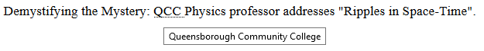

## **2.2. Working with *lists* in HTML**

There are lots of occasions when we need to use lists. HTML provides us with three different types: Ordered lists, unordered lists, definition lists.

### **Ordered listed**

Ordered lists are lists where each item in the list is numbered. For example, the list might be a set of steps for a recipe that must be performed in order, or a legal contract where each point needs to be identified by a section number.

The ordered list is created with the **<ol>** element.

Each item in the list is placed between an opening **<li>** tag and a closing **</li>** tag. (The **li** stands for list item.)

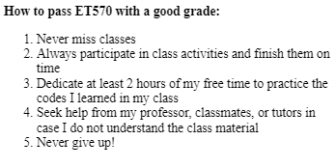

**DISPLAY**

<p><b>How to pass ET570 with a good grade:</b>

<ol>

<li>Never miss classes</li>

<li>Always participate in class activities and finish them on time</li>

<li>Dedicate at least 2 hours of my free time to practice the codes I learned in my class</li>

<li>Seek help from my professor, classmates, or tutors in case I do not understand the class material</li>

<li> Never give up!</li>

</ol>

</p>

**HTML**

### **Ordered List – “type” attribute**

Attributes provide additional information about HTML elements.

The **type** attribute of the <ol> tag, defines the type of the list item marker. Attributes provide additional information about HTML elements.

|  |  |
| --- | --- |
| **Type** | **Description** |
| type="1" | The list items will be numbered with numbers (default) |
| type="A" | The list items will be numbered with uppercase letters |
| type="a" | The list items will be numbered with lowercase letters |
| type="I" | The list items will be numbered with uppercase roman numbers |
| type="i" | The list items will be numbered with lowercase roman numbers |

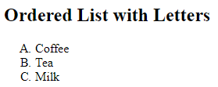

**DISPLAY**

<h2>Ordered List with Letters</h2>

<ol type="A">

<li>Coffee</li>

<li>Tea</li>

<li>Milk</li>

</ol>

**HTML**

### **Bullet or unordered listed**

* Unordered lists are lists that begin with a bullet point (rather than characters that indicate order).
* The unordered list is created with the **<ul>** element.
* Each item in the list is placed between an opening **<li>** tag and a closing **</li>** tag.

<ul><b>Lists of fruits</b>

<li>Apples</li>

<li>Oranges</li>

<li>Grapes</li>

</ul>

**DISPLAY**

### **Definition listed**

Definition lists are made up of a set of terms along with the definitions for each of those terms.

The definition list is created with the **<dl>** element.

Inside the <dl> element you will usually see pairs of **<dt>** and **<dd>** elements.

**<dt>** is used to contain the term being defined (the definition term).

**<dd>** is used to contain the definition.

<dl>

<dt><b>ET-570 Creating Smartphone Applications</b></dt>

<dd>This course introduces the use and features of smartphones in modern life and how to create working applications. </dd>

<br/>

<dt><b>ET-710 Web Technology: Building and Maintaining Web Sites</b></dt>

<dd>ET 710 focuses on the skills needed to build, maintain, and administrate a website. </dd

</dl>

**HTML**

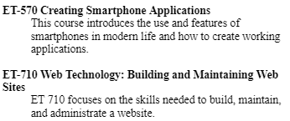

**DISPLAY**

## **2.3. Tables**

There are several types of information that need to be displayed in a grid or table. For example: sports results, stock reports, and train timetables.

### ***Basic tables structure***

The **<table>** element is used to create a table. The contents of the table are written out row by row.

You indicate the start of each row using the opening **<tr>** tag. (The tr stands for table row). At the end of the row you use a closing **</tr>** tag.

Each cell of a table is represented using a **<td>** element. (The td stands for table data.)

**Example)** Create a table with the following information

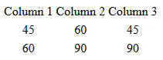

**DISPLAY**

<table>

<tr> <td>Column 1</td> <td> Column 2</td> <td>Column 3</td> </tr>

<tr align="center"> <td> 45</td> <td >60</td> <td>45</td></tr>

<tr align="center"><td>60</td> <td>90</td> <td>90</td> </tr>

</table>

**HTML**

The **<th>** element is used just like the **<td>** element but its purpose is to represent the heading for either a column or a row. (The **th** stands for table heading.)

You can use the **scope** attribute on the **<th>** element to indicate whether it is a heading for a **column** or a **row**. It can take the values row to indicate a heading for a row or col to indicate a heading for a column.

**Example)** Create the following table

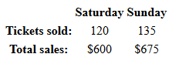

**DISPLAY**

<table>

<tr> <th></th> <th>Saturday</th> <th>Sunday</th></tr>

<tr><th>Tickets sold:</th> <td align='center'>120</td> <td align='center'>135</td></tr>

<tr><th>Total sales:</th> <td align='center'>$600</td> <td align='center'>$675</td></tr>

</table>

**HTML**

### ***Border and background***

The **border** attribute was used on both the <table> and <td> elements to indicate the width of the border in pixels.

The **bgcolor** attribute was used to indicate background colors of either the entire table or individual table cells.

Color can code in three ways:

* By the color name such as red, blue, green, black, lightblue, etc
* By the hex color palette code. You can get the hex color palette in: <http://www.color-hex.com/color-palettes>
* By the combination of RGB code.

**Example)** Create a following table with table border = 2px, table background ***yellow*** , 2nd row to ***pink*** , and one cell to ***lightgreen***

<table border="2" bgcolor="yellow">

<tr>

<th width="100"></th><th width="100">Withdrawn</th><th width="100">Credit</th>

<th width="100">Balance</th></tr>

<tr align="center" bgcolor="pink">

<th>January</th><td>$250.00</td><td>$660.50</td><td>$410.50</td></tr>

<tr align="center">

<th>February</th><td>$135.55</td><td>$895.20</td><td bgcolor="lightblue">$1170.15</td></tr>

</table>

**HTML**

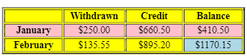

**DISPLAY**

## **2.4. Managing images in HTML**

There are many reasons why you might want to add an image to a web page: you might want to include a logo, photograph, illustration, diagram, or chart.

**Images should…**

* Be relevant
* Convey information
* Convey the right mood
* Be instantly recognizable
* Fit the color palette

**Stock photos**

If you do not have photographs to use on your website, there are companies who sell stock images or icons:

* [www.pexels.com](http://www.pexels.com)
* [www.iconfinders.com](http://www.iconfinders.com)

**What is the best screen size to design for?**

It is important to understand the size of the computer screen in order to coordinate the size of the image. Based on the worldwide screen resolution stats (nov 2016 – nov 2017) chart above and the charts below, these are the resolutions you need to be aware of in 2018.

* 360×640 – 21.54%
* 1366×768 – 12.85%
* 1920×1080 – 7.76%
* 375×667 – 4.94%
* 1440×900 – 3.32%
* 1280×800 – 2.67%

***Image formats***

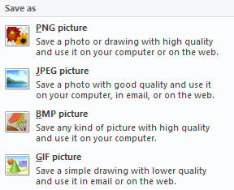PNG Portable Network Graphics

JPG or JPEG Joint Photographic Experts Group

BMP BitMaP

GIF Graphics Interchange format

The images on your computer screen are made up of lots of tiny squares known as pixels. The resolution of the screen is the number of pixels represented on it, and on most computers you can increase and decrease this number.

JPEG offers good quality when the image has many different colors.

GIF or PNG images are low quality images which are good for images with few colors or large areas of the same color (flat color). Example of them are logos, illustrations, and diagrams.

**Exercise)** which format would you save the following images?





***Image dimensions***

The images you use on your website should be saved at the same width and height that you want them to appear on the page.

**Cropping image**

When cropping images it is important not to lose valuable information. It is best to source images that are the correct shape if possible.

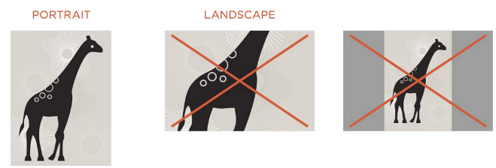

***Store Images***

As a website grows, keeping images in a separate folder helps you understand how the site is organized. Usually they are stored in sub-folder called “images”.

On a big site you might like to add subfolders inside the images folder. For example, images such as logos and buttons might sit in a folder called interface, product photographs might sit in a page called products, and images related to news might live in a folder called news.

### **Adding images to a webpage**

To add an image into the page you need to use an **<img>** element. This is an empty element (which means there is no closing tag). It must carry the attribute src.

**<img> attributes**

**src** tells the browser where it can find the image file. This will usually be a relative URL pointing to an image on your own site.

**alt** provides a text description of the image which describes the image if you cannot see it.

**title** provides additional information about the image. Most browsers will display the content of this attribute in a tooltip when the user hovers over the image.

**height** specifies the height of the image in pixels.

**width** specifies the width of the image in pixels.

### **Alignment of an image in a webpage**

The align attribute was commonly used to indicate how the other parts of a page should flow around an image. It has been removed from HTML5 and new websites should use CSS to control the alignment of images.

The align attribute can take these values:

**left** aligns the image to the left (allowing text to flow around its right-hand side).

**right** aligns the image to the right (allowing text to flow around its left-hand side).

**top** aligns the first line of the surrounding text with the top of the image.

**middle** aligns the first line of the surrounding text with the middle of the image.

**bottom** aligns the first line of the surrounding text with the bottom of the image.

<h3 align="center">Images and attributes</h3>

<img src="QCC_Tiger.jpg" alt="Logo of QCC tiger" title="This is tile of logo" height="200px" width="200px" border="2px" align="right"/>

**HTML**

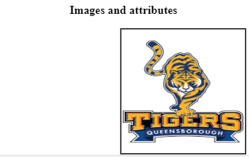

**DISPLAY**

### ***HTML5: figure and figure caption***

HTML5 has introduced a new **<figure>** element to contain images and their caption so that the two are associated.

You can have more than one image inside the **<figure>** element as long as they all share the same caption.

The **<figcaption>** element has been added to HTML5 in order to allow web page authors to add a caption to an image.

<h3 align="center">Images using figure and attributes</h3>

<figure>

<img src="QCC_Tiger.jpg" alt="Logo 1" height="90px" width="90px" border="1px">

<img src="QCC_Tiger.jpg" alt="Logo 2" height="90px" width="90px" border="1px">

<img src="QCC_Tiger.jpg" alt="Logo 3" height="90px" width="90px" border="1px">

<figcaption>This is a caption using tab figcaption <br/><i>QCC Logos </i>

</figcaption>

</figure>

**HTML**

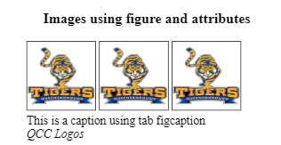

**DISPLAY**

**2.5. Links**

Links are the defining feature of the web because they allow you to move from one web page to another — enabling the very idea of browsing or surfing

### ***Writing Links***

Links are created using the **<a>** element. Users can click on anything between the opening **<a>** tag and the closing **</a>** tag.

By default, links will appear as follows in all browsers:

* An unvisited link is underlined and blue
* A visited link is underlined and purple
* An active link is underlined and red

Some of **<a>** attributes are **href** and target:

* **href:** Specifies the URL of the page the link goes to.
* **target:** Specifies where to open the linked document. Some of the value of attribute target are: _blank, _parent, _self, _top

### ***Linking to other sites***

Links are created using the **<a>** element which has an attribute called **href**. The value of the href attribute is the page that you want people to go to when they click on the link.

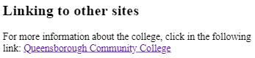

**DISPLAY**

<h3>Linking to other sites </h3>

<p>For more information about the college, click in the following link:

<a href="http://www.qcc.cuny.edu">Queensborough Community College</a></p>

**HTML**

### ***Opening Links in a New Window***

If you want a link to open in a new window, you can use the **target** attribute on the opening <a> tag. The value of this attribute should be **“blank”.**

<h3>Linking to other sites </h3>

<p>For more information about the college, click in the following link:

<a href=<http://www.qcc.cuny.edu> **target=_blank**>Queensborough Community College</a></p>

**HTML**

### ***Email Links***

To create a link that email to a specified email address, you use the **<a>** element, follow by the attribute **href** starts with **mailto**: and is followed by the email address you want the email to be sent to.

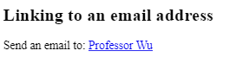

**DISPLAY**

<h3>Linking to an email address </h3>

<p>Send an email to: <a href="mailto:hwu@qcc.cuny.edu">Professor Wu</a></p>

**HTML**

### ***Linking to a specific part of the same page***

Before you can link to a specific part of a page, you need to identify the points in the page that the link will go to. You do this using the **id** attribute (which can be used on every HTML element).

The value of the **id** attribute should start with a letter or an underscore (not a number or any other character) and, on a single page, no two id attributes should have the same value.

To link to an element that uses an **id** attribute you use the <a> element again, but the value of the href attribute starts with the **#** symbol, followed by the value of the **id** attribute of the element you want to link to.

**Example)**identify the part of your page where the **id** **bottom** will return when is clicked:

**<img src="images/ny.jpg" id="bottom" alt="New York City“>**

When the word ***Go to Image*** is clicked, it will link to an element with id **bottom:**

**<p><a href="#bottom">Go to Image</a></p>**

This is possible if the image is at the same webpage. If the link is in the other webpage, the code has to link to the webpage that it has followed by the id name:

**<p><a href="index.com#bottom">Top</a></p>**

### ***Navigation Bars***

Having easy-to-use navigation is important for any web site.

Later in the class, you will use CSS to transform the HTML menus into good-looking navigation bars. For now, you can create navigation bar using unordered list.

**Example)** Create navigation bars using <ul> element.

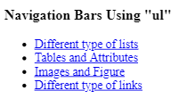

**DISPLAY**

<h3>Navigation Bars Using "ul"</h3>

<ul>

<li><a href="**#list1**">Different type of lists</a></li>

<li><a href="#tables2">Tables and Attributes</a></li>

<li><a href="#images">Images and Figure</a></li>

<li><a href="#links">Different type of links</a></li>

</ul>

**HTML**

In this case, we are using internal links that will link to a specific part of the same page.For that, we have to mark the element that the link has as reference using the id attribute. For example, to make an internal link to the Different type of lists, we can id el <ol> element with id="list1"

<ol **id="list1">**

<li>Never miss classes</li>

<li>Always participate in class activities and finish them on time</li>

<li>Dedicate at least 2 hours of my free time to practice the codes I learned in my class</li>

<li> Seek help from my professor, classmates, or tutors in case I do not understand the class material</li>

<li> Never give up!</li>

</ol>

**HTML**

The **<nav>** tag defines a set of navigation links in an inline form. The nav tag is not supported in Internet Explorer 8 and earlier versions.

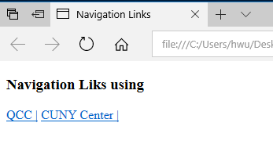

**DISPLAY**

<h3> Navigation Liks using </h3>

<nav>

<a href="http://www.qcc.cuny.edu" target="blank">QCC |</a>

<a href="http://www2.cuny.edu/" target="blank">CUNY Center |</a>

</nav>

**HTML**

### ***Linking to other pages on the same site***

To link the pages within the same, you will need to create and organize the html files in their respective folder. You will need to create parents folder, child folders, grandchildren folders (if it is necessary), etc.

The main homepage of a site written in HTML (and the homepages of each section in a child folder *recommended) is called **index.html**

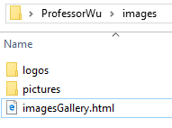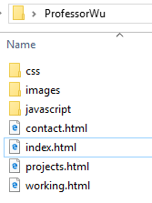

### ***How to link a webpage within the same site?***

* To link to a file in the same folder, just use the file name

**<p><a href="projects.html">Professional Projects</a></p>**

* To link a file in a child folder, use the name of the child folder, followed by a forward slash, then the file name

**<p><a href="images/imagesGallery.html">Project Gallery Images</a></p>**

* To link to the homepage from a child folder, or to one folder before it, use **../**

For example, if you are writing a code in webpage imagesGallery.html, which is located in a child folder “images”, and you want to make a link to go back to the index page, which is located in a parent folder, you will write the code as the following:

**<p><a href="../index.html">Go back to homepage</a></p>**

### ***How to link an image to other side***

To use an image as a link, put the <img> tag inside the <a> tag:

<h3>How to link an image to other side</h3>

<a href="http://www.qcc.cuny.edu/index.html" target="_blank">

<img src="QCC_Tiger.jpg" alt="Logo of QCC tiger" title="This is tile of logo" height="200px" width="200px" /></a>

**HTML**

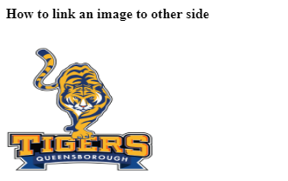

**DISPLAY**

Cascading Style Sheets (CSS)

# **3. Introduction to CSS**

## **3.1. CSS Basics**

CSS (Cascading Style Sheets) allows you to create rules that specify how the content of an element should appear. For example, you can specify that the background of the page is cream, all paragraphs should appear in gray using the Arial typeface, or that all level one headings should be in a blue, italic, Times typeface.

CSS works by associating rules with HTML elements. These rules govern how the content of specified elements should be displayed. A CSS rule contains two parts: a **selector** and a **declaration.**

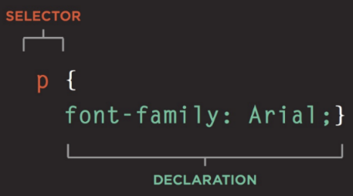**Selectors** indicate which element the rule applies to. The same rule can apply to more than one element if you separate the element names with commas.

**Declarations** indicate how the elements referred to in the selector should be styled. Declarations are placed between brackets.

Declarations are split into two parts (a property and a value) are separated by a colon.

### ***Within declaration***

The declaration should specific the property and value of element of the selector.

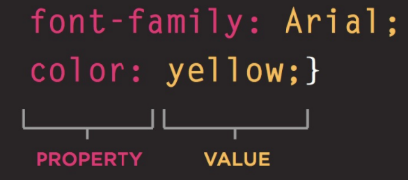**Properties** indicate the aspects of the element you want to change. For example, color, font, width, height and border. Each declaration ends with a semicolon. You can always refer to w3schools.com to check the list of all properties that is available in CSS.

**Values** specify the settings you want to use for the chosen properties. For example, if you want to specify a color property then the value is the color you want the text in these elements to be.

### ***Where should I place my CSS instructions?***

**Externally:** Your CSS code can be writing in a text editor and save it with file extension .css

Then the .css can be found using the link element.

**Internally:** You can also include CSS rules within an HTML page by placing them inside a **<style>** element, which usually sits inside the <head> element of the page.

***Using external CSS***

The **<link>** element can be used in an HTML document to tell the browser where to find the CSS file used to style the page. It is an empty element (meaning it does not need a closing tag), and it lives inside the <head> element. It should use three attributes:

**href:** This specifies the path to the CSS file (which is often placed in a folder called css or styles).

**type:** This attribute specifies the type of document being linked to. The value should be text/css.

**rel:** This specifies the relationship between the HTML page and the file it is linked to. The value should be stylesheet when linking to a CSS file.

An HTML page can use more than one CSS style sheet. To do this it could have a <link> element for every CSS file it uses. For example, some authors use one CSS file to control the presentation (such as fonts and colors) and a second to control the layout.

**Exercise)** Create a simple app with **<h1>** and **<p>** element. Save an external .css file as ***style.css***

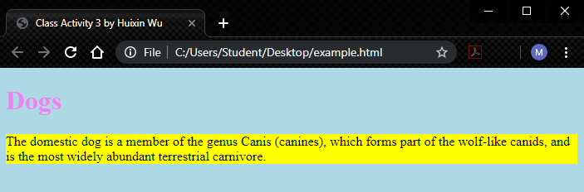

<!DOCTYPE html>

<html lang="en" dir="ltr">

<head>

<meta charset="utf-8">

<meta name="viewport" content="width=device-width, initial-scale=1.0">

<title>Class Activity 3 by Huixin Wu</title>

<link href="style.css" type="text/css" rel="stylesheet" />

</head>

<body> <h1>Dogs</h1>

<p> The domestic dog is a member of the genus Canis (canines), which forms part of the wolf-like canids, and is the most widely abundant terrestrial carnivore.</p>

</body>

</html>

**HTML**

body {

background-color: lightblue;

}

h1 {color:violet;}

p {background-color: yellow;}

***style.css***

***Using Internal CSS***

You can also include CSS rules within an HTML page by placing them inside a **<style>** element, which usually sits inside the <head> element of the page.

The **<style>** element should use the type attribute to indicate that the styles are specified in CSS. The value should be text/ css.

When building a site with more than one page, you should use an external CSS style sheet. This:

* Allows all pages to use the same style rules (rather than repeating them in each page).
* Keeps the content separate from how the page looks.
* Means you can change the styles used across all pages by altering just one file (rather than each individual page).

**Exercise)** Create the following text with font color.

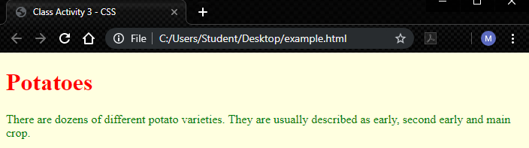

<!DOCTYPE html>

<html lang="en" dir="ltr">

<head>

<meta charset="utf-8">

<meta name="viewport" content="width=device-width, initial-scale=1.0">

<title>Class Activity 3 - CSS</title>

**<style type="text/css">**

**body { background-color: lightyellow;}**

**h1 { color: red;}**

**p{ color: green;}**

**</style>**

</head>

<body> <h1>Potatoes</h1><p> There are dozens of different potato

varieties. They are usually described as

early, second early and main crop.</p>

</body>

</html>

***style.css***

## **3.2. Text in CSS**

The formatting of your text can have a significant effect on how readable your pages are.

### ***Text Properties***

The properties that allow you to control the appearance of text can be split into two groups:

* Those that directly affect the font and its appearance (including the typeface, whether it is regular, bold or italic, and the size of the text)
* Those that would have the same effect on text no matter what font you were using (including the color of text and the spacing between words and letters)

When choosing a typeface, it is important to understand that a browser will usually only display it if it's installed on that user's computer.

***Typeface Terminology***

**SERIF**

Serif fonts have extra details on the ends of the main strokes of the letters. These details are known as serifs.

In print, serif fonts were traditionally used for long passages of text because they were considered easier to read.

**Examples:** Georgia, Times New Roman

**SANS-SERIF**

Sans-serif fonts have straight ends to letters, and therefore have a much cleaner design.

Screens have a lower resolution than print. So, if the text is small, sans-serif fonts can be clearer to read.

**Examples:** Arial , Verdana, Helvetica

**MONOSPACE**

Every letter in a monospace (or fixed-width) font is the same width. (Non-monospace fonts have different widths.)

Monospace fonts are commonly used for code because they align nicely, making the text easier to follow.

**Example:** Courier

**CURSIVE**

Cursive fonts either have joining strokes or other cursive characteristics, such as handwriting styles.

**Example**: Monotype Corsiva

im

**Exercise)** Using the previous html code, create a new paragraph and name it as **author** using **class** property.

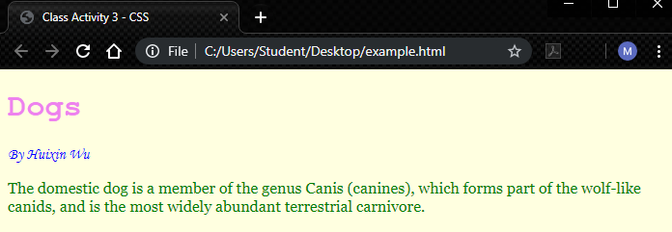

<!DOCTYPE html>

<html lang="en" dir="ltr">

<head>

<meta charset="utf-8">

<meta name="viewport" content="width=device-width, initial-scale=1.0">

<title>Class Activity 3 - CSS</title>

<link href="css/styles.css" type="text/css" rel="stylesheet" />

</head>

<body> <h1>Dogs</h1>

**<p class="author">**By <i>Huixin Wu</i> **</p>**

**<p class="intro">** The domestic dog is a member of the genus Canis (canines), which forms part of the wolf-like canids, and is the most widely abundant terrestrial carnivore**.</p>**

</body>

</html>

*html file*

Add new paragraph with class name **"author"**

body {

background-color: lightyellow;

}

h1 {

color:violet;font-family: courier;

}

**.intro**{

color: green; font-family: georgia;

}

**.author{**

color: blue;font-family: "monotype corsiva";

**}**

***style.css***

### ***Text Characteristics***

**font-weight**

The font weight not only adds emphasis but can also affect the amount of white space and contrast on a page.

**Examples:**

Light Medium **Bold** Black

**font-style**

Italic fonts have a cursive aspect to some of the lettering. Oblique font styles take the normal style and put it on an angle

**Examples:**

Normal *Italic Oblique*

**font-stretch**

In condensed (or narrow) versions of the font, letters are thinner and closer together. In expanded versions they are thicker and further apart.

**Examples:**

Condensed Regular Extended

**Exercise)** Using the previous code, add three more paragraphs with class name **fontWeight, fontStyle**, and **fontStretch**

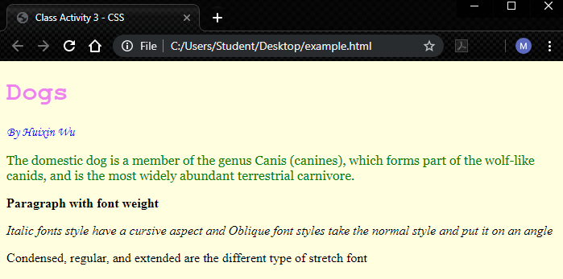

**fontWeight**

**fontStyle**

**fontStretch**

<!DOCTYPE html>

<html lang="en" dir="ltr">

<head>

<meta charset="utf-8">

<meta name="viewport" content="width=device-width, initial-scale=1.0">

<title>Class Activity 3 - CSS</title>

<link href="css/styles.css" type="text/css" rel="stylesheet" />

</head>

<body> <h1>Dogs</h1>

<p class="author">By <i>Huixin Wu</i></p>

<p class="intro"> The domestic dog is a member of the genus Canis (canines), which forms part of the wolf-like canids, and is the most widely abundant terrestrial carnivore.</p>

<p **class="fontWeight">**Paragraph with font weight</p>

<p **class="fontStyle">**Italic fonts style have a cursive aspect and Oblique font styles take the normal style and put it on an angle</p>

<p **class="fontStretch**">Condensed, regular, and extended are the different type of stretch font</p>

</body>

</html>

*html file*

Add the following paragraphs

**.fontWeight**{

font-weight: bold;

}

**.fontStyle**{

font-style: oblique;

}

**.fontStretch**{

font-stretch: condensed;

}

***style.css***

### ***Units of Text Type Size***

The default size of text in a browser is 16 pixels.

Text can be written as pixels, percentages, and ems.

|  |  |  |
| --- | --- | --- |
| **Pixels** | **Percentages** | **ems** |
| Setting font size in pixels is the best way to ensure that the type appears at the size you intended (because percentages and ems are more likely to vary if a user has changed the default size of text in their browser | The default size of text in a web browser is 16 pixels. Using percentages of this amount, you can create a scale where the default text size is 12 pixels, and headings are sized in relation to this. | Ems allow you to change the size of text relative to the size of the text in the parent element. Since the default size of text in web browsers is 16 pixels, you can use similar rules to those shown for percentages. |
| **Pixels** | **Percentages** | **Ems (Ephemeral Unit Scalable)** |
| body 🡺16px  h1 🡺 32px  h2 🡺 24px  h3 🡺18px | body 🡺100%  h1 🡺 200%  h2 🡺 150%  h3 🡺 112.5% | body 🡺100%  p 🡺1em  h1 🡺2em  h2 🡺1.5em  h3 🡺1.125em |

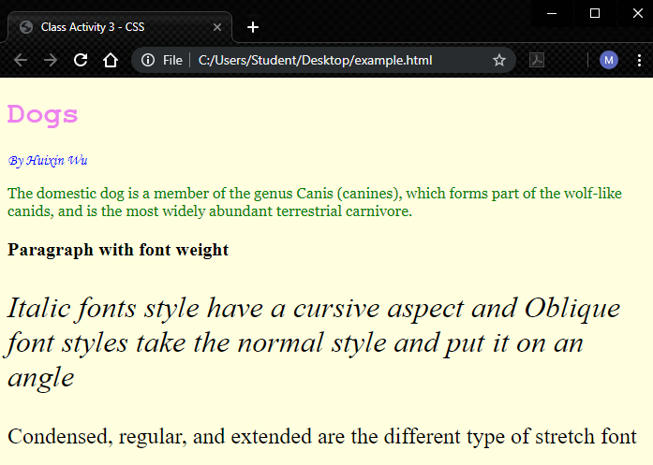**Exercise)** Using the previous css file, use different values of **font-size** to class fontWeight, fontStyle, and fontStretch

**font-size:20px;**

**font-size:200%;**

**font-size:1.5em;**

.fontWeight{

font-weight: bold;

**font-size: 20px;**

}

.fontStyle{

font-style: oblique;

**font-size: 200%;**

}

.fontStretch{

font-stretch: condensed;

**font-size: 1.5em;**

}

***style.css***

### ***Text Alignment (horizontal)***

The **text-align** property allows you to control the alignment of text. The property can take one of four values:

* **left**: This indicates that the text should be left-aligned.
* **right**: This indicates that the text should be right-aligned.
* **center**: This allows you to center text.
* **justify**: This indicates that every line in a paragraph, except the last line, should be set to take up the full width of the containing box.

**Exercise)** Using the previous css code, add different **text-align** properties to **h1**, **.intro**, and **.author**

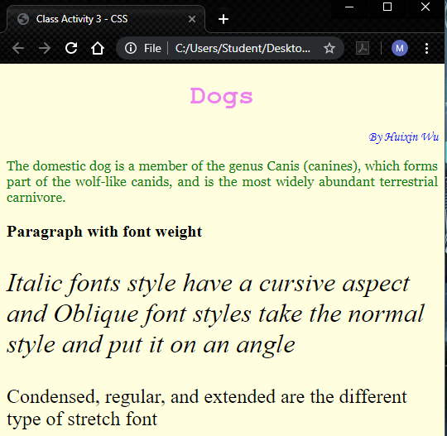

text-align: center;

**text-align: right;**

**text-align: justify;**

h1 {

color:violet;

font-family: courier;

**text-align: center;**

}

.intro{

color: green;

font-family: georgia;

**text-align: justify;**

}

.author{

font-family: "monotype corsiva";

color: blue;

**text-align: right;**

}

***style.css***

### ***Text-Shadow***

The **text-shadow** property is used to create a drop shadow, which is a dark version of the word just behind it and slightly offset. It can also be used to create an embossed effect by adding a shadow that is slightly lighter than the text.

**text-shadow** can use three lengths and a color for the drop shadow.

The first length indicates how far to the left or right the shadow should fall.

The second value indicates the distance to the top or bottom that the shadow should fall.

The third value is optional and specifies the amount of blur that should be applied to the drop shadow.

The fourth value is the color of the drop shadow.

text-shadow: 5px 10px 20px black;

**Exercise)** Create different **text-shadow** effect.

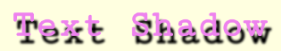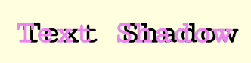

<h1 class="title4">Text Shadow</h1>

***html***

<h1 class="title1">Text Shadow</h1>

***html***

.title4{

text-shadow: 5px 10px 5px black;

}

***style.css***

.title1{

text-shadow: 10px 0px 0px black;

}

***style.css***

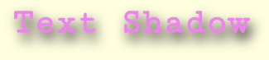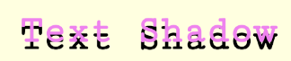

<h1 class="title5">Text Shadow</h1>

***html***

<h1 class="title2">Text Shadow</h1>

***html***

.title5{

text-shadow: 5px 10px 30px black;

}

***style.css***

.title2{

text-shadow: 0px 10px 0px black;

}

***style.css***

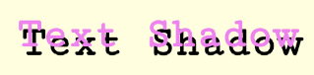

<h1 class="title3">Text Shadow</h1>

***html***

.title3{

text-shadow: 5px 10px 0px black;

}

***style.css***

### ***First Letter or Line***

You can specify different values for the first letter or first line of text inside an element using **:first-letter** and **:first-line**. For this, first you will need the attribute **class** to identify the paragraph where the first-letter or first-line will be applied.

**Activity)** Create a paragraph and apply CSS property to the **first-letter** of this paragraph.

<p class="name">First text letter<p>

***html***

p.name:first-letter{

font-size:3em;

color: purple;

font-weight: bold;

}

***style.css***

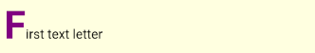

***output***

### ***Text Border, Margin & Padding***

Every box has three available properties that can be adjusted to control its appearance:

**border**

Every box has a border (even if it is not visible or is specified to be 0 pixels wide). The border separates the edge of one box from another.

**Border Style**

You can control the style of a border using the border-style property. This property can take the following values:

* **solid** a single solid line.
* **dotted** a series of square dots (if your border is 2px wide, then the dots are 2px squared with a 2px gap between each dot)
* **dashed** a series of short lines
* double two solid lines (the value of the border-width property creates the sum of the two lines)
* **groove** appears to be carved into the page
* **ridge** appears to stick out from the page
* **inset** appears embedded into the page
* **outset** looks like it is coming out of the screen
* **hidden / none** no border is shown

**borde**r values can be written in one line: border style, border size, and border color:

**border: dashed 5px red;**

**Exercise)** Add border style, size, and color to a paragraph

<p class="page_border">How to work with border</p>

***html***

.page_border{

border: dashed 5px red;

font-size: 30px;

}

***style.css***

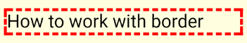

***output***

**margin**

Margins sit outside the edge of the border. You can set the width of a margin to create a gap between the borders of two adjacent boxes.

The margin property controls the gap between boxes. Its value is commonly given in pixels, although you may also use percentages or ems.

You can specify values for each side of a box using: margin-top, margin-right, margin-bottom, margin-left.

You can also use the shorthand (where the values are in clockwise order: top, right, bottom, left):

margin: 1px 2px 3px 4px;

**Exercise)** Create three paragraphs and apply different margin and border values to each paragraph

<p class="margin1">Top Paragraph </p>

<p class="margin2">Center Paragraph</p>

<p class="margin3">Bottom Paragraph</p>

***html***

***output***

.margin1{

margin-top: 100px;

border: dotted green 3px;

}

.margin2{

margin: 30px;

border:inset blue 10px;

}

.margin3{

margin-left: 60px;

border: outset red;

}

***style.css***

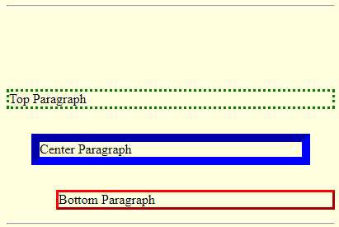

**padding**

Padding is the space between the border of a box and any content contained within it. Adding padding can increase the readability of its contents.

The padding property allows you to specify how much space should appear between the content of an element and its border.

The value of this property is most often specified in pixels (although it is also possible to use percentages or ems). If a percentage is used, the padding is a percentage of the browser window (or of the containing box if it is inside another box).

You can specify different values for each side of a box using:

padding-top; padding-right; padding-bottom; padding-left.

Or you can use a shorthand (where the values are in clockwise order: top, right, bottom, left):

**padding: 10px 5px 3px 1px;**

**Exercise)** Create three paragraphs and apply three different padding to each of them.

<p class="one">Without Padding</p>

<p class="two">padding to 20px</p>

<p class="three">padding top by 50px</p>

***html file***

.one{ border: ridge green;}

.two{

padding:20px;

border: solid gray 2px;

}

.three{

padding-top: 50px;

border: dotted black;

}

***style.css***

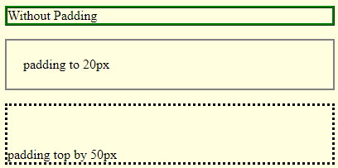

***output***

# **4 – Layout in CSS, Icons and Social Medial Icons, Navigation bars**

## **4.1 Layout in CSS**

In this chapter we are going to look at how to control where each element sits on a page and how to create attractive page layouts.

**Screen size**

Different visitors to your site will have different sized screens that show different amounts of information, so your design needs to be able to work on a range of different sized screens.

|  |  |
| --- | --- |
| Image result for dell xps 13 laptop  **13.3”**  Dell XPS 13 Laptop  Display: 13.3 inches across screen  Display resolution: 1920 × 1080 pixels | https://cdn.shopify.com/s/files/1/1183/6364/products/1496789480000_1342538_1200x.jpg?v=1496868021    **12”**  Apple MacBook  Display: 12 inches across screen  Display resolution: 2304 × 1440 pixels |

**Building blocks**

CSS treats each HTML element as if it is in its own box. This box will either be a block-level box or an inline box.

If one block-level element sits inside another block-level element then the outer box is known as the containing or parent element.

It is common to group a number of elements together inside a <div> (or other block-level) element.

**Static Layouts: Fixed Width**

Fixed width layout designs do not change size as the user increases or decreases the size of their app window. Measurements tend to be given in pixels.

**Advantages**

* Pixel values are accurate at controlling size and positioning of elements.
* The designer has far greater control over the appearance and position of items on the page than with liquid layouts.
* You can control the lengths of lines of text regardless of the size of the user's window.
* The size of an image will always remain the same relative to the rest of the page.

**Disadvantages**

You can end up with big gaps around the edge of a page.

* If the user's screen is a much higher resolution than the designer's screen, the page can look smaller and text can be harder to read.
* If a user increases font sizes, text might not fit into the allotted spaces.
* The design works best on devices that have a site or resolution similar to that of desktop or laptop computers.
* The page will often take up more vertical space than a liquid layout with the same content.

**Dynamic Layouts: Liquid Layout**

The liquid layout uses percentages to specify the width of each box so that the design will stretch to fit the size of the screen.

**Advantages**

* Pages expand to fill the entire app window so there are no spaces around the page on a large screen.
* If the user has a small window, the page can contract to fit it without the user having to scroll to the side.
* The design is tolerant of users setting font sizes larger than the designer intended (because the page can stretch).

**Disadvantages**

* If you do not control the width of sections of the page then the design can look very different than you intended, with unexpected gaps around certain elements or items squashed together.
* If the user has a wide app window, lines of text can become very long, which makes them harder to read.
* If the user has a very narrow app window, words may be squashed and you can end up with few words on each line.
* If a fixed width item (such as an image) is in a box that is too small to hold it (because the user has made the window smaller) the image can overflow over the text.

**Floating Elements. float property in CSS**

The float property allows you to take an element in normal flow and place it as far to the left or right of the containing element as possible.

Anything else that sits inside the containing element will flow around the element that is floated.

When you use the float property, you should also use the width property to indicate how wide the floated element should be. If you do not, results can be inconsistent but the box is likely to take up the full width of the containing element (just like it would in normal flow).

The CSS float property specifies how an element should float. The float property can have one of the following values:

* **left** - The element floats to the left of its container

**right**- The element floats to the right of its container**none** - The element does not float (will be displayed just where it occurs in the text). This is default**inherit** - The element inherits the float value of its paren**tResponsive effect**

Responsive app web is about using html and css to resize, hide, shrink, enlarge, or move the content to make it look good on any screen.

The **box-sizing** property can make building CSS layouts easier and a lot more intuitive. **box-sizing: border-box;** , we can change the **box** model to what was once the "quirky" way, where an element's specified width and height aren't affected by padding or borders.

**<div> division tag**

The **<div>** tag defines a division or a section in an HTML document and is very often used together with CSS, to layout a web page. The **<div>** element is often used as a container for other HTML elements to style them with CSS or to perform certain tasks with JavaScript.

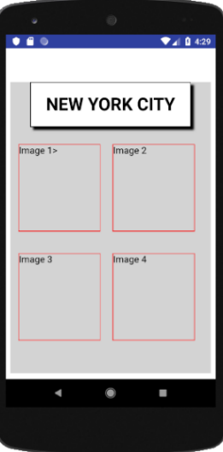**Exercise)** Create a layout using <div> to save four images

To create the layout, first we create a container to hold the header and the four images. We can create this container using <div> and name it container

**<div class="container">**

**</div>**

Once the container is set, we are going to create five more division within the container; one division for the header and four for the images:

<div class="container">

**<div class="header">NEW YORK CITY</div>**

**<div class="images">IMAGE 1</div>**

**<div class="images">IMAGE 2</div>**

**<div class="images">IMAGE 3</div>**

**<div class="images">IMAGE 4</div>**

</div>

A complete HTML file looks as the following:

<!DOCTYPE html>

<html lang="en" dir="ltr">

<head>

<meta charset="utf-8">

<meta name="viewport" content="width=device-width, initial-scale=1.0">

<link href="index.css" rel="stylesheet" type="text/css"/>

<title>Layout Design</title>

</head>

<body>

<div class="container">

<div class="header">NEW YORK CITY</div>

<div class="images">IMAGE 1</div>

<div class="images">IMAGE 2</div>

<div class="images">IMAGE 3</div>

<div class="images">IMAGE 4</div>

</div>

</body>

</html>

***html file***

Now in the CSS file, we can set the background-color, width, and height to the container first:

.container{

background-color: lightgray;

width: 100%;

height: 500px;

}

After it, we can set the css to the header as the following:

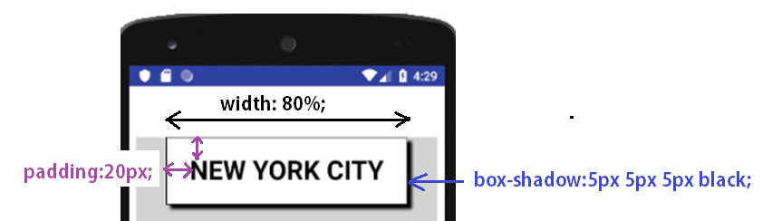

.header{

width: 80%;

margin: auto;

border: solid black;

box-shadow: 5px 5px 5px black;

padding: 20px;

font-size: 30px;

font-weight: 600;

text-align: center;

background-color: white;

}

Once the header is set, we can set the css to the **images** container. For this, we can add a border to the images container to use it as reference. This border can be erased after the layout is set.

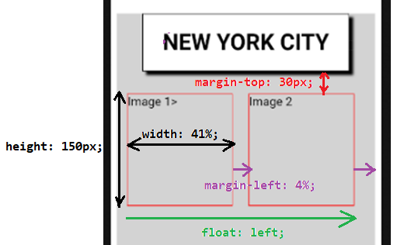

.images{

border: solid red;

height: 150px;

width: 41%;

float: left;

margin-left: 2%;

margin-top: 30px;

margin-left: 4%;

}

The complete CSS file looks as the following:

*{ box-sizing: border-box; }

.container{

background-color: lightgray;

width: 100%;

height: 500px;

}

.header{

width: 80%;

margin: auto;

border: solid black;

box-shadow: 5px 5px 5px black;

padding: 20px;

font-size: 30px;

font-weight: 600;

text-align: center;

background-color: white;

}

.images{

border: solid red;

height: 150px;

width: 41%;

float: left;

margin-left: 2%;

margin-top: 30px;

margin-left: 4%;

}

***index.css***

**4.2 CSS styling images**The images can fit in a <div> container. For the image to fully fit within the <div>, the image **width** and **height** must be set to 100%

**Exercise**) Insert four different images to the previous code.

We can download four images and save them in assets folder. If we want to organize our assets folder and put all the images in one folder name *images*:

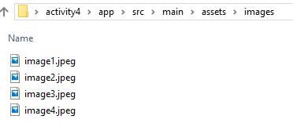

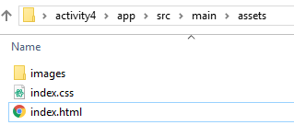

If the images are inside of the *images* folder, the code in HTML should indicate the location of the folder as the following:

<div class="images"><img **src="images/image1.jpeg"** /></div>

If the images are in the same folder that the HTML file:

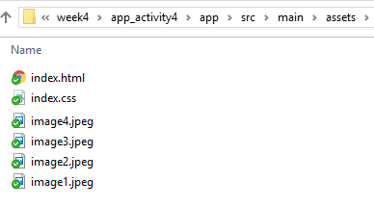

the code in HTML should just indicate the image name:

<div class="images"><img **src="image1.jpeg"** /></div>

For this activity, we are going to organize all images inside the *images* folder. The complete HTML file

looks as the following:

<!DOCTYPE html>

<html lang="en" dir="ltr">

<head>

<meta charset="utf-8">

<meta name="viewport" content="width=device-width, initial-scale=1.0">

<link href="index.css" rel="stylesheet" type="text/css"/>

<title>Layout Design</title>

</head>

<body>

<div class="container">

<div class="header">NEW YORK CITY</div>

<div class="images"><img src="images/image1.jpeg" /></div>

<div class="images"><img src="images/image2.jpeg" /></div>

<div class="images"><img src="images/image3.jpeg" /></div>

<div class="images"><img src="images/image4.jpeg" /></div>

</div>

</body>

</html>

***html file***

Now in css, for the images to sit within the box that contain them, we have to write a css code that specifies that images will sit 100% to the height and width of its container:

**img{**

**width: 100%;**

**height: 100%;**

**}**

The complete css file looks as the following:

*{ box-sizing: border-box; }

img{ width: 100%; height: 100%;

}

.container{

background-color: lightgray;

width: 100%;

height: 800px;

}

.header{

width: 80%;

margin: auto;

border: solid black;

box-shadow: 5px 5px 5px black;

padding: 20px;

font-size: 30px;

font-weight: 600;

text-align: center;

background-color: white;

}

.images{

height: 300px;

width: 41%;

float: left;

margin-left: 2%;

margin-top: 30px;

margin-left: 4%;

}

***index.css***

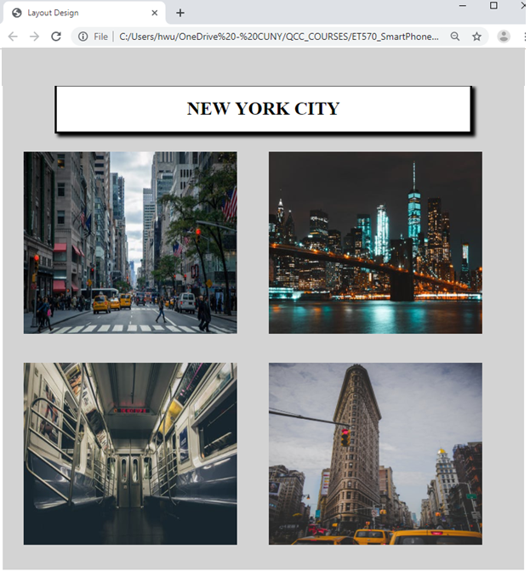

### ***Image format***

To create rounded and circled images, we can use the border-radius property.

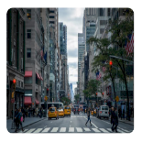**Rounded Images**

img1 {   
  border-radius: 50px;  
}

**Circled Image**

img2 {  
  border-radius: 50%;  
}

To create a border or shadow to an image, we can use the border property to create thumbnail images.

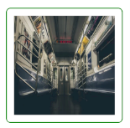**Border image**

img3 {  
  border: 1px solid green;  
  border-radius: 10px;  
  padding: 20px;  
}

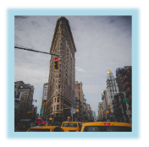**Shadow image**

img4 {  
  box-shadow: 0 0 5px 20px lightblue;  
}

**Exercise)** Using the previous code, add the css code to round the first image, make the second image to be a cicle, add border to the third image, and box-shadow to the fourth image.

To complete this activity, we can add the css code within the HTML code using **style** as the following:

<div class="images"><img src="images/image1.jpeg" **style="border-radius: 8px;"**/></div>

If we want to complete this activity using external css code, we can add a class name to each image and then add the css code in the css file. For this case, the HTML code will be:

<div class="images "><img src="images/image1.jpeg" **class=“img1”** /></div>

CSS code:

**.img1{border-radius: 8px;}**

You can also use an internal CSS code in the HTML file. The complete HTML code using internal css code is as the following:

<!DOCTYPE html>

<html lang="en" dir="ltr">

<head>

<meta charset="utf-8">

<meta name="viewport" content="width=device-width, initial-scale=1.0">

<link href="index.css" rel="stylesheet" type="text/css"/>

<title>Layout Design</title>

</head>

<body>

<div class="container">

<div class="images"><img src="images/image1.jpeg" **style="border-radius: 8px;"**/></div>

<div class="images"><img src="images/image2.jpeg" **style="border-radius: 50%;"**/></div>

<div class="images"><img src="images/image3.jpeg" **style="border: 1px solid green;**

**border-radius: 6px; padding: 10px;"** /> </div>

<div class="images"><img src="images/image4.jpeg"

**style="box-shadow:0 0 5px 10px lightblue"**/></div>

</div>

</body>

</html>

***html file***

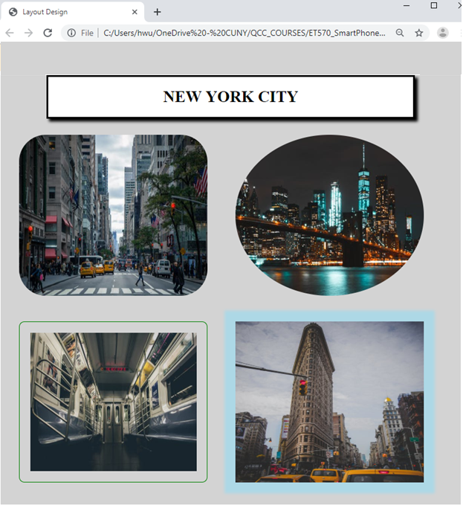

## **4.3 Navigation Bars**

A navigation bar needs standard HTML as a base, which can be built using the <ul> and <li> elements or <div> element. To create a navigation bar using <ul> and <li>

**Vertical Navigation Bars**

To create a basic vertical navigation bar using **<ul>,** we can list each hyperlink using **<a>** tag as the following:

<ul class="navbar">

<li><a href="#home">Home</a></li>

<li><a href="#nav">Tabs</a></li>

<li><a href="#flex">Flex-Wrap</a></li>

<li><a href="#social">Social Media</a></li>

</ul>

To take off the bullet of each list, we can set the **list-style-type** to **none** of the <ul>:

.navbar{

list-style-type: none;

}

To make the vertical navigation bar with a purple background-color, we can write CSS codes to make changes to the hyperlinks in the list item. Also, **display: block;** property sets the list in a block, column, format.

.navbar li a {

display: block;

padding: 8px 16px;

color: white;

background-color: purple;

width: 50%;

text-decoration: none;

}

After it, we can change the background color of the links when the user clicks on them:

.navbar li a:hover {

background-color: gray;

color: white;

}

The HTML and CSS code looks as the following:

<h2 >NAVIGATION TABS</h2>

<hr/>

<i><h3 >Vertical Navigation Tabs using ul</h3></i>

<ul class="navbar">

<li><a href="#home">Home</a></li>

<li><a href="#nav">Tabs</a></li>

<li><a href="#flex">Flex-Wrap</a></li>

<li><a href="#social">Social Media</a></li>

</ul></html>

***html file***

/* -- navigation bars --*/

h2{

width: 90%;

text-align: center;

margin-top: 70px;

}

.navbar{

list-style-type: none;

}

.navbar li a {

display: block;

padding: 8px 16px;

color: white;

background-color: purple;

width: 50%;

text-decoration: none;

}

/* Change the link color when is active*/

.navbar li a:hover {

background-color: gray;

color: white;

}

***css file***

The output will look as the following:

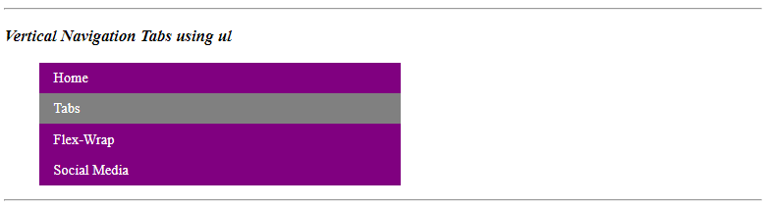

### **Horizontal Navigation Bars**

There are two ways to create a horizontal navigation bar using **inline** or **floating** list items in css once the list is created in HTML

**Exercise)** Create a horizontal navigation bar using **<div>** tag

To create the navigation bar using **<div>,** we create the <div> as the container of each hyperlink:

<div class="nav_div">

<a href="#home">Home</a>

<a href="#nav">Tabs</a>

<a href="#flex">Flex-Wrap</a>

<a href="#social">Social Media</a>

</div>

Once we have the HTML code set, in CSS, we can set the hyperlink container with background-color, the width, the height, and the font-size:

.nav_div{

background-color: black;

width: 100%;

height: 50px;

font-size: 16px;

}

After it, we can set hyperlink with left border, height, width, font color, center the text, and add the padding. We also set the hyperlink to float from the left to right without underline:

.nav_div a {

border-left: ridge 2px white;

height: 100%;

width: 25%;

color: white;

text-align: center;

padding: 10px;

float: left;

text-decoration: none;

}

After it, we can change the background color of the links when the user clicks on them:

.navbar li a:hover {

background-color: orange;

}

The HTML and CSS code looks as the following:

<i><h3 >Horizontal navigation Tabs using div tag</h3></i>

<div class="nav_div">

<a href="#home">Home</a>

<a href="#nav">Tabs</a>

<a href="#flex">Flex-Wrap</a>

<a href="#social">Social Media</a>

</div>

***html file***

/* navigation bar using div tag */

.nav_div{

background-color: black;

width: 100%;

height: 50px;

font-size: 16px;

}

.nav_div a {

float: left;

border-left: ridge 2px white;

height: 100%;

width: 25%;

color: white;

text-align: center;

padding: 10px;

text-decoration: none;

}

.nav_div a:hover{

background-color: orange;

}

***css file***

The output will look as the following:

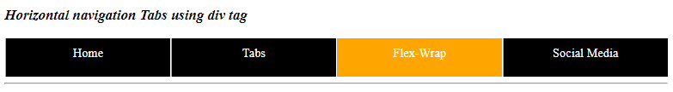

### **Fixed navigation bar**

Fixed navigation bar happens when the navigation bar remain at the top or bottom of the app, even when the user moves the page. For this, you can use the CSS property position: sticky; to the element that contains the hyperlinks:

  position: sticky;

position: fixed;  
  top: 0;

**position:fixed;** and **top: 0;** will make the element to have a position fixed to the top of the app.

**Exercise)** Create a navigation bar that will stick on the top of the app.

We can create the hyperlink using **<div>**

<div class="nav_top">

<a href="#home">Home</a>

<a href="#nav">Tabs</a>

<a href="#flex">Flex-Wrap</a>

<a href="#social">Social Media</a>

</div>

Once we have the HTML code set, in CSS, we can set the hyperlink container with background-color, the width, the height, the font-size, and the position:

.nav_top{

background-color: orange;

width: 100%;

height: 50px;

font-size: 16px;

position: sticky;

position: fixed;

top: 0;

}

After it, we can set hyperlink with left border, height, font color, center the text, and add the padding. We also set the hyperlink to float from the left to right without underline:

.nav_top a {

float: left;

color: white;

text-align: center;

text-decoration: none;

padding: 12px;

height: 100%;

}

After it, we can change the background color of the links when the user clicks on them:

.navbar li a:hover {

background-color: green;

}

The HTML and CSS code looks as the following:

/* navigation stick on the top */

.nav_top{

background-color: orange;

width: 100%;

height: 50px;

font-size: 16px;

position: sticky;

position: fixed;

top: 0;

}

.nav_top a {

float: left;

color: white;

text-align: center;

text-decoration: none;

padding: 12px;

height: 100%;

}

.nav_top a:hover{

background-color: green;

}

***css file***

<i><h3>Navigation Tabs sticky on the top</h3></i>

<div class="nav_top">

<a href="#home">Home</a>

<a href="#nav">Tabs</a>

<a href="#flex">Flex-Wrap</a>

<a href="#social">Social Media</a>

</div>

***html file***

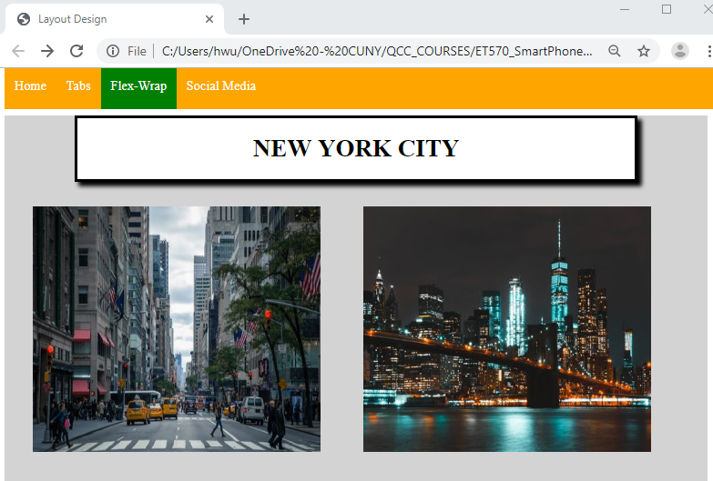

If you need the navigation bar stick in the bottom, you can change **top: 0;** to **bottom: 0;**

### **4.4 Extra Markup - Adding Media Logos – contact information (flex-container)**

***CSS flexbox layout***

Flexible container layout makes it easier to design flexible responsive layout structure without using float or positioning.

***The flex-wrap Property***

The **flex-wrap** property in css specifies whether the flex items should wrap or not.

**Exercise)** The example below have 6 flex items, to better demonstrate the **flex-wrap** property. For this first try we can set the **flex-wrap**  container with **width: 40%;**

<h2>FLEX CONTAINER </h2>

<i><h3 id="about">The flex-wrap property</h3></i>

<div class="flex-container">

<div>1</div>

<div>2</div>

<div>3</div>

<div>4</div>

<div>5</div>

<div>6</div>

</div>

***html file***

.flex-container {

display: flex;

flex-wrap: wrap;

background-color: DodgerBlue;

}

.flex-container > div {

background-color: lightblue;

width: 40%;

margin: 10px;

text-align: center;

line-height: 75px;

font-size: 30px;

}

***css file***

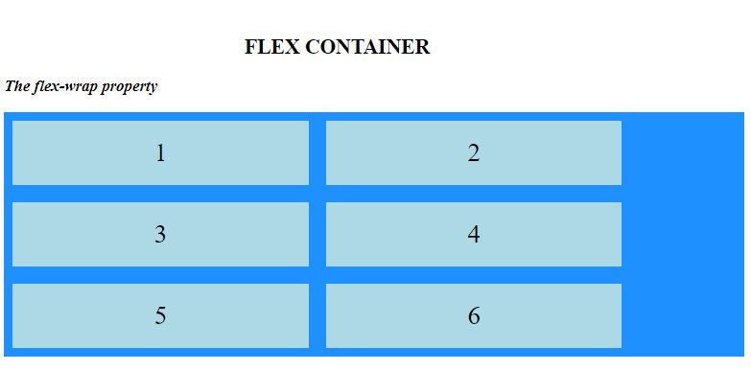

Now we can set the **width: 80%;** and see the changes:

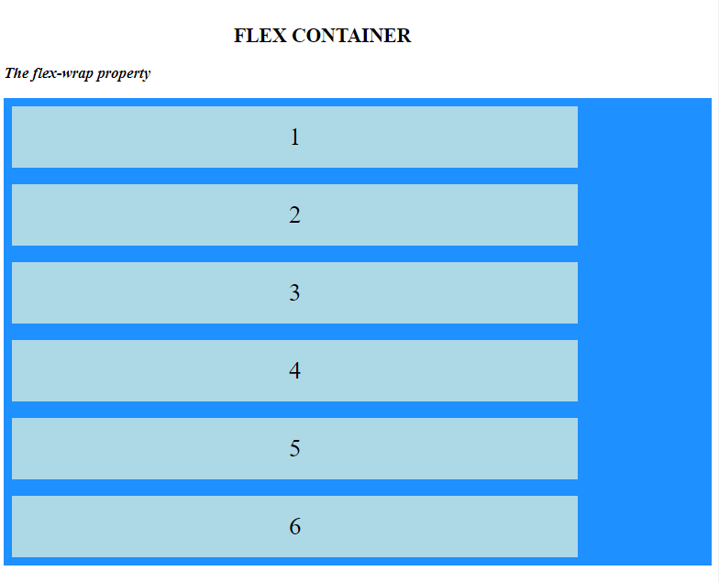

### **4.5 Logo and social media logo**

There are many logos on the internet that we can use in the app you are creating. One of the website that you can use to download logos and use in your app is <https://www.iconfinder.com/>

     

To add the social media information in your app as part of the contact you can use <a>:

<a target="_blank" title="follow me on Twitter" href="https://www.twitter.com/PLACEHOLDER"><img alt="follow me on Twitter" src="twitter.png" border=0></a>

**HTML**

The PLACEHOLDER space should go the Twitter username, for example, if your Twitter username was '@thecakeshop', you would replace 'www.twitter.com/PLACEHOLDER with 'www.twitter.com/thecakeshop', ensuring you don't include the @ symbol so that the button directs to the right page.

Also, flex-wrap can also use create the social medial container

**Exercise)** Download three icon images and use flex-wrap to create a social media contacts

<h2>SOCIAL MEDIA </h2>

<i><h3 "social">Social Media Icons Using flex-wrap</h3></i>

<div class="flex-media">

<div><a target="_blank" title="follow me on Twitter" href="https://www.twitter.com/PLACEHOLDER"><img alt="follow me on Twitter" src="images/twitter.png" border=0></a> </div>

<div><a target="_blank" title="Android Icon" href="#"><img alt="Android Icon" src="images/android.png" border=0></a></div>

<div><a target="_blank" title="Mail to" href="mailto:hwu@qcc.cuny.edu"><img alt="Mail to Icon" src="images/mail.png" border=0></a></div>

</div>

***html file***

/* -- flex media --*/

.flex-media {

display: flex;

flex-wrap: wrap;

background-color: lightgray;

height: 400px;

}

.flex-media > div {

width: 30px;

height: 30px;

margin: 10px;

text-align: center;

font-size: 30px;

}

***css file***

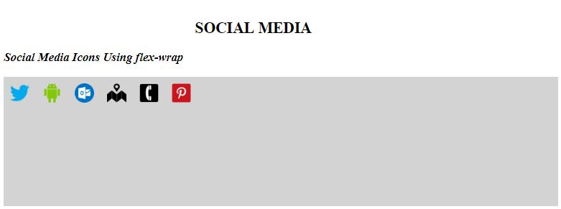

# **5 – Color and images manipulation in CSS**

## ***5.1. Colors***

The color property allows us to specify the color of text inside an element. We can specify any color in CSS in one of three ways:

**5.1.1. Color Names**

There are 147 predefined color names that are recognized by browsers. For example: darkcyan

**5.1.2. RGB Values**

These express colors in terms of how much red, green and blue are used to make it up. Every color on a computer screen is created by mixing amounts of red, green, and blue. To find the color you want, we can use a color picker.



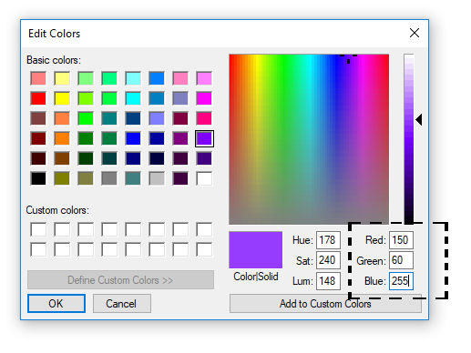

rgb(150, 60, 255)

**5.1.3. HEX Codes**

These are six-digit codes that represent the amount of red, green and blue in a color, preceded by a pound or hash # sign. For example: #ee3e80

**Exercise**) Go to the following website: ***https://www.w3schools.com/cssref/css_colors.asp*** and select two colors using color name, hex code, and color value. Using the colors code, create paragraphs with different background colors using the three CSS color property.

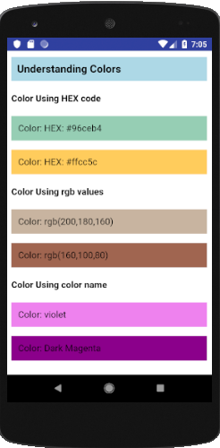

<h3> Understanding Colors </h3>

<h4>Color Using HEX code</h4>

<p class="color1"> Color: HEX: #96ceb4</p>

<p class="color2"> Color: HEX: #ffcc5c</p>

<h4>Color Using rgb values</h4>

<p class="color3"> Color: rgb(200,180,160)</p>

<p class="color4"> Color: rgb(160,100,80)</p>

<h4>Color Using color name</h4>

<p class="color5"> Color: violet</p>

<p class="color6"> Color: Dark Magenta</p>

**HTML**

h3{ background-color: lightblue; padding: 10px; }

.color1{background-color: #96ceb4; padding: 12px; }

.color2{background-color: #ffcc5c; padding: 12px; }

.color3{background-color: rgb(200,180,160); padding: 12px; }

.color4{background-color: rgb(160,100,80); padding: 12px;}

.color5{background-color:violet; padding: 12px; }

.color6{background-color: darkmagenta; padding: 12px; }

**CSS**

**5.1.4. rgba( ) color**

The rgba( ) function define colors using the red-green-blue-alpha (RGBA) model where alpha specifies the opacity of the color. Alpha color goes from 0 to 1, 0 means fully transparent (0% of opacity) and 1 means fully opaque (100% of opacity). The syntax of the code is:

rgba(red, green, blue, alpha)

For example, for color **rgb(150, 60, 255)**with 35% of opacity, we can write the code as:

**rgba(150, 60, 255,0.35)**

**Exericse)** Obtain a color using its rgb value and create paragraphs of the chosen color with 0%, 30%, 60%, 80%, and 100% of opacity. Add 30% of padding to each paragraph.

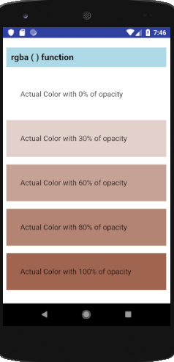

<h3>rgba ( ) function </h3>

<p class="rgba1">Actual Color with 0% of opacity</p>

<p class="rgba2">Actual Color with 30% of opacity</p>

<p class="rgba3">Actual Color with 60% of opacity</p>

<p class="rgba4">Actual Color with 80% of opacity</p>

<p class="rgba5">Actual Color with 100% of opacity</p>

**HTML**

.rgba1{background-color:rgba(160,100,80,0); padding:30px;}

.rgba2{background-color:rgba(160,100,80,0.3); padding:30px;}

.rgba3{background-color:rgba(160,100,80,0.6); padding:30px;}

.rgba4{background-color:rgba(160,100,80,0.8); padding:30px;}

.rgba5{background-color:rgba(160,100,80,1); padding: 30px;}

**CSS**

## ***5.2. CSS linear-grading***

CSS gradient display smooth transition between two or more specified colors. Those colors are the colors that we want to render smooth transition among the grading space. For example, we can create a **linear-gradient** of the red and blue color from top to bottom as the following:

<div class="gradient1"></div>

**HTML**

.grading1 {

height: 200px;

background-image: linear-gradient(red, blue);

}

**CSS**

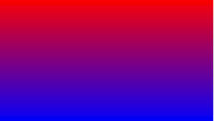

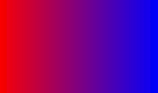linear-gradient can set the color from left to right. For this, we can add **to right** value to the background-image property as the following:

**background-image: linear-gradient(to right, red, blue);**

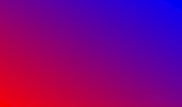We can also set the linear-gradient from bottom-left to top-right:

**background-image: linear-gradient(to top right, red, blue);**

The output will look as the following:

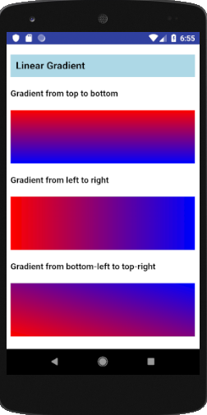

## ***5.3. Position Property***

One importation property of CSS layout is the **position** property. The **position** property specifies the type of positioning method used for an element (static, relative, fixed, absolute or sticky).

**position: static;**

HTML elements are positioned static by default.

Static positioned elements are not affected by the top, bottom, left, and right properties.

An element with position: static; is not positioned in any special way; it is always positioned according to the normal flow of the page.

**position: relative;**

An element with position: relative; is positioned relative to its normal position.

Setting the top, right, bottom, and left properties of a relatively-positioned element will cause it to be adjusted away from its normal position. Other content will not be adjusted to fit into any gap left by the element.

**position: absolute;**

An element with position: absolute; is positioned relative to the nearest positioned ancestor (instead of positioned relative to the viewport, like fixed).

However; if an absolute positioned element has no positioned ancestors, it uses the document body, and moves along with page scrolling.

**Note:** A "positioned" element is one whose position is anything except static.



Message has position:absolute; in CSS

Background image has position:relative; in CSS

**Exercise)** Create container with a back image with position:relative; and a message with position:absolute;

We can create a container for the back image using **<div>** element

<!DOCTYPE html>

<html lang="en" dir="ltr">

<head>

<meta charset="utf-8">

<meta name="viewport" content="width=device-width, initial-scale=1.0">

<link href="index.css" rel="stylesheet" type="text/css"/>

<title>Activity 5 by Huixin Wu</title>

</head>

<body>

<h3> Position relative and absolute </h3>

<div class="image">

<img src="image.jpg">

</div>

</body>

</html>

**HTML**

img{ width: 100%; height: 100%;}

.image{

width: 80%;

height: 450px;

margin: auto;

position: relative;

}

**css**

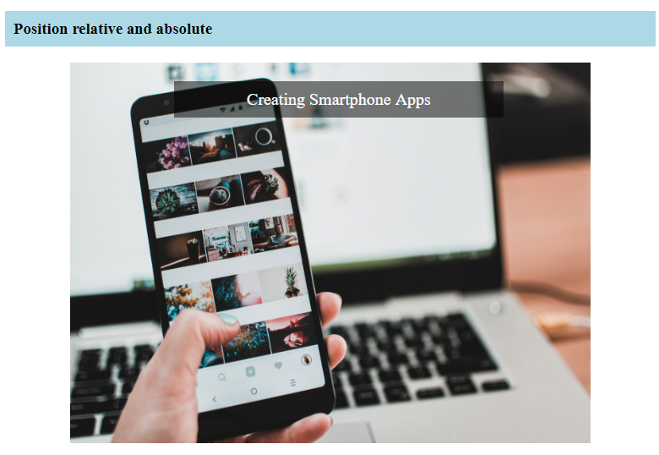

After it, we can add the text message using another <div> or <p> and use position:absolute;

<div class="message"> Creating Smartphone Apps</div>

**HTML**

.message{

**position: absolute;**

top: 10%;

left: 20%;

width: 60%;

background-color: rgba(0, 0, 0, 0.3);

color: white;

text-align: center;

padding: 10px;

font-size: 20px;

}

**css**

top:10%;

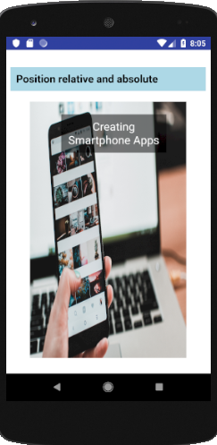

left:20%;

width: 60%;

**position: sticky;**

An element with position: sticky; is positioned based on the user's scroll position.

A sticky element toggles between relative and fixed, depending on the scroll position. It is positioned relative until a given offset position is met in the viewport - then it "sticks" in place (like position:fixed).

**Exercise)** Create a message box using position:sticky;

We can create a container for the sticky message using **<div>** element with position:sticky; and the position to stick to, in this case, we can set the message to stick on the top of the screen using top:0;

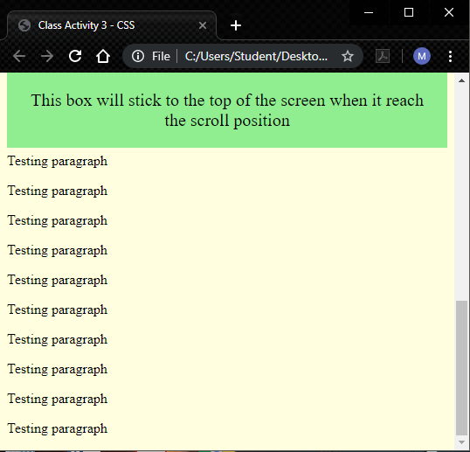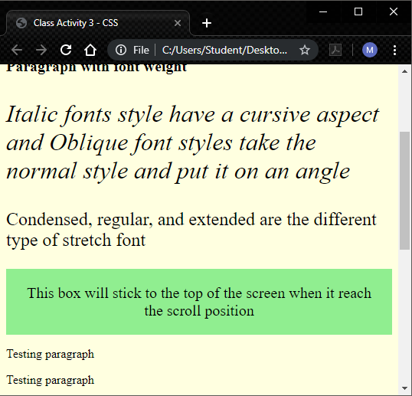We can also add 16 testing paragraphs to see the sticky effect.

Scroll the app page to the top

<h3>Position sticky </h3>

<p>Scroll down this page to see how sticky positioning works.</p>

<div class="**stickyBox**">This box will stick to the top of the screen when it reach the scroll position</div>

<p>Testing paragraph </p> <p>Testing paragraph </p>

<p>Testing paragraph </p> <p>Testing paragraph </p>

<p>Testing paragraph </p> <p>Testing paragraph </p>

<p>Testing paragraph </p> <p>Testing paragraph </p>

<p>Testing paragraph </p> <p>Testing paragraph </p>

<p>Testing paragraph </p> <p>Testing paragraph </p>

<p>Testing paragraph </p> <p>Testing paragraph </p>

<p>Testing paragraph </p> <p>Testing paragraph </p>

**HTML**

.**stickyBox**{

font-size: 20px;

text-align: center;

padding: 20px;

background-color: lightgreen;

**position: sticky;**

**top:0;**

}

**css**

## ***5.4. Hero image***

A hero image is a large image with text places on the top of it. For this, we can use the position absolute and relative.

**Exercise)** Create an ad of an image with a text places on top of it as the following:

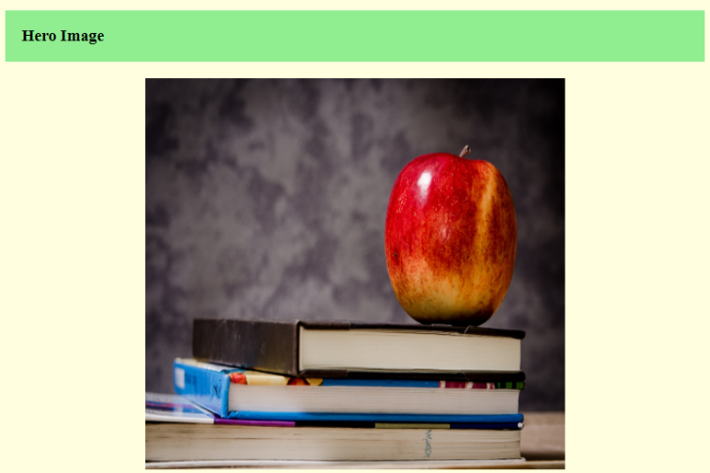

**100% = 450px;**

**60%**

First, we create a container with a background image:

<h3>Hero Image </h3>

<div class="heroImage">

</div>

**HTML**

We can insert a background image from a CSS using **background-image** property. Also, we can align the background image using **background-position: center;** and adjust the width and height using **background-size: 60% 100%;** which 60% is the width and 100% is the height.

.heroImage{

background-image: url("apple.jpg");

background-repeat: no-repeat;

background-position: center;

background-size: 60% 100%;

height: 450px;

position: relative;

}

**CSS**

Once we have the container and the background image set, we can create the text that will sit on top of the background image. We can name the text container **heroText**

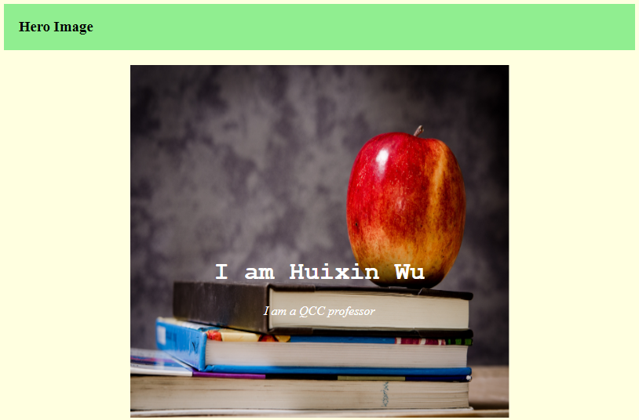

**top: 50%;**

**left:15%**

**width:60%**

<h3>Hero Image </h3>

<div class="heroImage">

<div class="**heroText**">

<h1>I am Huixin Wu</h1>

<i>I am a QCC professor</i>

</div>

</div>

**HTML**

.heroText{

position: absolute;

top: 50%;

**left: 15%;**

**width: 70%;**

color: white;

text-align: center;

}

**CSS**

A text on top of an image makes the text information very hard to write, for this, we can add linear-gradient to the background image. We can set a red to black gradient with 60% of opacity from left to right:

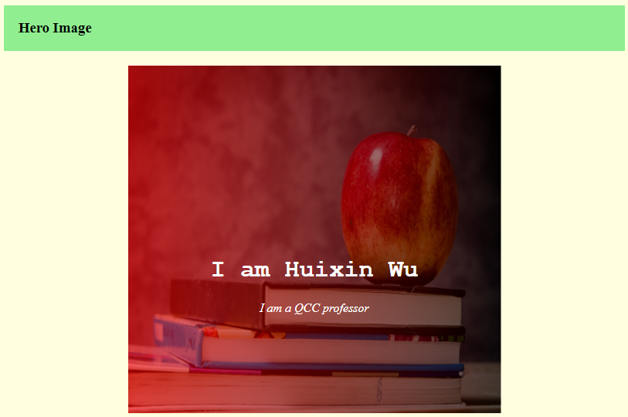

.heroImage{

background-image: linear-gradient(to right, rgba(255,0,0,0.6),rgba(0,0,0,0.6)), url("apple.jpg");

background-position: center;

background-repeat: no-repeat;

background-size: 100% 100%;

height: 450px;

position: relative;

}

**CSS**

After it, we can add a Hire Me! link to the text.



<h3>Hero Image </h3>

<div class="heroImage">

<div class="heroText">

<h1>I am Huixin Wu</h1>

<i>I am a QCC professor</i>

<br>

<a href="#" class="submit">Hire Me!</a>

</div>

</div>

**HTML**

.submit{

padding: 10px 25px;

color: black;

background-color: rgba(255,255,255,0.6);

font-weight: 600;

font-size: 20px;

margin-top: 20px;

text-align: center;

border-radius: 10px;

display: inline-block;}

a.submit{text-decoration: none;}

**CSS**

## ***5.5. Filter images***

Filter property adds visual effects to an element. Some of the filter attributes are: blur, contrast, sepia, grayscale, and invert.

**blur(px)**

**blur** applies a blur effect to an element. The value, in pixels *px*, between the parenthesis defines the blurriness of the element, a larger value will create more blur.

**Activity)** Create four different blur effects to an image with 1px, 4px, 8px, and 12px.

<h3>Blurred Images </h3>

<div class="filterContainer">

<div class="filter1">

<h4>blurred with 1px</h4>

<img src="book.jpg" style="filter:blur(1px);"/></div>

<div class="filter2">

<h4>blurred with 4px</h4>

<img src="book.jpg" style="filter:blur(4px);"/></div>

<div class="filter3">

<h4>blurred with 8px</h4>

<img src="book.jpg" style="filter:blur(8px);"/></div>

<div class="filter4">

<h4>blurred with 12px</h4>

<img src="book.jpg" style="filter:blur(12px);"/></div>

</div>

**HTML**

/* BLURRED IMAGES */

.filterContainer{height:700px;}

.filter1, .filter2, .filter3, .filter4{

width: 40%;

height: 40%;

padding:2%;

float:left;

}

**CSS**

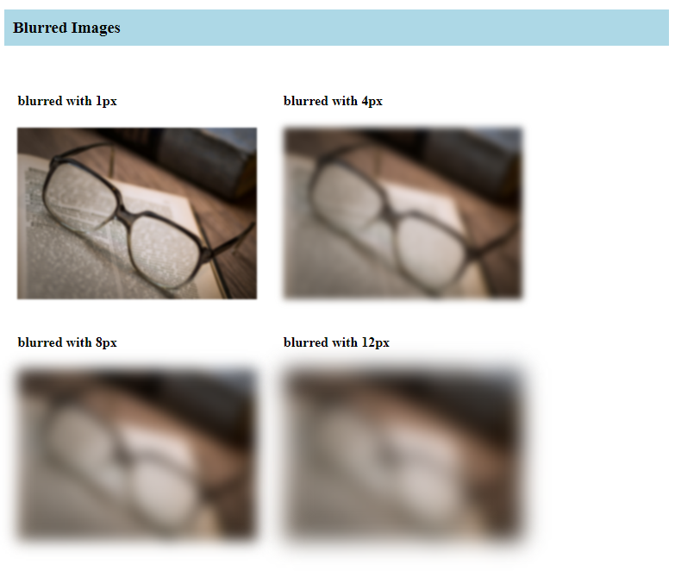

**contrast( %)**

**contrast** adjusts the contrast of an element. If the element is used as the container for an image, then contrast will adjust the contrast of the image.

**contrast(0%)** will make the image completely black and **contrast(100%),** which is by default, will show the original image, and values over 100% will provide results with more contrast:

<h3>Images with Contrast</h3>

<div class="filterContainer">

<div class="filter1">

<h4>Contrast 0%</h4>

<img src="book.jpg" style="filter:contrast(0%);"/></div>

<div class="filter2">

<h4>Contrast 20%</h4>

<img src="book.jpg" style="filter:contrast(20%);"/></div>

<div class="filter3">

<h4>Contrast 50%</h4>

<img src="book.jpg" style="filter:contrast(50%);"/></div>

<div class="filter4">

<h4>Contrast 90%</h4>

<img src="book.jpg" style="filter:contrast(90%);"/></div>

</div>

**HTML**

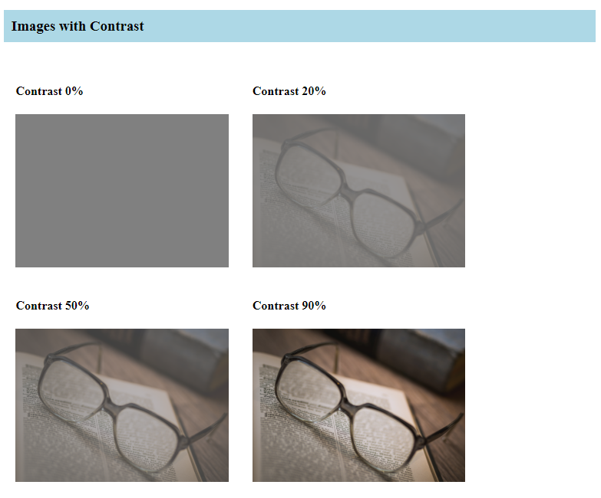

**sepia(%)**

**sepia** converts the element to sepia color. **sepia(0%)** is default means that there is no sepia applies to the element, and **sepia(100%)** will make the image completely sepia. For this attributes, negative values are not allowed.

<h3>Sepia Images</h3>

<div class="filterContainer">

<div class="filter1">

<h4>Sepia 0%</h4>

<img src="book.jpg" style="filter:sepia(0%);"/></div>

<div class="filter2">

<h4>Sepia 20%</h4>

<img src="book.jpg" style="filter:sepia(20%);"/></div>

<div class="filter3">

<h4>Sepia 50%</h4>

<img src="book.jpg" style="filter:sepia(50%);"/></div>

<div class="filter4">

<h4>Sepia 90%</h4>

<img src="book.jpg" style="filter:sepia(90%);"/></div>

</div>

**HTML**

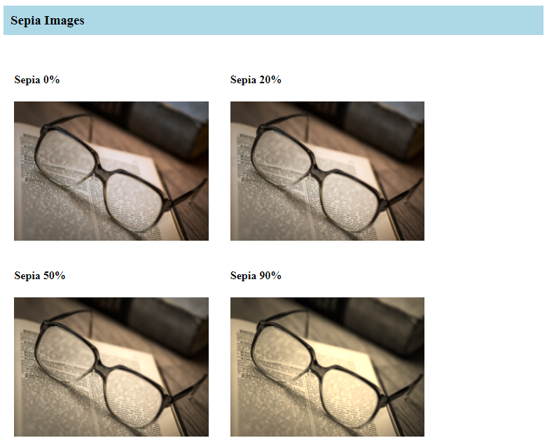

**grayscale(%)**

**grayscale** converts the element to loose its black and white color. **grayscale(0%)** is default and it means that there isn’t any changes in its grayscale. **grayscale(100%)** will make the image completely gray, black and white. This property does not allowed negative values.

<h3>Grayscale Images</h3>

<div class="filterContainer">

<div class="filter1">

<h4>Grayscale 0%</h4>

<img src="book.jpg" style="filter:grayscale(0%);"/></div>

<div class="filter2">

<h4>Grayscale 20%</h4>

<img src="book.jpg" style="filter:grayscale(20%);"/></div>

<div class="filter3">

<h4>Grayscale 50%</h4>

<img src="book.jpg" style="filter:grayscale(50%);"/></div>

<div class="filter4">

<h4>Grayscale 90%</h4>

<img src="book.jpg" style="filter:grayscale(90%);"/></div>

</div>

**HTML**

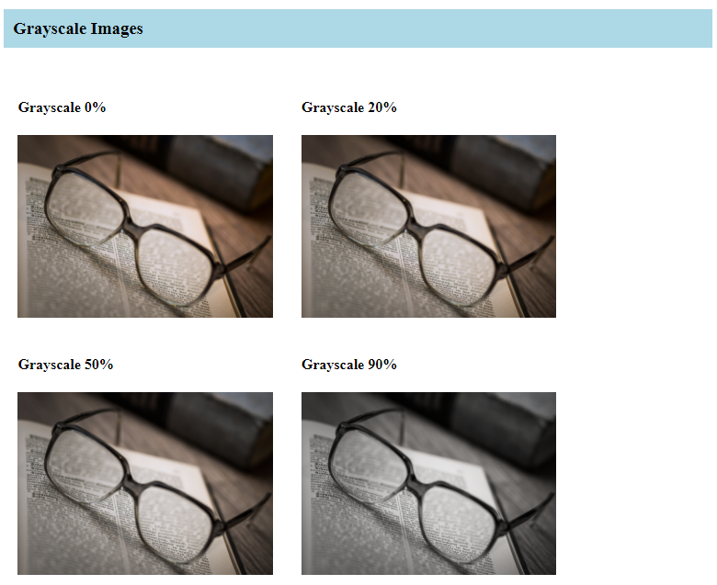

**invert(%)**

**invert( )** inverts the sample color of the element. **invert(0%)** is default and means that there isn’t any color inversion in the element. **invert(100%)** will make the image will invert completely its sample color.

<h3>Invert Images</h3>

<div class="filterContainer">

<div class="filter1">

<h4>Invert 0%</h4>

<img src="book.jpg" style="filter:invert(0%);"/></div>

<div class="filter2">

<h4>Invert 20%</h4>

<img src="book.jpg" style="filter:invert(20%);"/></div>

<div class="filter3">

<h4>Invert 60%</h4>

<img src="book.jpg" style="filter:invert(60%);"/></div>

<div class="filter4">

<h4>Invert 90%</h4>

<img src="book.jpg" style="filter:invert(90%);"/></div>

</div>

**HTML**

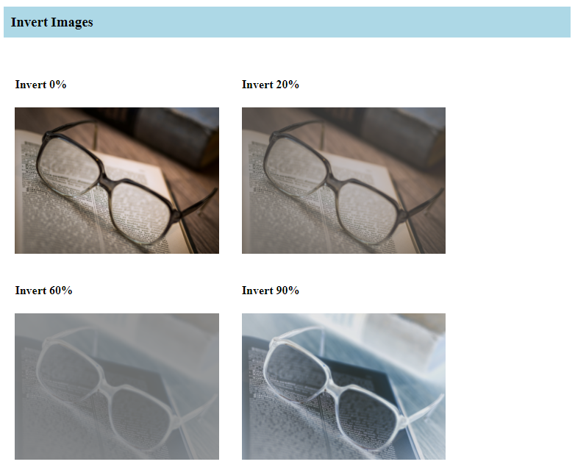

**Class Activity**

Create three activities with different image properties as the following:

* Image 1 will have an invert image with text on the bottom of it. The text should have opacity effect.

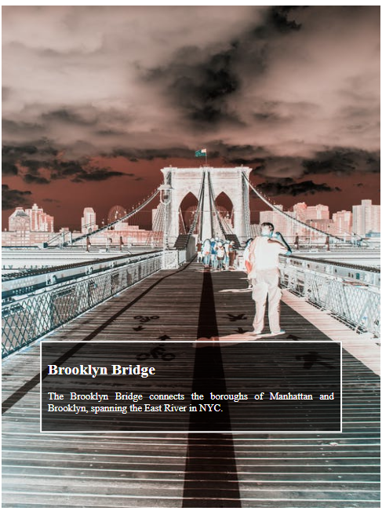

* Image 2 will have a blurred image with text in the middle of it. The text should have opacity and box-shadow effect.

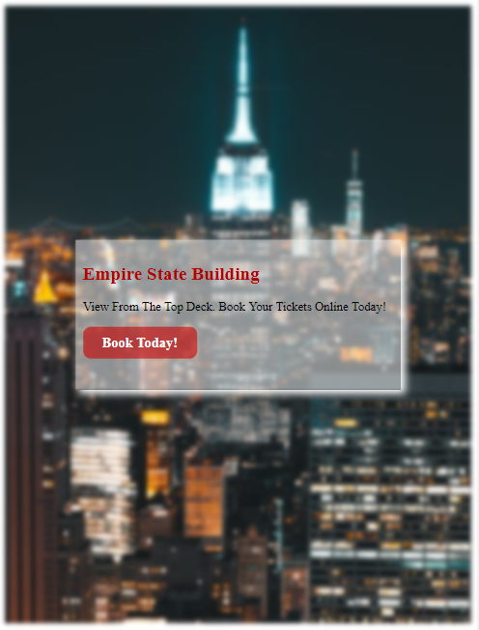

* Image 3 will have linear-gradient with texts in different location.

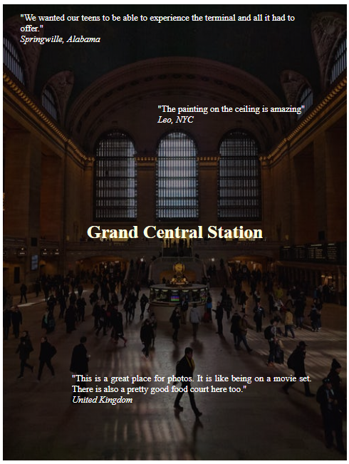

# **6. CSS Animation**

## **CSS transitions**

CSS transitions are one of the ways we can create animation with CSS, even though they are not called animations. By definition, animation means causing change over time and transitions absolutely do that. They just do it in a little bit of a different way than CSS keyframe animations do.

*How to use CSS Transitions?*

To create a transition effect, we must specify two things:

* The CSS property you want to add an effect to
* The duration of the effect

**Note:** If the duration part is not specified, the transition will have no effect, because the default value is 0.

## **Understanding CSS animation**

### ***CSS transform property***

The transform property applies a 2D or 3D transformation to an element. This property allows you to rotate, scale, move, skew, etc., elements.

Transform property has values as:

|  |  |
| --- | --- |
| **translate(*x,y*)** | Defines a 2D translation |
| **translateX(*x*)** | Defines a translation, using only the value for the X-axis |
| **translateY(*y*)** | Defines a translation, using only the value for the Y-axis |
| **scale(*x,y*)** | Defines a 2D scale transformation |
| **rotate(*angle*)** | Defines a 2D rotation, the angle is specified in the parameter |

For any CSS keyframe animation we create, we have to first define the animation. Basically, tell CSS what it is that should happen and we also need to assign that animation to a specific element or elements in your HTML. We can do these two steps in any order.

### ***@keyframes***

We will start creating our CSS animation by defining it's keyframes using the **@keyframes** rule. **@keyframes** are essentially a list describing everything that should happen over the course of the animation. We define the values for the animating properties at various points during the animation and any property that we will see change over the course of one's cycle of an animation.

* The **@keyframes** rule works like most other CSS rules, anything contained within its curly braces are considered part of that block.
* The second step to our **@keyframes** rule is giving our animation a name. It's really important to name the animation because without a name, it would not be able to assign the animation to an element.

There are a few options available to us for how we can define each **@keyframes** within our **@keyframes** rule:

* **from, to**: You define where to animate from and where to animate to.

**Activity)** create an animation that will move an image from one place to another within the x-axis.

For this exercise, we will download two images, one for the moving object and the other one as a back image. Once we have the images, will be create two containers for each of the images using <div> with position relative and absolute respectively.

<h3>CSS animation using @keyframes with attributes from - to </h3>

<div class="mountainImage"><img src="mountain.jpg"/>

<div class="busImage"><img src="bus.png"/></div>

</div>

**HTML**

.mountainImage{

width: 700px;

height: 500px;

position: relative;

margin: auto;}

.busImage{

width: 250px;

height: 150px;

position: absolute;

bottom: 0;}

**CSS**

Once we have the images set up, we can start writing the css animation using @keyframes. We are going to name this animation *slide*. The animation will make the element to move from left to right. The basic rules to use @keyframes are:

1. Use @keyframes to create the animation frame
2. Assign a name to the keyframe
3. Specify what do you want the animation to do. For this project, we want the image to move *from* left *to* right. For this, we need to transform the element within the X axis from position 0 to 220px.

**@keyframes** **slide**{

**from** {transform: translateX(0px);}

**to** {transform: translateX(450px);}

}

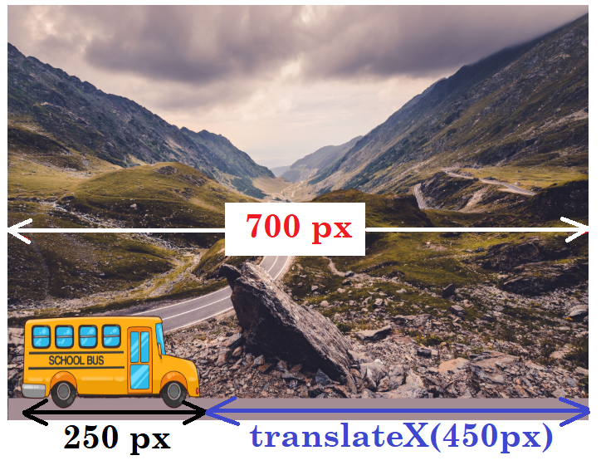

Now that we have the animation created, we need to add it into the image that we want to be animated, in our case, we will add the animation to the element that has the bus image, which has the class name ***busImage***:

div class="**busImage**"><img src="bus.png"/></div>

Now in css, we call for the class name and add some animation properties to it:

1. **animation-name:** **slide**; 🡺 This tells our image with class name **busImage** to apply the **@keyframes** animation named **slide**
2. **animation-duration: 2s;** 🡺 The second property we need to define is the animation duration. Our keyframes define what should change over the course of an animation, but they don't give any indication as to how long this should take, so that's what we do in animation duration. For this case, our animation **slide**is set to 2 seconds.

**.busImage**{

animation-name: slide;

animation-duration: 3s;

1. The **animation-iteration-count** property is also a good one to set for yourself even though it has a default value. This one determines how many times the animation will play. By default, the animation runs once, but we can set it runs **infinite** times.

animation-iteration-count: 2;

1. **animation-delay** property sets the waiting before the animation actually executes.

animation-delay: 2s;

1. *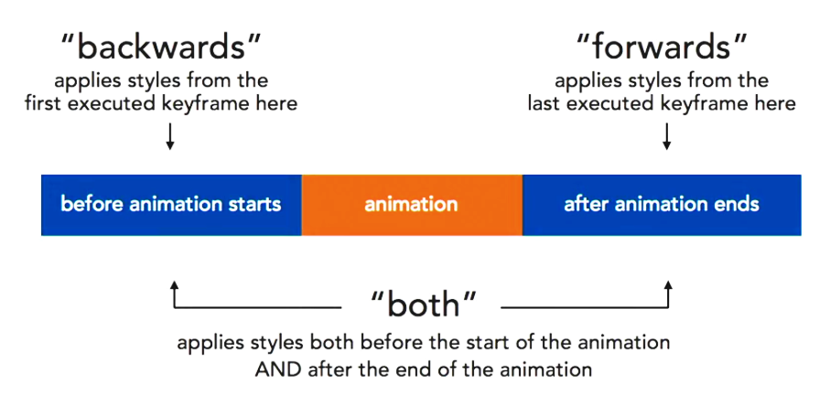***animation-fill-mode** is a way of telling the animating element what to do outside of the actual duration of its animation and it can take four values: *none, backwards, forward, and both*. The default value is *none*. If we use the value *forward*, the image will stay at the position at the end of the animation.**

animation-fill-mode: forwards;

1. **animation-direction** let's us manipulate what order our **keyframes** are executed in. Animation-direction can be set to *normal, reverse, alternate, and alternate-reverse.*

An animation-direction of **normal** means that all iterations of the animation will be played as specified. So your keyframes will play from start to end. That means your keyframes will play from your from keyframe to your to keyframe, or your 0% percent keyframe to your 100% keyframe exactly in the order that you wrote them.

The animation direction of **reverse** means that all iterations of your animation will be played in the reverse direction. Your last keyframe will be played first, and your first keyframe will be played last. So this would play your animation from your to keyframe to your from keyframe, or your 100% keyframe to your 0% keyframe.

An animation-direction of **alternate** means that the direction of your animation will alternate each iteration of the animation. It will play in the normal direction the first time. So that would be 0% keyframe to 100% keyframe, and in the reverse direction the second time. So that would be the 100% keyframe back to 0%. **alternate** can only be used if your animation plays more than once because otherwise you won't have any space to see the alternating. So we'll change our animation iteration count to two. With those two small changes made, we'll go back to our robot and see how it's changed.

An **alternate-reverse** works in very much the same way as alternate, but it starts playing your animation in the reverse direction first, and then normal. **alternate-reverse** works in much the same way as *alternate,* it plays in reverse the first time, and then forwards, but it still plays twice.

animation-direction: alternate;

**animation-timing-function** is the way speed is distributed across the duration of our animation. The in animation-timing-function keywords include *ease, linear, ease-in, ease-out, and ease-in-out*.

With the **linear** easing our robot moves across the screen at the same constant speed for the entire animation. Linear easing creates a constant speed of motion that never changes at all. This is often perceived as mechanical motion because nothing in real life actually moves like that.

**ease** allows the animation to start and slowly and then speed up to a uniform speed.

**ease-in** has a distinct starting slow and then speeding up as the image reaches it's destination.

**ease-out** is the opposite of ease-in. The image starts at a higher speed and then slows down as it gets to it's destination.

**ease-in-out** combines the effects of ease-in and ease-out. It starts out a little bit slow, hits a top speed in the middle of the animation, and then slows down as it reaches the end.

animation-timing-function: ease;

### ***Infinitely looping animation***

CSS is great for looping animation because it makes it possible to set an infinite loop with much less code than other methods.

**Example)** Using the previous exercises, creating a couple of animated clouds that continently drift across the sky with different distance and speed. For this, we can download a cloud image and create three containers of different sizes for each cloud.

<div class="mountainImage"><img src="mountain.jpg"/>

<div class="busImage"><img src="bus.png"></div>

<div class="sunImage"><img src="sun.png"></div>

<div class="cloud1"><img src="cloud1.png"></div>

<div class="cloud2"><img src="cloud1.png"></div>

</div>

**HTML**

Since the clouds are displayed on top of the back image, the containers’ position must be set to absolute. We can also set different width and height to the clouds container and also the top position to each cloud.

sunImage

cloud1

cloud2



/* animation clouds */

.sunImage{

width: 30%;

height: 20%;

position: absolute;

top: 0;

}

.cloud1{

width: 30%;

height: 26%;

position: absolute;

top: 20px;

}

.cloud2{

width: 30%;

height: 26%;

position: absolute;

top: 60px;

}

**css**

Once we have the HTML and CSS set, now we can set the animation using the @keyframes. Since we want the clouds to flow from left to right, we can use the property **from** to **to**

@keyframes cloudsFlowing {

from {transform: translateX(0);}

to {transform: translateX(500px);}

}

**css**

We are going to use the same animation for all three clouds, but we are going to adjust the properties to make each cloud to behave in a slightly different way. For example, we can set different **animation-iteration-count** to each cloud.

. sunImage{

width: 30%;

height: 20%;

position: absolute;

top: 0;

animation-name: cloudsFlowing;

animation-duration: 30s;

animation-timing-function: linear;

animation-iteration-count: infinite;

}

**css**

The animation properties can also be written in one line using the property **animation**. For example, we can simplify the following properties:

animation-name: **cloudsFlowing**;

animation-duration: **30s**;

animation-timing-function: **linear**;

animation-iteration-count: **infinite**;

using **animation** property, we can write each property values in one line and separate the values with a space:

**animation:** **cloudsFlowing 30s** **linear** **infinite**;

Now, we can apply the **cloudsFlowing** animation to the other two clouds with 8 and 5 seconds respectively.

.cloud1{

width: 30%;

height: 26%;

position: absolute;

top: 20px;

animation: cloudsFlowing 10s linear infinite;

}

.cloud2{

width: 30%;

height: 26%;

position: absolute;

top: 60px;

animation: cloudsFlowing 6s linear infinite;

}

**css**

Simplify the animation lines using **animation** property

### ***opacity***

One of the transition properties is **opacity**. **Opacity** property happens when a new value is assigned to it. It will cause a smooth change between the old value and the new value over a period of time. The value of opacity is ranged in between 0 and 1 where 0 is clear and 1 is the full color of the element.

**Activity)** Using the previous animation, make the clouds to be almost half visible when they reach the edge of the right side.

@keyframes cloudsFlowing {

from{transform: translateX(0); **opacity: 0.9;**}

to{transform: translateX(500px); **opacity: 0.3;**}

}

**css**

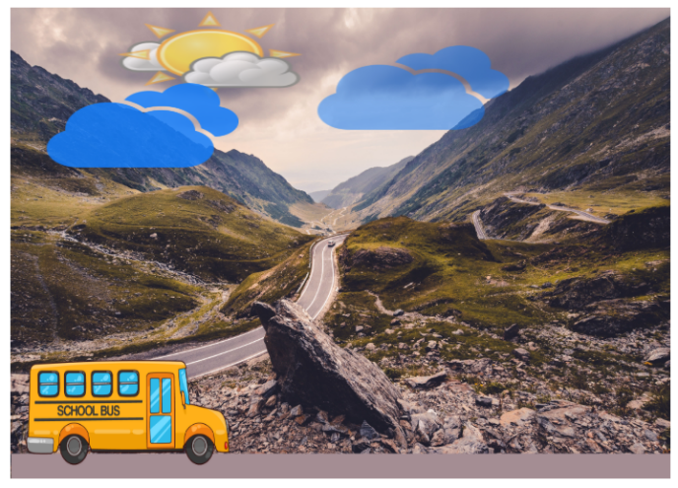

***CSS animation using “%” time frame***

CSS animation in an element can be slip using % time frame. For example, from a **@keyframes** animation using **from** to **to** attributes, we can replace **from** to **0%** and **to** to **100%**:

@keyframes cloudsFlowing{

**from**{ transform: translateX(0px); opacity:1;}

**to**{transform: translateX(250px);opacity:0.5;}

}

@keyframes cloudsFlowing{

**0%**{ transform: translateX(0px); opacity:1;}

**100%**{transform: translateX(250px);opacity:0.5;}

}

**Activity)** Create an animation that will move a square from one position to another and change its background color at the different position. The total time of the animation is 10s and the animation will repeat 20 times.

To understand how the position works on an element, first we need to create a container to place the square:

<h3> CSS animation using "%" time frame </h3>

<div class=" frameContainer">

</div>

**HTML**

.frameContainer{

width: 1500px;

height: 600px;

background-color: lightblue;

position: relative;

}

**CSS**

Once we have the container for the square, we create the square that sits inside the container:

<div class="frameContainer">

<div class="animationSquare"></div>

</div>

**HTML**

Add this line to create a square using <div> element

width: 1400px;

.animationSquare{

width: 100px;

height: 100px;

background-color: rgb(10,50,100);

position: absolute;

}

**CSS**



height: 600px;

height: 100px;

height: 500px;

Width:1500px;

After the square is set, we need to create the animation using % time frame as the following:

|  |  |  |  |  |  |
| --- | --- | --- | --- | --- | --- |
| **Total time** | 10 seconds | | | | |
| **Time frame** | 0% | 25% | 50% | 75% | 100% |
| 0 to 2 secs | 2.1 to 4 secs | 4.1 to 6 secs | 6.1 to 8 secs | 8.1 to 10 secs |
| **background color** | Darkblue | Darkred | Green | Yellow | darkblue |
| **border-radius** | 0%  (squared shape) | 50%  (circled shape) | 0%  (squared shape) | 50%  (circled shape) | 0%  (squared shape) |
| **Position** | Top-left | Bottom-right | Top-right | Bottom-left | Top-left |

To create the animation, we need to understand the position first. The position of an element is measured from the top-left corner of the element:

**Position: top-left**

top:0px;

left:0px;

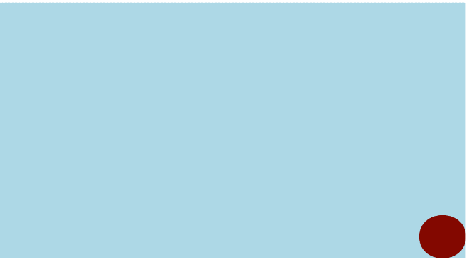

**Position: bottom-right**

top:500px;

left:1400px;

**Position: top-left**

top:0px;

left:1400px;

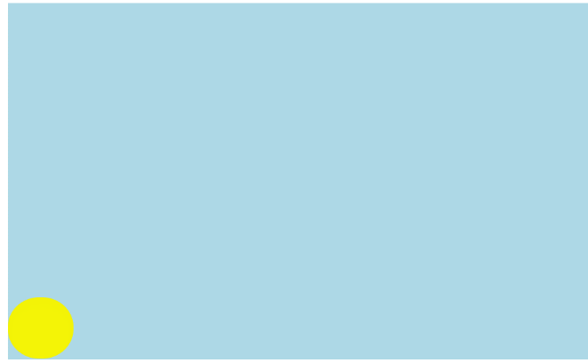

**Position: top-left**

top:500px;

left:0px;

One complete cycle of the animation:

**25%**

**50%**

**75%**

**100%**

**0%**

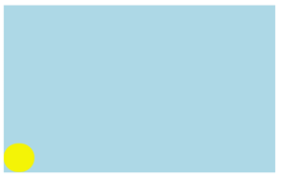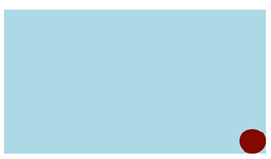

@keyframes animation_square{

0% {background-color: darkblue; left: 0px; top: 0px; border-radius: 0%;}

25%{background-color: darkred; left:1400px; top: 500px; border-radius: 50%;}

50%{background-color: green; left: 1400px; top: 0px; border-radius: 0%;}

75%{background-color: yellow; left: 0px; top: 500px; border-radius: 50%;}

100%{background-color: darkblue; left: 0px; top: 0px;border-radius: 0%;}

}

**CSS**

### ***Rotating animation***

Rotation is a CSS property that defines a 2D rotation and the rotation angle is specified within the parenthesis. For example, if we want to rotate an element 200 degree clockwise, we can write: rotate(200deg). If we want to rotate an element 200 degree counter-clockwise, we can write: rotate(-200deg)

**Activity)** Create an animation that will rotate an image clockwise 180 degree and then 360 degree counter-clockwise. The animation duration will be 6s and it will repeat 10 times.

For this animation, first, we create the animation structure in HTML and CSS:

<h3>animation using transform property "rotate"</h3>

<div class="frameRotation">

<div class="rotationImage">

<img src="hexagon.png"/>

</div>

</div>

**HTML**

.frameRotation{

width: 1500px;

height: 500px;

background-color: lightblue;

position: relative;}

.rotationImage{

width: 200px;

height: 200px;

position: absolute;

top: 20%;

left: 40%;

animation: spin 10s 20;

}

**CSS**



Once the structure is set, we can start the animation according to the following time frame:

|  |  |  |  |  |
| --- | --- | --- | --- | --- |
| **Total time** | 6 seconds | | | |
| **Time frame** | 0% | 30% | 70% | 100% |
| **rotation** | Rotate 0 deg | Rotate 180 deg | Rotate -360 deg | Rotate 0 deg |

@keyframes spin {

0%{transform: rotate(0deg);}

30%{transform: rotate(180deg);}

70%{transform: rotate(-360deg);}

100%{transform: rotate(0deg);}

}

**CSS**

### ***Zooming an image***

**CSS animation transform property has value scale( ) to create zoom-in and zoom-out effect on an element. There are different parameters that we can use within the scale’s parenthesis, for now, we are going to use one value inside the parenthesis. The highest value is 1 and the lowest value is 0. 1 means 100% of the actual element’s size, and 0 means 0% of the actual element’s size.**

**100% of the element size**

**transform: scale(1);**

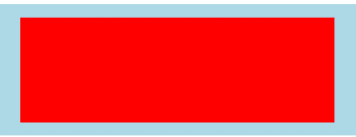

**30% of the element size**

**transform: scale(0.3);**

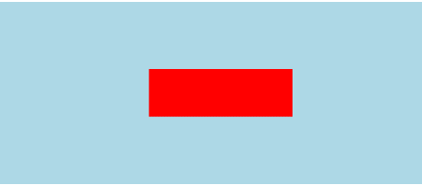

**Activity)** Create an animation that the element will zoom-in to 100% of the image and zoom-out to 30% of the image. The animation duration is 10s and it will play 5 times.

Time frame = 0%

scale(0)

Time frame = 50%

scale(1)

Time frame = 100%

scale(0.3)

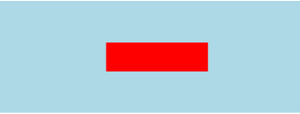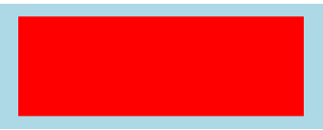

<h3>animation using transform property "scale"</h3>

<div class="scaleAnimation">

<div class="zoomImage"></div>

</div>

**HTML**

.zoomImage{

width: 80%;

height: 80%;

top: 10%;

left: 10%;

background-color: red;

position: absolute;

animation: zoomAnimation 10s 5;}

@keyframes zoomAnimation {

0%{transform: scale(0);}

50%{transform: scale(1);}

100%{transform: scale(0.3);}

}

**CSS**

**In-Class activity)** Modify the zoom-in and zoom-out animation that instead of a box, an image will appear in five different locations within the zoom container. Each appearance should have different % of zoom size. Also, create a sticky-top navigation bar where the links are linked to each

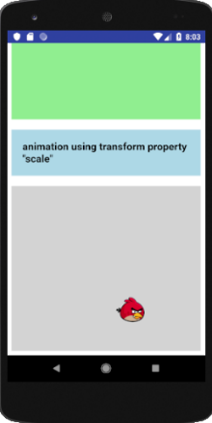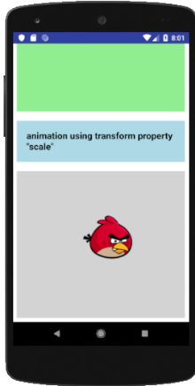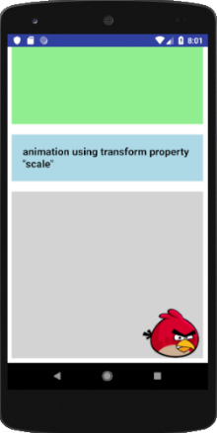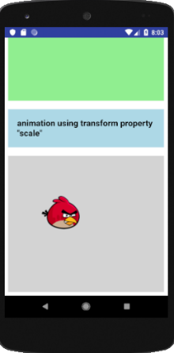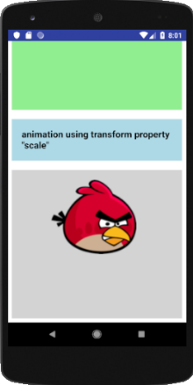

Also, add a sticky navigation bar to link each of the activities:

Sticky up navigation bar

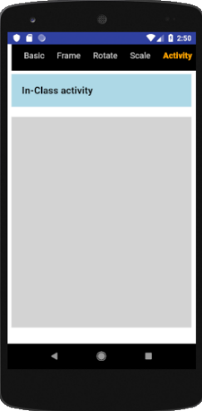

# **7 – Creating Slideshow using CSS**

Slideshow is one of the fun features in website. It presents to the viewer a series of information, images, or text slides looping in certain time. The purpose of a slideshow is to promote visual interest or artistic value, sometimes accompanied with description or text, or to clarify or reinforce information, ideas, comments, solutions, or suggestions.

There are different way to create slideshow, one of the way to create slideshow in CSS is to use the *animation* feature.

**Example 1)** Create an infinite slideshow to display a number from 1 to 4, increasing order, with different background color.

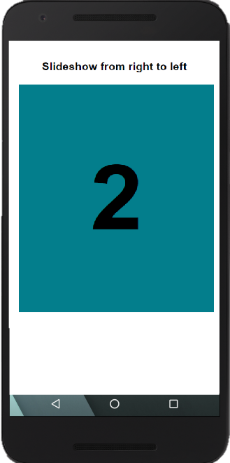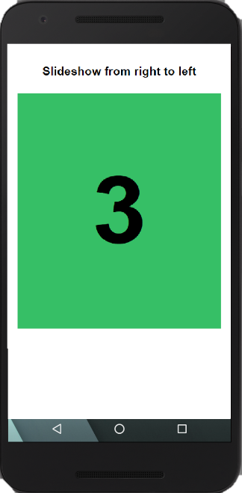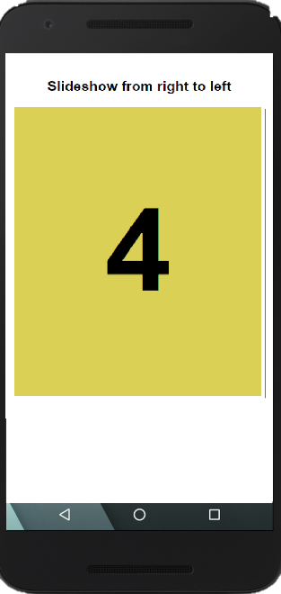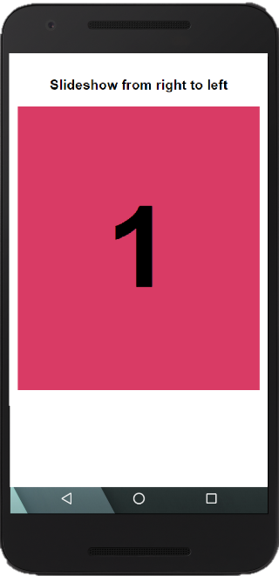

Let’s set up the html structure with a link to index.css

<!DOCTYPE html>

<html lang="en" dir="ltr">

<head>

<meta charset="utf-8">

<meta name="viewport" content="width=device-width, initial-scale=1.0">

<link href="index.css" rel="stylesheet" type="text/css"/>

<title>Slideshow by Huixin Wu</title>

</head>

<body>

</body>

</html>

HTML

We start with creating the html structure and add the padding to the entire body document to 2% and set all elements’ box-sizing: border-box;

In index.css, we are going to set the **body** padding to 2%. This will prevent that elements within the body sit in the border of the smartphone’s screen.

body {

font-family: Helvetica, sans-serif;

padding: 2%;

text-align: center;

}

*{

box-sizing: border-box;

}

CSS

Now that we have the **body** set, we can create the slide container with the id name as **slideshow1**

<!DOCTYPE html>

<html lang="en" dir="ltr">

<head>

<meta charset="utf-8">

<meta name="viewport" content="width=device-width, initial-scale=1.0">

<link href="index.css" rel="stylesheet" type="text/css"/>

<title>Slideshow by Huixin Wu</title>

</head>

<body>

<div id="slideshow1">

</div> <!—end of slideshow1 -->

</body>

</html>

HTML

Once we have the html structure for slideshow1, in css, we are going to set the height to 400px, the width to fit 100% of the app screen, and all the overflow information in slideshow1 will be hidden. Also, we are going to add border to slideshow1 for reference, but remember that the border will be deleted once the slideshow frame is set.

#slideshow1{

overflow: hidden;

height: 400px;

width: 100%;

border: solid red;

}

CSS

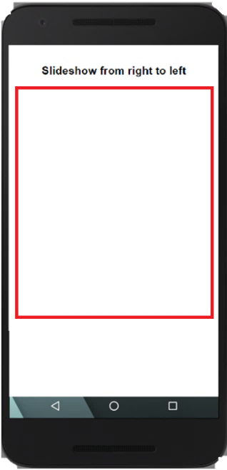

After it, we need to create a container to wrap all four numbers. We are going to name the wrapper **slide-wrapper**. The total width of the **slide-wrapper** is the sum of the width of each image in the slideshow. For example, if we are planning to display four images in a slideshow and each image will display 100% to the width of the app screen, then the width of the **slide-wrapper** will be 400%.

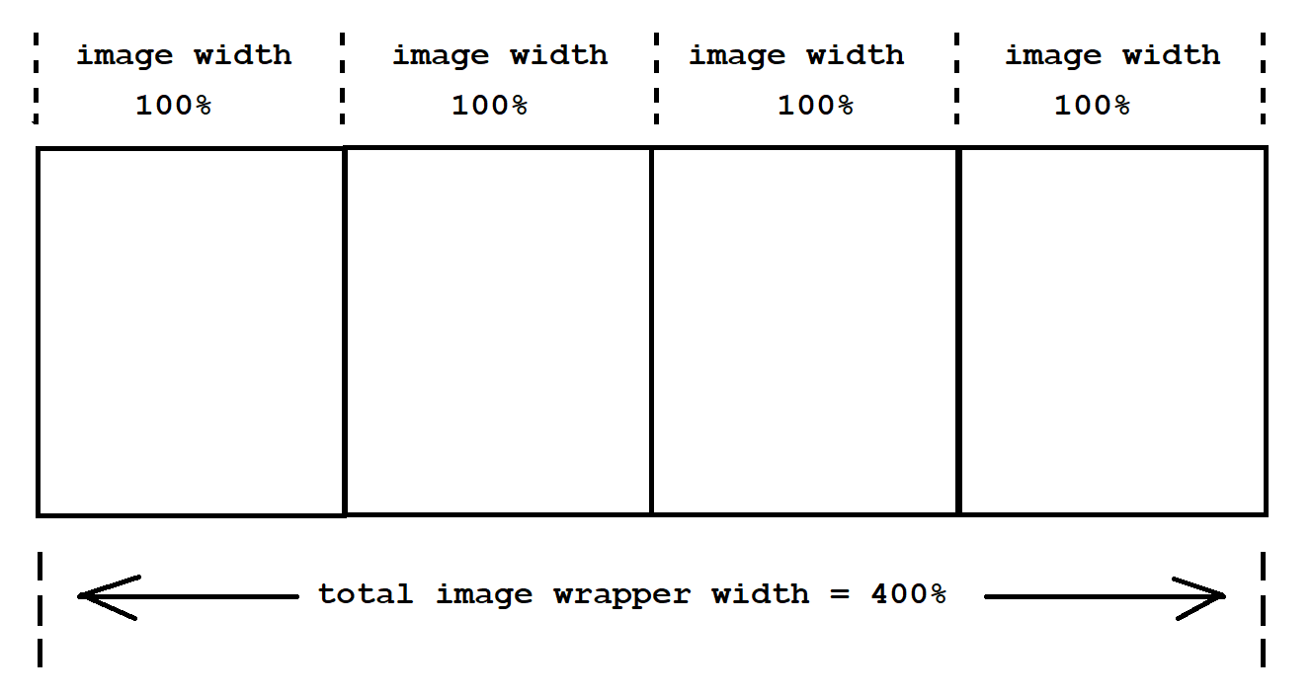

The other feature that we need to add to the **slide-wrapper** is the animation. The animation will slide each image in the slideshow from right to left one at the time. To do so, at each time frame the **slide-wrapper** will add margin to the left by 100% of the image width. Since the **slide-wrapper** is shifted to the left, the **margin-left** should be set to **-100%**. For example, at the first time frame, the slideshow will show the first image:

.slide-wrapper {

width: 400%;

height: 100%;

}

CSS

<!DOCTYPE html>

<html lang="en" dir="ltr">

<head>

<meta charset="utf-8">

<meta name="viewport" content="width=device-width, initial-scale=1.0">

<link href="index.css" rel="stylesheet" type="text/css"/>

<title>Slideshow by Huixin Wu</title>

</head>

<body>

<div id="slideshow1">

<div class="slide-wrapper">

</div> <!—end of slide-wrapper -->

</div> <!—end of slideshow1 -->

</body>

</html>

HTML

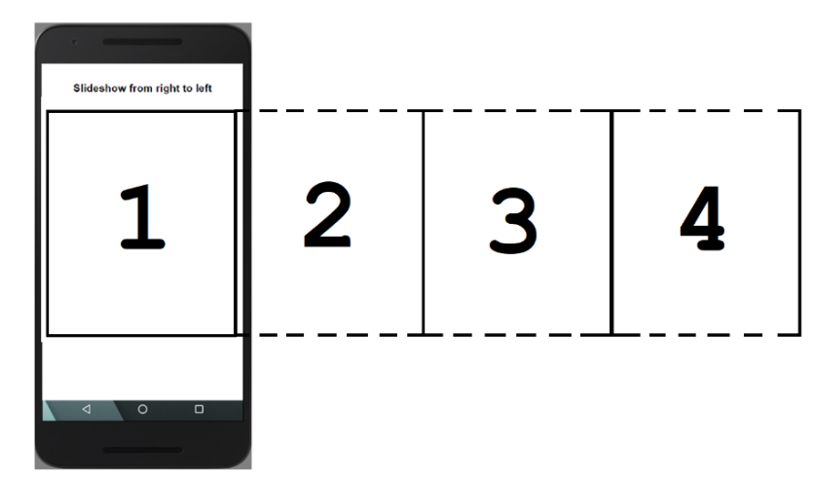

At the second time frame, the **margin-left** set to **-100%** to show the second image:

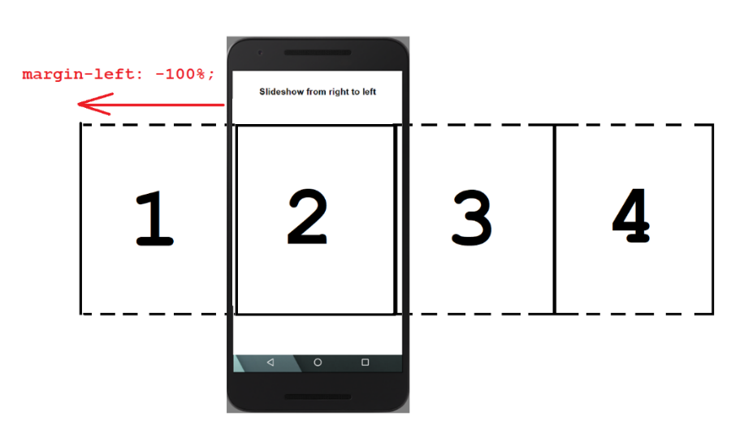

At the third time frame, the **margin-left** set to **-200%** to show the third image:

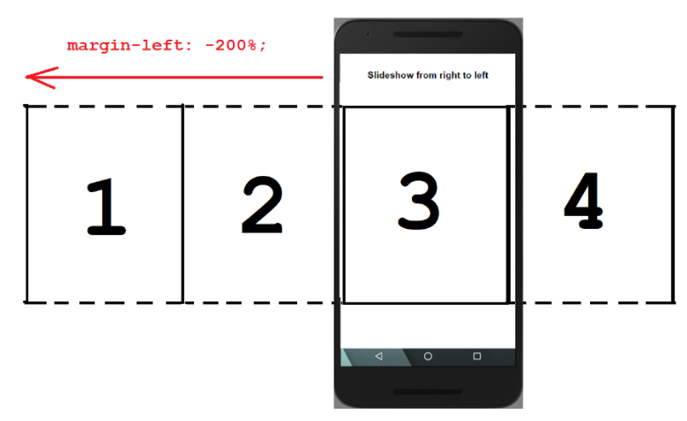

At the fourth time frame, the **margin-left** set to **-300%** to show the fourth image:

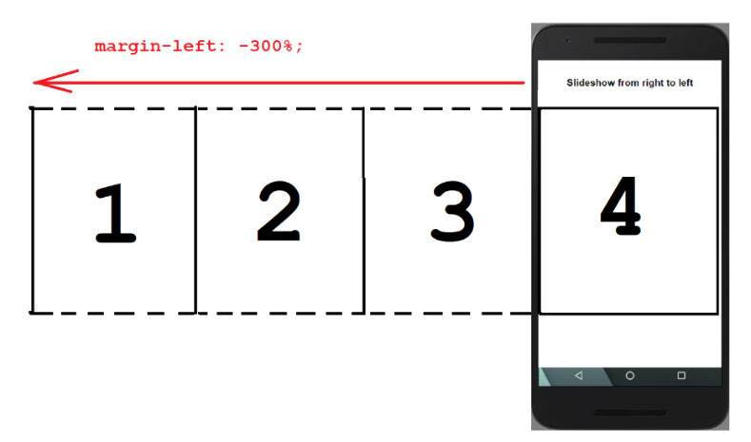

.slide-wrapper {

width: 400%;

height: 100%;

animation: slideshow 12s infinite;

}

@keyframes slideshow {

0% {margin-left: 0px;}

35% {margin-left: -100%;}

70% {margin-left: -200%;}

100% {margin-left: -300%;}

}

CSS

Add animation to **.slide-wrapper**

We are naming the animation as slideshow, the total animation duration is 12 seconds, and it is an infinite slideshow

If we run the slideshow, nothing is showing because we have not set each image into the **slide-wrapper** yet. Since we are planning to show four numbers, then we need to create four slide divisions:

<!DOCTYPE html>

<html lang="en" dir="ltr">

<head>

<meta charset="utf-8">

<meta name="viewport" content="width=device-width, initial-scale=1.0">

<link href="index.css" rel="stylesheet" type="text/css"/>

<title>Slideshow by Huixin Wu</title>

</head>

<body>

<div id="slideshow1">

<div class="slide-wrapper">

<div class="slide"><h1>1</h1></div>

<div class="slide"><h1>2</h1></div>

<div class="slide"><h1>3</h1></div>

<div class="slide"><h1>4</h1></div>

</div> <!—end of slide-wrapper -->

</div> <!—end of slideshow1 -->

</body>

</html>

HTML

Since all four **slide** divisions is set inside the **slide-wrapper**, then each **slide** division width must be set to 25%, $\frac{100\%}{4}=25\%$

Also, all four divisions will be in-line from left to right, for this, we can set all four divisions to float left

.slide {

float: left;

height: 100%;

width: 25%;}

CSS

We can also add some CSS to all **h1** within **slide** class:

.slide h1{

text-align: center;

font-size: 10em;}

CSS

Now, we can run the slideshow and see the number displaying one at the time.

The next features to add to each slide is the background color. There is different way we can set different background color to each slide, for example, we can use different class name to each slide division, or add the CSS code in the HTML code using **style="background-color: yellow;"**

For this activity, we are going to use the **nth-child** selector in CSS to set different background color to each **slide** division. The **nth-child** selector is a structural pseudo-class, meaning it is used to style content based on its relationship with the parent element. For our program, the parent element will be **slide** because **slide** has four divisions of the same class name. Then, each **slide** division, according to line order, will be the **nth-child** of the **slide** element. The syntax of the **nth-child** is:

Child order

Parent Element Name

.slide:**nth-child**(1) {

CSS attributes

color: red;

}

For example, if we are setting the background color for the first slide to lightblue, then we can write the code as:

.slide:nth-child(1) {

background-color:lightblue;

}

Then, to set different background color to each four slide elements:

.slide:nth-child(1) {

background-color:lightblue;

}

.slide:nth-child(2) {

background-color: pink;

}

.slide:nth-child(3) {

background-color: lightgreen;

}

.slide:nth-child(4) {

background-color: orange;

}

CSS

Now, we can run the slideshow and see the number of each slide changes with different background color.

If we want each number of the slideshow to rest before it shifts to the next number, we can adjust the previous animation’s time frame, **@keyframes** slideshow, to rest by 10% of the total time frame at each slide, and 20% of the total time frame as the transition time between slide:

@keyframes slideshow {

0% {margin-left: 0px;}

10% {margin-left: 0px;}

30% {margin-left: -100%;}

40% {margin-left: -100%;}

60% {margin-left: -200%;}

70% {margin-left: -200%;}

90% {margin-left: -300%;}

100% {margin-left: -300%;}

}

CSS

Run the slideshow and see how the number rest for 1.2 seconds, 10% of the total time frame 12 seconds, before it moves to the next number.

The other features that we can add to the animation is to see slideshow images to backward to the beginning to the slideshow when it reaches the last slide. For this, we can adjust the time frame to up 85% for the last slide. This will allow the slideshow to have the rest 86% to 100% to backward to the beginning to the slideshow. Therefore, the rest time at each slide will be 10% of the total time frame, the transition time between slides will be 15% of the total time frame, and the backward time will be 15% of the total time frame, which is from 86% to 100%:

@keyframes slideshow {

0% {margin-left: 0px;}

10% {margin-left: 0px;}

25% {margin-left: -100%;}

35% {margin-left: -100%;}

50% {margin-left: -200%;}

60% {margin-left: -200%;}

75% {margin-left: -300%;}

85% {margin-left: -300%;}

}

CSS

# **8 – Creating a modal window using HTML and CSS**

Modal windows are boxes that opens in front on the computer screen. They are widely used for advertisements, promotion code, item description, login/register forms, etc.

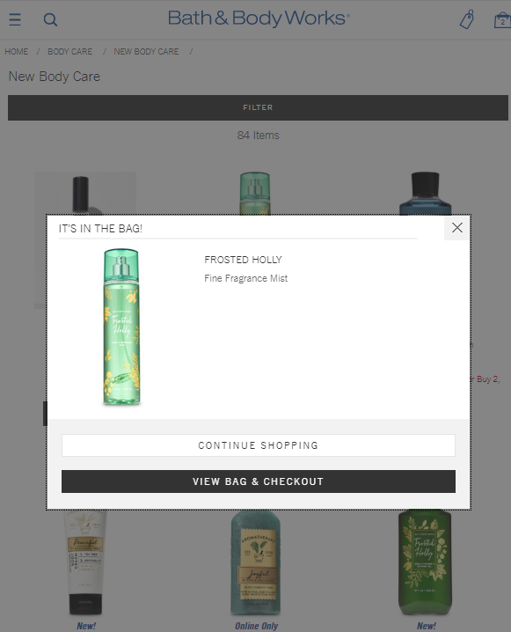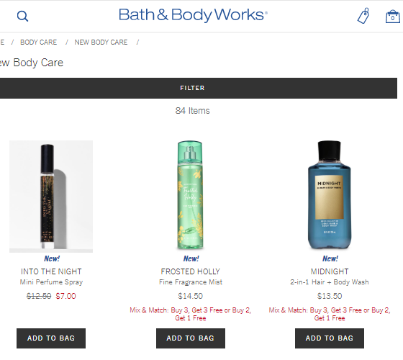

Open Modal window

Click on ADD TO BAG

There are different techniques to create modal windows, one way to create a modal window is by using CSS’s attributes as transition, opacity, pointer-event, and background gradient properties.

To create a modal window we need to create open modal link:

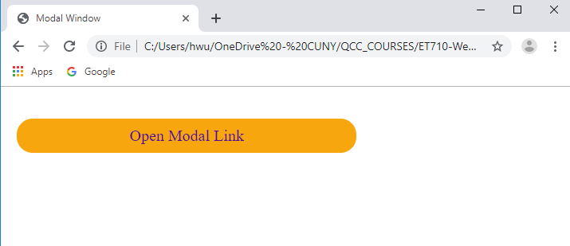

<!DOCTYPE html>

<html lang="en" dir="ltr">

<head>

<meta charset="utf-8">

<title>Modal Window</title>

<link rel="stylesheet" href="modal.css" type="text/css">

</head>

<body>

<a href="#openModal" class="linkModel">Open Modal Link</a>

</body>

</html>

**HTML**

.linkModel{

text-align:center;

background-color: orange;

font-size: 20px;

padding: 10px;

border-radius: 20px;

text-decoration:none;

}

**modal.css**

Run the program to see if the modal link looks like this: 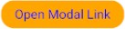

From the HTML code, the code line:

**<a href="#openModal" class="linkModel">Open Modal Link</a>**

we can see that the modal is linked to an element **id** as "#openModal". Therefore, we have to create the modal element using <div> element and we will **id** it as: id="openModal". This division we will also has a class name as: **class="modalWindow"** for css attributes.

<!DOCTYPE html>

<html lang="en" dir="ltr">

<head>

<meta charset="utf-8">

<title>Modal Window</title>

<link rel="stylesheet" href="modal.css" type="text/css">

</head>

<body>

<a href="#openModal" class="linkModel">Open Modal Link</a>

<!-- Modal Window container -->

**<div id="openModal" class="modalWindow">**

**</div>**

</body>

</html>

**HTML**

Since the modal window will cover the entire screen, we can set the top, right, left, and bottom to 0px. This setting meaning that there will be 0px of distance between the top, right, left, and bottom to the modal window.

top: 0px;



left: 0px;

right: 0px;

bottom: 0px;

Once the modal window is created, we have to apply transparency to the modal window. This property can be set by setting the window background to 80% of transparency using the **rgba** color property:

Background-color: rgba(160,80,160,0.8);

The CSS code should look as the following:

.linkModel{

width: 60%;

text-align:center; background-color: orange; font-size: 20px; padding: 10px;

border-radius: 20px;

}

.linkModel a{

text-decoration:none;

}

.modalWindow {

position: fixed; top: 0;

right: 0;

bottom: 0;

left: 0;

background-color: rgba(160,80,160,0.8);

}

**modal.css**

The internet browser should look as:

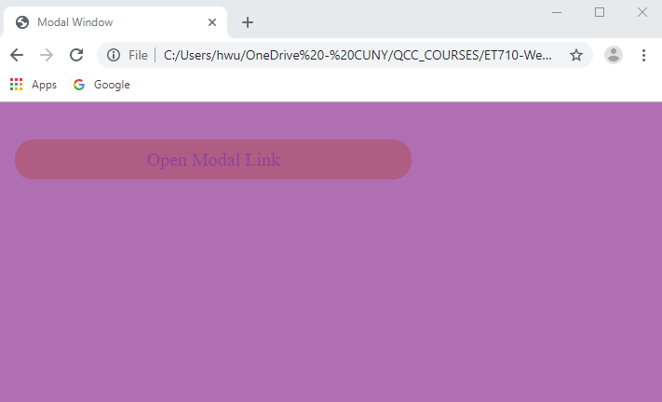

Having the background of the modal window set, we can add a message window on top of the modal window using a <div> with class name **msgText.** This message window is used to display the advertisement of the modal. Since the message window will display in-front of the modal window, therefore this division will have **position: relative**. To make the message window more colorful and organized, we can add linear-gradient background to it, set the width to 80%, the height to border- radius, and 40% of top margin:

.msgText{

position: relative;

width: 700px;

height: 500px;

border-radius: 10px;

margin: auto;

margin-top: 200px;

background: linear-gradient(to top right, black, white);

}

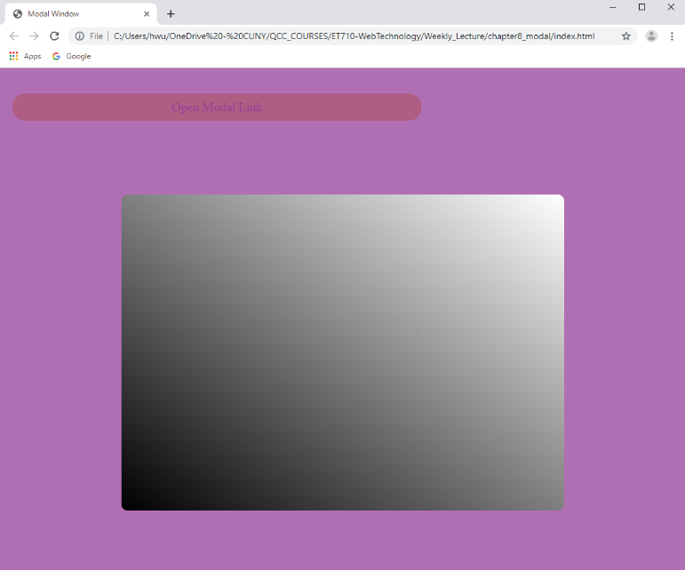

The internet browser should look as:

**msgText** is used as a message window. Therefore, we can add a title to this message window using **<h3>** and a text container using **<p>.**

<!DOCTYPE html>

<html lang="en" dir="ltr">

<head>

<meta charset="utf-8">

<title>Modal Window</title>

<link rel="stylesheet" href="modal.css" type="text/css">

</head>

<body>

<a href="#openModal" class="linkModel">Open Modal Link</a>

<!-- Modal Window container -->

<div id="openModal" class="modalWindow">

. <div class="msgText">

**<h3>Modal Window by Huixin</h3>**

**<p>This is a paragraph in the message window. You could do a lot of things here like have a pop-up that shows promotion information, images, or create a login/register from for users</p>**

</div>

</div>

</body>

</html>

**HTML**

Refreshing the internet browser, the modal window should look as:

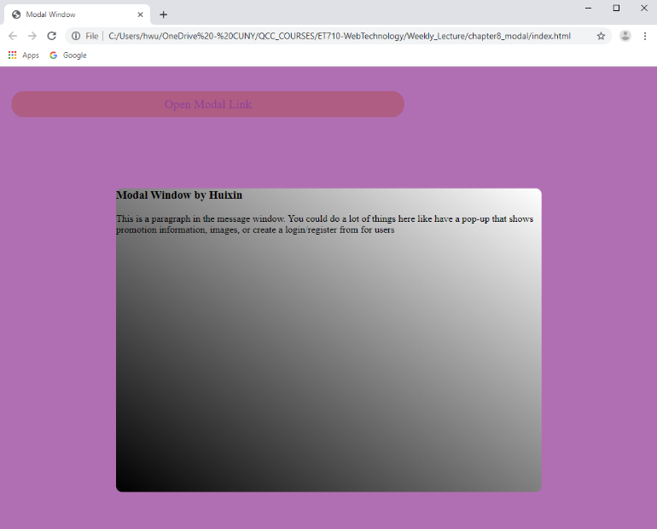

To make my message window more styling, in CSS, we add padding to **<h3>** and **<p>,** and align the text to justify in **<p>**. Remember that to call the **<h3>** and **<p>** without using a class name, we will need to call the division that contains them first and then the element, for example: **.msgText h3**

**.msgText h3**{

padding: 20px; background-color: black; color: white; }

**.msgText p**{

padding: 20px; text-align: justify; background-color: white;}

Refreshing the internet browser, the modal window should look as:

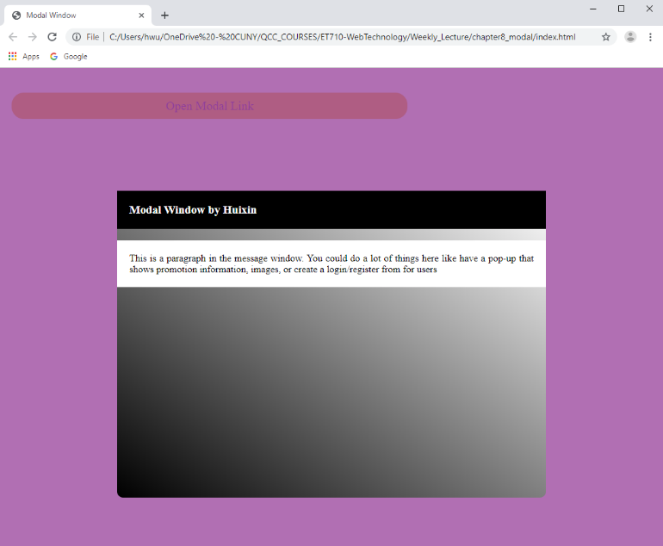

We can also add an image to the message window:

<!DOCTYPE html>

<html lang="en" dir="ltr">

<head>

<meta charset="utf-8">

<title>Modal Window</title>

<link rel="stylesheet" href="modal.css" type="text/css">

</head>

<body>

<a href="#openModal" class="linkModel">Open Modal Link</a>

<!-- Modal Window container -->

<div id="openModal" class="modalWindow">

<div class="msgText">

<h3>Modal Window by Huixin</h3>

<p>This is a paragraph in the message window. You could do a lot of things here like have a pop-up that shows promotion information, images, or create a login/register from for users</p>

**<img src="rose.jpg" alt="Image of a rose" title="Rose">**

</div>

</div>

</body>

</html>

**HTML**

To style the image in the message window, we can make the width of the image to 50% of the message window width, and center the image by setting the margin-left or margin-right to 25%:

.msgText img{

width: 50%;

height: auto;

margin-left: 25%;

}

Refreshing the internet browser, the modal window looks as:

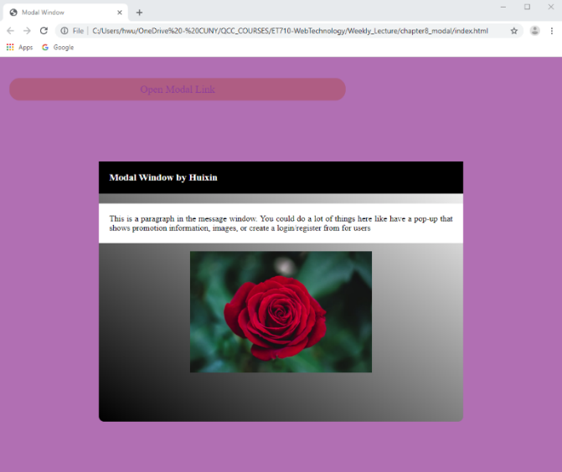

The next thing to add to the message window **msgText** is a link to close the modal window. For this, we can use an anchor **<a>** tag and link it to the top of the web app using: **href="#"**. We can name it as **class="modal-close"** for CSS attributes.

<!DOCTYPE html>

<html lang="en" dir="ltr">

<head>

<meta charset="utf-8">

<title>Modal Window</title>

<link rel="stylesheet" href="modal.css" type="text/css">

</head>

<body>

<a href="#openModal" class="linkModel">Open Modal Link</a>

<!-- Modal Window container -->

<div id="openModal" class="modalWindow">

<div class="msgText">

<h3>Modal Window by Huixin</h3>

<p>This is a paragraph in the message window. You could do a lot of things here like have a pop-up that shows promotion information, images, or create a login/register from for users</p>

<img src="rose.jpg" alt="Image of a rose" title="Rose">

**<a href="#" class="modal-close">CLOSE</a>**

</div>

</div>

</body>

</html>

**HTML**

Now is CSS, we can set attributes to **.modal-close** such as width, the font color, padding, font-weight, text-align, and set the text-decoration to none:

.modal-close {

color: #00d9ff;

padding: 12px;

font-weight: bold;

text-align: center;

text-decoration: none; }

Refreshing the internet browser, the webpage looks as:

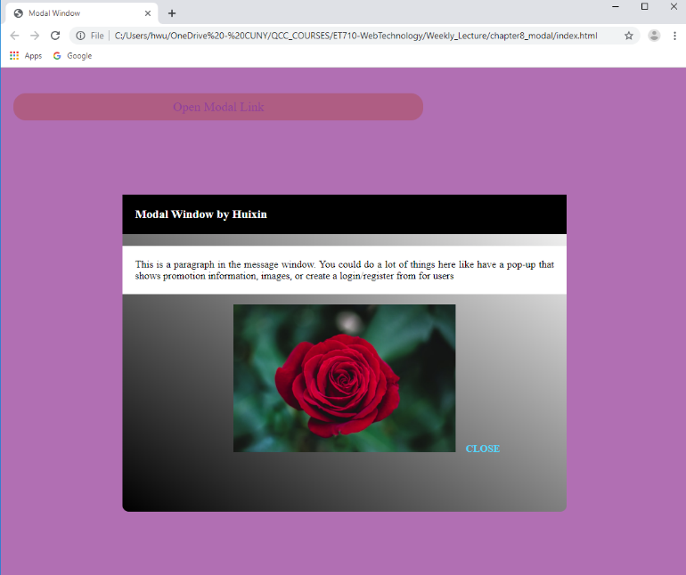

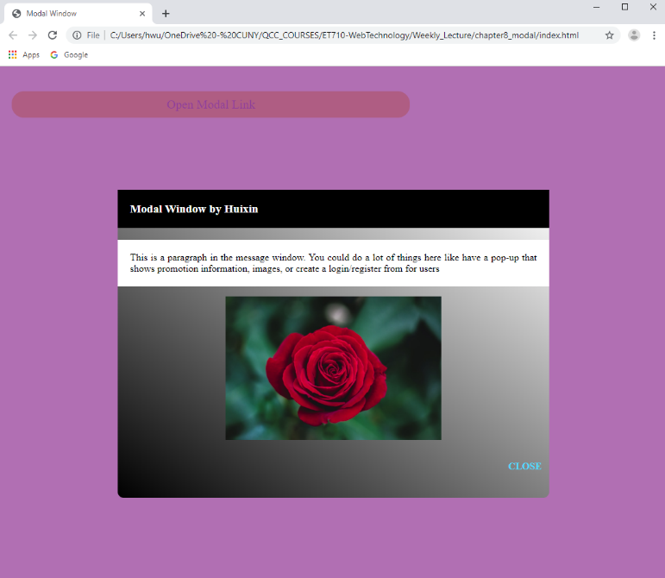We can also add two break lines **<br>** in between the image and the CLOSE link to move the CLOSE link to the next line. If we want to have the CLOSE link in the right side, we can use **float:right;** attribute.

Once we have the modal window set, we can set the **opacity** attribute to it. The idea of using the **opacity** attribute is to make the modal window to invisible, **opacity:0;** , when the web app is loaded, then when the modal link is clicked, the modal window will become visible, **opacity: 1; .** To set this attribute, we add **opacity:0;** in the CSS of the modal window **.modalWindow**

.modalWindow {

position: fixed; top: 0;

right: 0;

bottom: 0;

left: 0;

background-color: rgba(160,80,160,0.8);

**opacity: 0;**

}

The other setting is to create a hover effect to the modal window to open to modal window using **opacity: 1;**

**.modalWindow:hover{**

**opacity: 1;**

**}**

If we run the app, the message window will not close when we click on the CLOSE link. This happens because we did not set the **pointer-events** to **target** an element that has the CLOSE link. For this, we can include **pointer-events:none**; to the element that has the anchor tag **<a>** beneath it. In this activity, we target the modal window **.modalWindow** and when click on the CLOSE link, the model window will close, that is why we need to change **.modalWindow:hover** to **.modalWindow:target** and add a **pointer-events: auto;** which means that the any anchor **<a>** tag under **.modalWindow** will react to the pointer events. In other words, when we click on the CLOSE link, the anchor **<a>** tag will take us to the beginning to the web app as states with href="#"

.modalWindow {

position: fixed; top: 0;

right: 0;

bottom: 0;

left: 0;

background-color: rgba(160,80,160,0.8);

opacity: 0;

Change **hover** to **target**

Add this line

**pointer-events: none;**

}

.modalWindow:**target**{

opacity: 1;

Add this line

**pointer-events: auto;**

}

We can also add some animation to our modal window, for example, we can make the modal window to **ease-in** when it opens.

.modalWindow:target{

opacity: 1;

pointer-events: auto;

Add this line

**transition: ease-in 0.5s;**

}

Refreshing the internet browser, the modal window looks as:

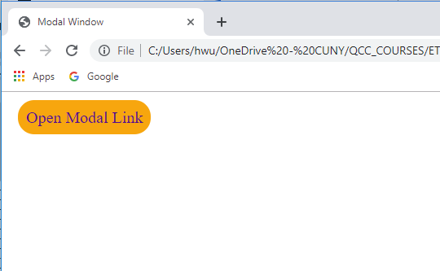

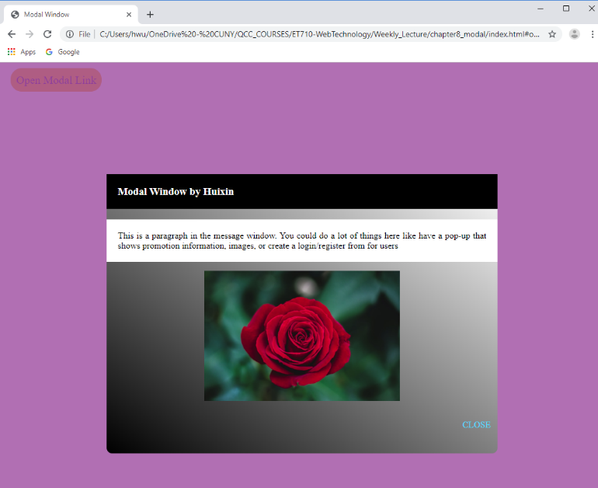

# **9. Responsive Webpages**

Making a webpage responsive to the screen size is an important features in web technology. Nowadays, web pages open on devices with different screen sizes, for example a **desktop computer** screen has a width of 1200px, a Samsung Galaxy Tab 10.1 tablet has the width of 900px, and the width of a Samsung Galaxy J7 smartphone is 720px . Therefore, it is important that when you design a webpage, the elements on the webpage can adjust to the screen of the device. You can visit: <http://screensiz.es/> to view more devices width.

For app view development, it is an important to add the following line:

<meta name="viewport" content="width=device-width, initial-scale=1.0">

The **viewport** is the user's visible area of a web page. It varies with the device, and will be smaller on a mobile phone than on a computer screen. **viewport** element gives the browser instructions on how to control the page's dimensions and scaling.

The **width=device-width** part sets the width of the page to follow the screen-width of the device (which will vary depending on the device).

The **initial-scale=1.0** part sets the initial zoom level when the page is first loaded by the browser.

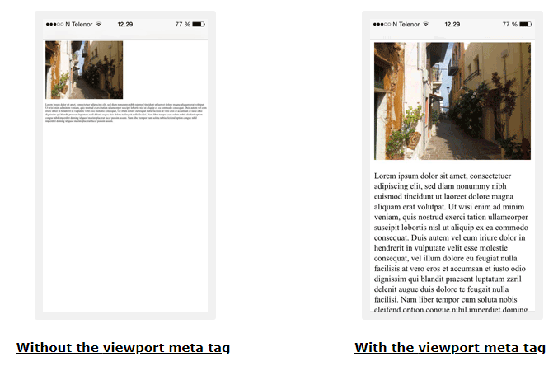

## **@media query**

Media query is a CSS technique introduced in CSS3 and it is used to make responsive pages.

It uses the @media rule to include a block of CSS properties only if a certain condition is true.

When using @media, instead of changing styles when the width gets *smaller* than 720px, we should change the design when the width gets *larger* than 720px. This will make our design Mobile First. The syntax code will look as:

@media only screen and (min-width: 720px){

}

Between the curly brackets should go the CSS attributes of the elements that will changed when the screen has the width of 720px or greater.

Mobile First means designing for mobile before designing for desktop or any other device (This will make the page display faster on smaller devices). Some web developer prepares to design a mobile view first as it moves toward the tablet’s, laptop’s, and desktop’s screen size. Therefore, when we apply @media query, the screen size has property **min-width: 720px**. On the other hand, since the material in this lab manual was designed from a desktop computer screen view, then we can design from the desktop computer screen toward the tablet’s and smartphone’s screen size. For this, instead of using **min-width:720px** we use **max-width: 720px**

**Example 9.1)** Create the following layout for a desktop screen:

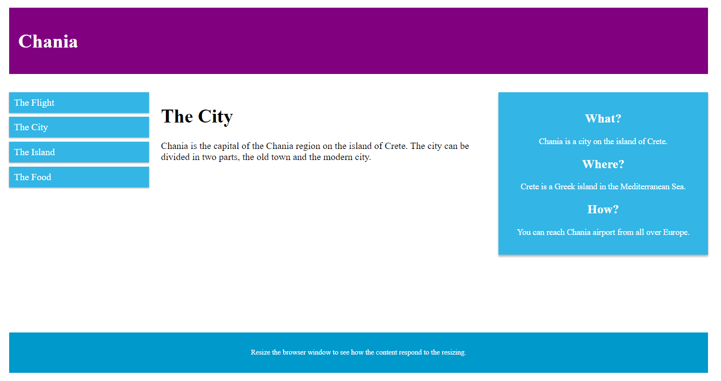

<!DOCTYPE html>

<html lang="en" dir="ltr">

<head>

<meta charset="utf-8">

<meta name="viewport" content="width=device-width, initial-scale=1.0">

<title>Responsive Webpage by Prof. Wu</title>

<link rel="stylesheet" href="index.css" type="text/css">

</head>

<body>

<div class="header">

<h1>Chania</h1>

</div>

<div class="container">

<div class="col_left">

<ul>

<li>The Flight</li>

<li>The City</li>

<li>The Island</li>

<li>The Food</li>

</ul>

</div>

<div class="col_middle">

<h1>The City</h1>

<p>Chania is the capital of the Chania region on the island of Crete. The city can be divided in two parts, the old town and the modern city.</p>

</div>

<div class="col_right">

<div class="aside">

<h2>What?</h2>

<p>Chania is a city on the island of Crete.</p>

<h2>Where?</h2>

<p>Crete is a Greek island in the Mediterranean Sea.</p>

<h2>How?</h2>

<p>You can reach Chania airport from all over Europe.</p>

</div>

</div>

</div> <!-- end of container -->

<div class="footer">

<p>Resize the browser window to see how the content respond to the resizing.</p>

</div>

</body>

</html>

**HTML**

body{padding: 20px;}

* { box-sizing: border-box; }

.header {

background-color: purple; color: white; padding: 15px;

}

.container{

width: 100%; height: 400px; margin-top: 30px;

}

/*-- left column --*/

.col_left{

width: 20%; float: left; height: auto;

}

.col_left ul {

list-style-type: none; margin: 0; padding: 0;

}

.col_left li {

padding: 8px;

margin-bottom: 7px;

background-color: #33b5e5;

color: #ffffff;

box-shadow: 0 1px 3px rgba(0,0,0,0.12), 0 1px 2px rgba(0,0,0,0.24);

}

.col_left li:hover { background-color: #0099cc;

}

/*-- middle column --*/

.col_middle{

width: 50%;

height: auto;

float: left;

padding: 0px 20px 20px 20px;

}

/*-- right column --*/

.col_right{

width: 30%;

height: auto;

float: left;

}

.aside {

background-color: #33b5e5;

padding: 15px;

color: white;

text-align: center;

font-size: 14px;

box-shadow: 0 3px 3px rgba(0,0,0,0.3);

}

.footer {

background-color: #0099cc;

color: white;

text-align: center;

font-size: 12px;

padding: 15px;

}

**index.css**

***Breakpoint of a tablet screen size view***

Once the desktop view is set, we can create a responsive webpage to a tablet of 1024px of width. The following layout for a tablet screen with a maximum width of 1024px:

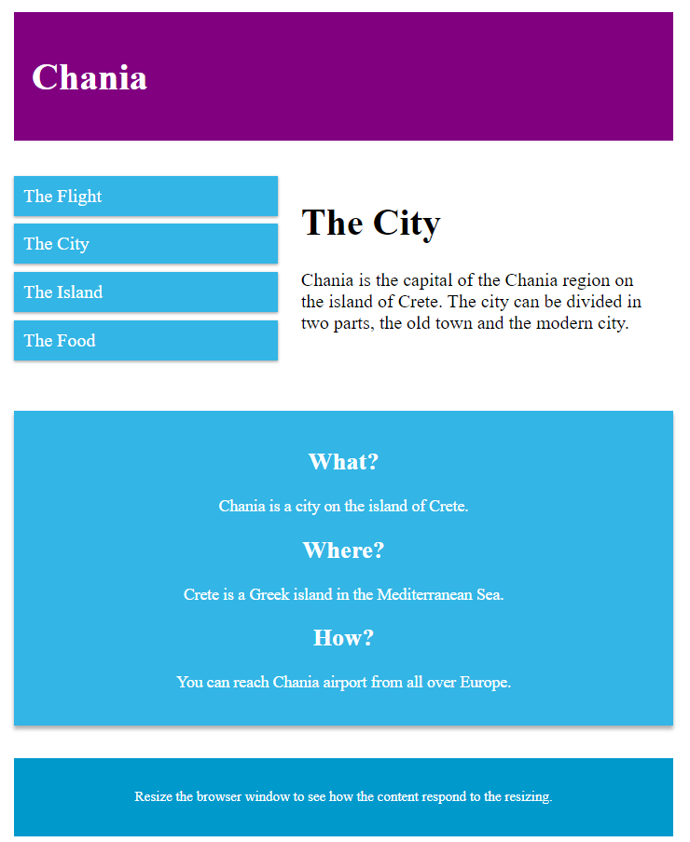

In CSS, we can write a media query with a maximum width of **1024px** as the following

@media only screen and (max-width: 1024px){

}

Within the curly brackets, we will need to change the height of the **container** element to **550px**. We need to change the **height** of the container, otherwise the **.col_right** will overlap. Once the **height** of the **container** element is set, we need to set the **.col_left** element’s **width** to **40%** of the container element, **.col_middle** element’s **width** to **60%**, and the **.col_right** element’s **width** to **100%.**

We can add the media query code to the end of the index.css

* Responsible to a tablet of 1024px width*/

@media only screen and (max-width: 1024px) {

.container{ height: 550px; }

.col_left{ width: 40%; }

.col_middle{ width: 60%; }

.col_right{

width: 100%;

margin-top: 30px;

margin-bottom: 50px;

}

}

**index.css**

When we refresh the internet browser, we can see the change or rearrangement of the elements to fit the window screen of at least **1024px**.

***Breakpoint of a smartphone screen size view***

Once the tablet view is set, we can create a responsive webpage to a smartphone screen width of 720px. The following layout for a smartphone screen with a maximum width of 720px:

/* Responsive webpage of of 720px width*/

@media only screen and (max-width: 720px) {

.container{ height: 700px; }

.col_left{ width: 100%; }

.col_middle{ width: 100%; }

.col_right{

width: 100%;

margin-top: 30px;

margin-bottom: 50px;

}

}

**index.css**

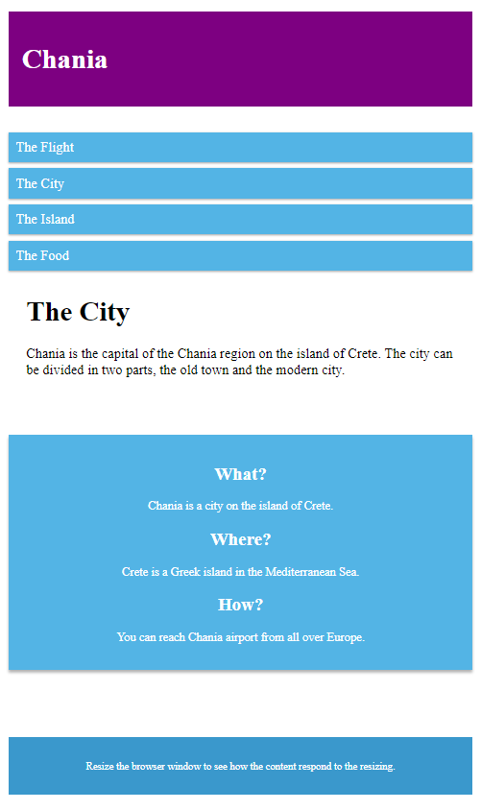When we refresh the internet browser, we can see the change or rearrangement of the elements to fit the window screen of at least **1024px.** If we keep decreasing the width of the internet browser, we can see the elements to rearrange again to fit the window screen of at least **720px**.

Bootstrap 4

# **10.** **Using Basic Styles in Bootstrap 4**

## ***Installing Bootstrap 4***

**Bootstrap** is a free and open-source front-end framework (library) for designing websites and web applications. It contains HTML- and CSS-based design templates for typography, forms, buttons, navigation and other interface components, as well as optional JavaScript extensions.

**Installation**

This version of Bootstrap has a lot of different installation options. So let's take a quick look at what we have available. Now you can install Bootstrap in one of four ways. The first way is to simply download the pre compiled Bootstrap CSS and JavaScript files. It works really well if you need to install a copy of Bootstrap that will work even without an internet connection. Another way is to use CDNs. A CDN is a content delivery network, which needs a place that hosts common libraries like Bootstrap. You can also download the source files. This way, you download not just the CSS and JavaScript, but all the files that the developers use to create Bootstrap.

Now to get instructions and to download a copy of Bootstrap manually, first go to the getbootstrap.com website right here and then click on this Download button.

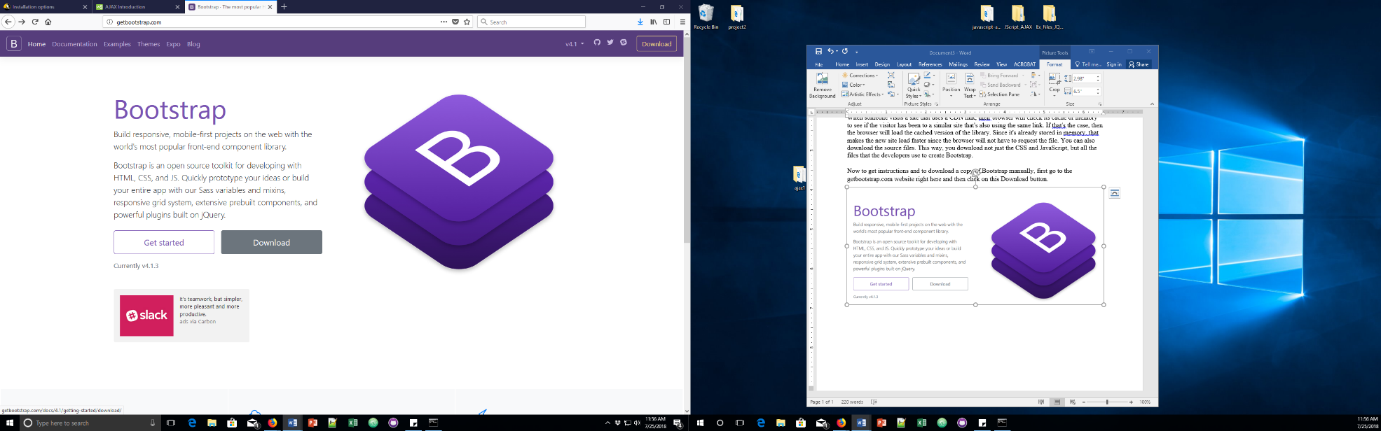

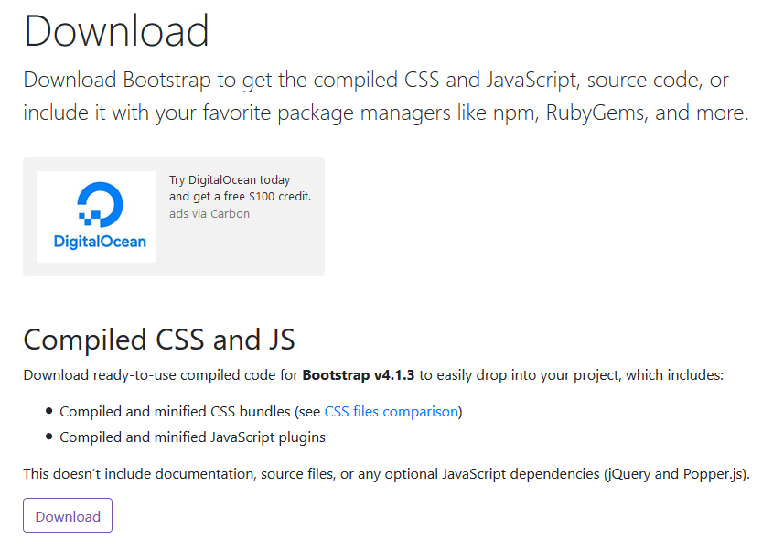

Now this is not going to download anything. It's going to take you to another page where it shows all the different download options. If you scroll down you can see the first option is Compiled CSS and JavaScript. Let's go ahead and click on this button because we want decompiled and minified CSS versions of the library.

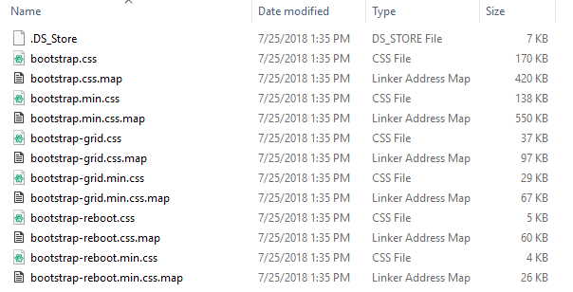If you open up the folder, you see a CSS folder plus a JavaScript folder. The CSS folder has a number of different versions of the CSS use for the Bootstrap framework. Now if you look at this folder, you'll notice that there are three types of files: regular css files, minimized version, and map files. Map files are files that are useful if you're using Bootstrap in development mode so that they could point you not to the CSS, but to the original SAS code that was used to create the CSS. Some people like to use only the grid features of Bootstrap for a layout so you can get just that if you want to. There's also a Bootstrap reboot file. The reboot files are the special Bootstrap code that resets the CSS and browsers so that they work more consistently in different platforms.

The regular version of Bootstrap contains the grid, the reset, and everything else in Bootstrap. You can choose the regular version if you're going to customize Bootstrap, or just choose Bootstrap.min.css if you just want to use that file.

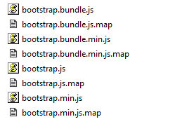In the JavaScript folder, you'll also find several files as well. JavaScript also has maps. Since most people write in a version of JavaScript, it gets translated so that it works with older browsers. There are regular and minimized versions of the JavaScript as well. Other than that, there are two types of files: the regular Bootstrap and the Bootstrap bundle. The Bootstrap bundle has all the Bootstrap code plus an additional library called 'popper.js'. **Popper**.**js** is a positioning engine, its purpose is to calculate the position of an element to make it possible to position it near a given reference element.

Most of time you're going to need just the regular Bootstrap file, however you also use the minimized version since you don't want to edit any of the Bootstrap JavaScript yourself.

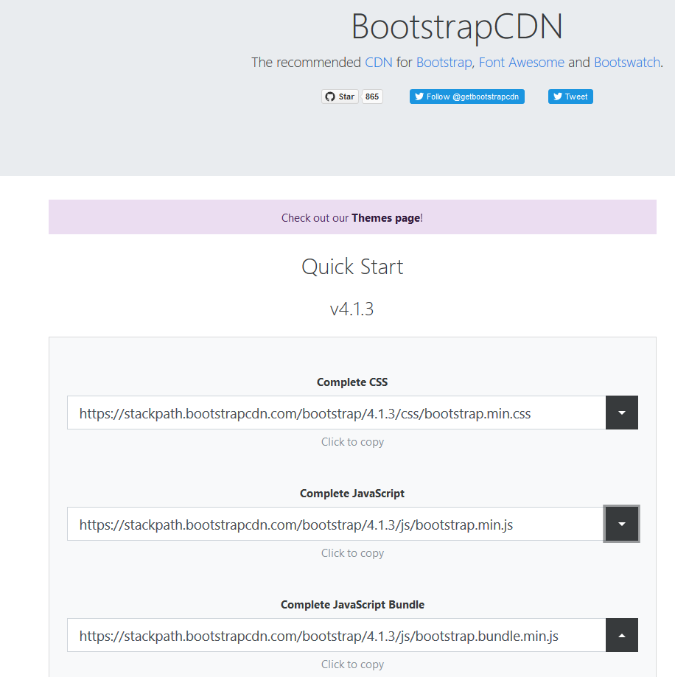

When someone visits a site that uses a CDN link, their browser will check its cache or memory to see if the visitor has been to a similar site that's also using the same link. If that's the case, then the browser will load the cached version of the library. Since it's already stored in memory, that makes the new site load faster since the browser will not have to request the file. You can download the CDN version of bootstrap at https://www.bootstrapcdn.com/

## 

**All together**

In order to get start a project using bootstrap, you will need the following file links to your project document:

* Bootstrap
* jQuery
* popper.js
* basic HTML document

To get all the templates at once, you can go to: <http://getbootstrap.com/docs/4.0/getting-started/introduction/> and get a preset code.

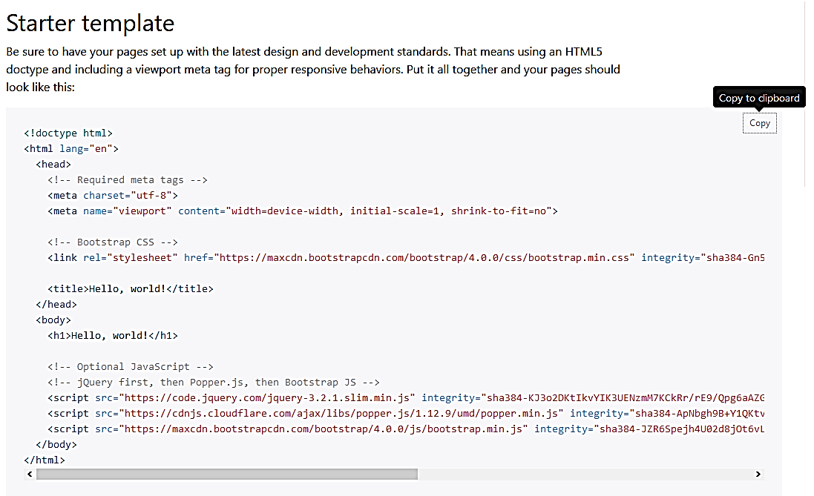

# **11. Text/Typography**

The CSS code that comes with Bootstrap overrides default browser behavior. Besides making things look great, it's also designed to be easy to override with your own CSS.

Bootstrap 4 uses a default **font-size** of 16px, and its **line-height** is **1.5**.

The default **font-family** is "Helvetica Neue", Helvetica, Arial, sans-serif.

In addition, all <p> elements have **margin-top: 0** and **margin-bottom: 1em** (16px by default).

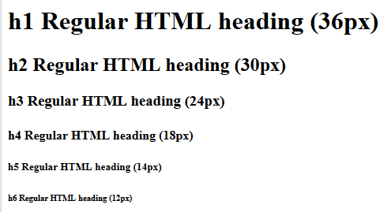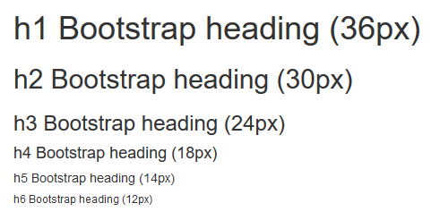

You can try some to the HTML code in bootstrap:

* **<small>** 🡺 element is used to create a lighter, secondary text in any heading.

**<h1>**h1 heading **<small>**secondary text**</small></h1>**

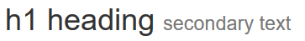

* **<mark>** 🡺 element in used to highlight text

**<p>**Use the mark element to **<mark>**highlight**</mark>** text**.</p**>



* **<kbd>** 🡺 element indicates input that is typically entered via the keyboard

**<p>**Use **<kbd>**ctrl + p**</kbd>** to open the Print dialog box**.</p>**

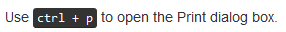

<!doctype html>

<html lang="en">

<head>

<!-- Required meta tags -->

<meta charset="utf-8">

<meta name="viewport" content="width=device-width, initial-scale=1, shrink-to-fit=no">

<link rel="stylesheet" href="index.css" type="text/css">

<!-- Bootstrap CSS -->

<link rel="stylesheet" href="https://maxcdn.bootstrapcdn.com/bootstrap/4.0.0/css/bootstrap.min.css" integrity="sha384-Gn5384xqQ1aoWXA+058RXPxPg6fy4IWvTNh0E263XmFcJlSAwiGgFAW/dAiS6JXm" crossorigin="anonymous">

<title>Bootstrap - Text and Typography</title>

</head>

<body>

<h2 class="title">Bootstrap: Text and Typography</h2>

<h1>h1 heading <small>secondary text</small></h1>

<p>Use the mark element to <mark>highlight</mark> text.</p>

<p>Use <kbd>ctrl + p</kbd> to open the Print dialog box.</p>

<!-- Optional JavaScript -->

<!-- jQuery first, then Popper.js, then Bootstrap JS -->

<script src="https://code.jquery.com/jquery-3.2.1.slim.min.js" integrity="sha384-KJ3o2DKtIkvYIK3UENzmM7KCkRr/rE9/Qpg6aAZGJwFDMVNA/GpGFF93hXpG5KkN" crossorigin="anonymous"></script>

<script src="https://cdnjs.cloudflare.com/ajax/libs/popper.js/1.12.9/umd/popper.min.js" integrity="sha384-ApNbgh9B+Y1QKtv3Rn7W3mgPxhU9K/ScQsAP7hUibX39j7fakFPskvXusvfa0b4Q" crossorigin="anonymous"></script>

<script src="https://maxcdn.bootstrapcdn.com/bootstrap/4.0.0/js/bootstrap.min.js" integrity="sha384-JZR6Spejh4U02d8jOt6vLEHfe/JQGiRRSQQxSfFWpi1MquVdAyjUar5+76PVCmYl" crossorigin="anonymous"></script>

</body>

</html>

**html**

Bootstrap also has some contextual classes.

* **display-1, display-2, display-3, display-4** 🡺 class is an almost twice the regular size
* **text-nowrap** 🡺 class lets the text of a paragraph or any other element sort of fit to the left and the right with the same amount of spacing.
* **Text** 🡺 class allows to set the position itself or size and position

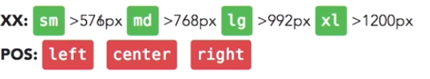

There is also other classes related to text: **text-lowercase, text-uppercase, text-capitalize, font-weight-bold, font-weight-normal, font-italic, text-justify**

You can check more bootstrap typography at [w3schools](https://www.w3schools.com/bootstrap/bootstrap_tables.asp)

<p class="text-uppercase">Undestanding display classes in Bootstrap</p>

<p class="text-uppercase display-4">Undestanding display classes in Bootstrap</p>

<p class="font-weight-bold">Undestanding display classes in Bootstrap. Undestanding display classes in Bootstrap. Undestanding display classes in Bootstrap. Undestanding display classes in Bootstrap</p>

<p class="text-justify">Undestanding display classes in Bootstrap. Undestanding display classes in Bootstrap. Undestanding display classes in Bootstrap. Undestanding display classes in Bootstrap</p>

<p class="text-nowrap">Undestanding display classes in Bootstrap. Undestanding display classes in Bootstrap. Undestanding display classes in Bootstrap. Undestanding display classes in Bootstrap</p>

**html**

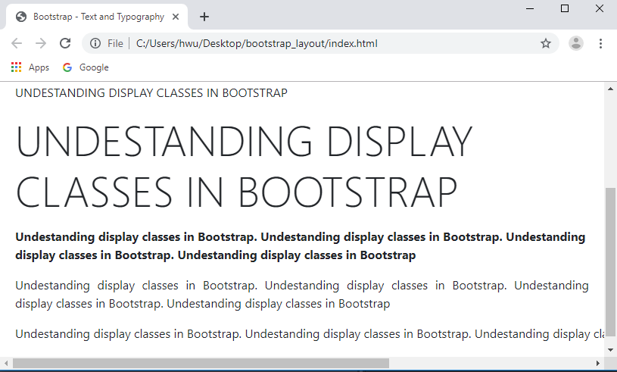

## ***Lists and blockquotes***

Bootstrap provides some classes that help you work with common CSS tags like lists and blockquote elements.

* **list-unstyled** 🡺 displays the list without bullets
* **list-inline-item** 🡺 display the element in line

<ul class="list-unstyled"> <p class="text-uppercase font-weight-bold"> Fruits</p>

<li>Apples</li>

<li>Oranges</li>

<li>Pineapples</li>

</ul>

<ul class="list-unstyled "> <p class="text-uppercase font-weight-bold"> Colors</p>

<li class="list-inline-item">Red</li>

<li class="list-inline-item">Green</li>

<li class="list-inline-item">Blue</li>

<li>Orange</li>

</ul>

**html**

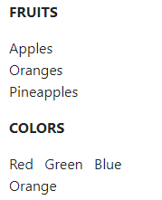

The **<blockquote>** tag specifies a section that is quoted from another source.

Browsers usually indent **<blockquote>** elements. In bootstrap, the class **blockquote** makes the font a little bigger and it also gives a vertical line within the quoted text.

You can also create a **blockquote-footer** it creates a nice format around the wrapped text.

**class="blockquote-reverse"** aligns the quoted section to the right.

<blockquote cite="http://www.qcc.cuny.edu/">

Queensborough Community College

<p class="blockquote-footer">Department of Engineering Technology</p>

</blockquote>

**html**



# **12 – Colors and Image Manipulation using Bootstrap 4**

## ***Colors***

Bootstrap has a number of colors that you can access through contextual color names. They're used everywhere, including in buttons, background colors, as well as texts, so you'll hear some of these names in different places, but let's take a look at the basic options available in texts, links, and backgrounds. So the way that these work is by using the prefix text, and then using one of the contextual color names.

The classes for text colors are**: text-muted, text-primary, text-success, text-info, text-warning, and text-danger**

<p class="text-muted">The text is muted</p>

<p class="text-primary">The text is important</p>

<p class="text-success">The text indicates success</p>

<p class="text-info">The text represents some information</p>

<p class="text-warning">The text represents a warning</p>

<p class="text-danger">The text represents danger</p>

**html**

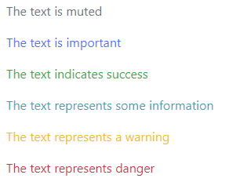

The classes for background colors are: **bg-primary, bg-success, bg-info, bg-warning, bg-danger**

<p class="bg-primary">The text with primary color background</p>

<p class="bg-success">The text with success color background</p>

<p class="bg-info">The text with info color background</p>

<p class="bg-warning">The text with warning color background</p>

<p class="bg-danger">The text with danger color background</p>

**html**

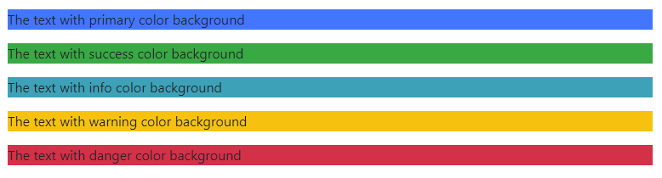

## ***Working with images***

Bootstrap also has some very useful classes that help you work with images, as well as with figures.

### ***Border images***

The **rounded** class adds rounded corners to an image. You can also apply direction of which edge the image do you want it to be rounded.

<img src="nyc.jpg" alt="apple image" title="Red Apple Image" class="rounded" width="400px" height="250px">

**html**

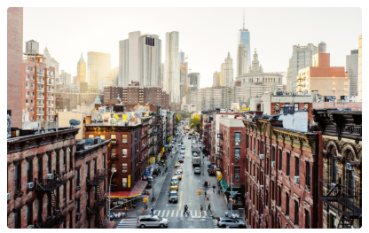

The **rounded-circle** 🡺 class shapes the image to a circle

<img src="nyc.jpg" alt="apple image" title="Red Apple Image" class="rounded-circle" width="300px" height="300px">

**html**



The **img-thumbnail** 🡺 class shapes the image to a thumbnail (bordered)

<img src="nyc.jpg" alt="apple image" title="Red Apple Image" class="img-thumbnail" width="400px" height="250px">

**html**

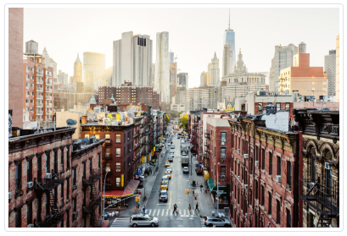

### ***Aligning images***

Float an image to the right with the **float-right** class or to the left with **float-left**

Center an image by adding the utility classes **mx-auto** (margin:auto) and **d-block** (display:block) to the image.

### ***Responsive images***

Responsive images automatically adjust to fit the size of the screen.

* **img-fluid:** Create responsive images by adding an **img-fluid** class to the **<img>** tag. The image will then scale nicely to the parent element.

The **img-fluid** class applies **max-width: 100%;** and **height: auto;**

* **figure-img** class makes the text with a smaller font and lighter color. The **<figure>** tag in HTML specifies self-contained content, like illustrations, diagrams, photos, code listings, etc.

While the content of the **<figure>** element is related to the main flow, its position is independent of the main flow, and if removed it should not affect the flow of the document.

* **figure-caption** class makes the text in **<figcaption>**with a smaller font and lighter color. The HTML **<figcaption>** element represents a caption or legend for the rest of the contents its parent figure element, if any.

<img src="nyc.jpg" alt="apple image" title="Red Apple Image" class="img-fluid">

<figure class="figure-img">

<img src="nyc.jpg" alt="apple image" title="Red Apple Image"

width="400px" height="250px">

<img src="nyc.jpg" alt="apple image" title="Red Apple Image"

width="400px" height="250px">

<img src="nyc.jpg" alt="apple image" title="Red Apple Image"

width="400px" height="250px">

<figcaption class="figure-caption">New York City</figcaption>

</figure>

**html**

### 

### ***CSS variables***

Bootstrap has some features that allows you to work with a new feature of CSS called CSS Variables. Now CCS Variables are a newer feature within CSS that allows you to store a set of property values that you can reuse within your CSS. Now this version of Bootstrap provides pre-written CSS variables that can be used in developing your projects and customizing your colors. CSS Variables are so new that browser support is an issue. They're not supported in any version of Internet Explorer, and only on very new versions of the other browsers.

**Syntax**

var(*custom-name, value*)

<style>

:root{

--hello:#25FF64;

}

</style>

<h1 style="color:var(--hello);">Our Commitment</h1>

# **13. Mastering Layout with bootstrap**

By far the most useful part of Bootstrap is the grid, so this is the first thing you should master. The Bootstrap grid gives you a framework to create any layout that you can think of. Now, Bootstrap layouts have three main pieces. The first is containers, which can be either responsive fixed width that snap to certain breakpoints, or completely fluid containers which take up 100% of the width of the view port, which is the browser window or the width of your device. Inside containers, you can also place content in rows and columns.

Bootstrap uses a 12-column grid system that has breakpoints for extra small, small, medium, large, and extra large devices. If you're coming from a previous version of Bootstrap, note that there is an additional breakpoint for smaller devices. The grid is extremely flexible. You can create multiple layouts for different breakpoints, reset, offset, nest, and even customize the order of the columns at different breakpoints. Bootstrap's grid is very powerful.

If you can think of a layout, you can build it easily and responsively with the Bootstrap grid. The more time you spend learning how to use it, the easier it will be to get your work done.

## ***Containers and rows***

One of the main reasons people use Bootstrap is to have access to an amazing grid that makes layout easy to do and responsive. This is one of the most important things you should master in Bootstrap, so let's take a look. First of all, the grid is a responsive 12-column system for creating just about any layout you can think of. It uses a technology called Flexbox that makes it easier to create complex layout with minimal code. In order to work with the grid, you need to master three simple components.

The first is containers, which can be used with or without the grid to **align-content** either to the viewport, or center it around a set of breakpoints. Next is rows and columns. They work together to allow you to create the layouts. The rows prepare the columns for layout, and the columns are complex and extremely flexible, so we'll cover them in a separate video in detail. So first, let's go ahead and take a look at containers. There are two different types of containers.

**container** class is used for regular containers, which center content and snap to certain grid points.

**container-fluid** are fluid containers, which are always the full width of the viewport, which means the width of the device or the browser window. One of the reasons you use a container is because you get a 15 pixel padding on each side to make sure it works well with backgrounds and other elements. Now here's the breakpoints that the regular container will adjust to. First is anything smaller than 576 pixels, and so the bootstrap grid adjusts to content that is smaller than 576 pixels, and then some of these other breakpoints.

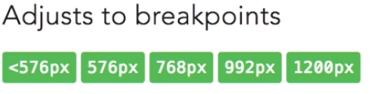

## ***Rows and columns***

Bootstrap’s grid system allows up to 12 columns across the page. If you do not want to use all 12 column individually, you can group the columns together to create wider columns:

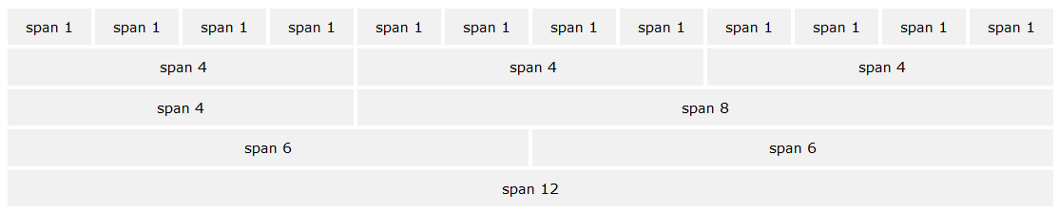

Bootstrap's grid system is responsive, and the columns will re-arrange depending on the screen size: On a big screen it might look better with the content organized in three columns, but on a small screen it would be better if the content items were stacked on top of each other.

***Grid Classes***

The Bootstrap 4 grid system has five classes:

**.col**- (extra small devices - screen width less than 576px)

**.col-sm**- (small devices - screen width equal to or greater than 576px)

**.col-md**- (medium devices - screen width equal to or greater than 768px)

**.col-lg**- (large devices - screen width equal to or greater than 992px)

**.col-xl**- (xlarge devices - screen width equal to or greater than 1200px)

The classes above can be combined to create more dynamic and flexible layouts.

**Tip:** Each class scales up, so if you wish to set the same widths for **sm** and **md**, you only need to specify **sm**.

Screen Breakpoints

***Grid System Rules***

Some Bootstrap 4 grid system rules:

* Rows must be placed within a **.container** (fixed-width) or **.container-fluid** (full-width) for proper alignment and padding
* Use rows to create horizontal groups of columns
* Content should be placed within columns, and only columns may be immediate children of rows
* Predefined classes like **.row** and **.col-sm-4** are available for quickly making grid layouts
* Columns create gutters (gaps between column content) via padding. That padding is offset in rows for the first and last column via negative margin on .rows
* Grid columns are created by specifying the number of 12 available columns you wish to span. For example, three equal columns would use three **.col-sm-4**
* Column widths are in percentage, so they are always fluid and sized relative to their parent element

**Example)** Create row with different width:

*Computer view*

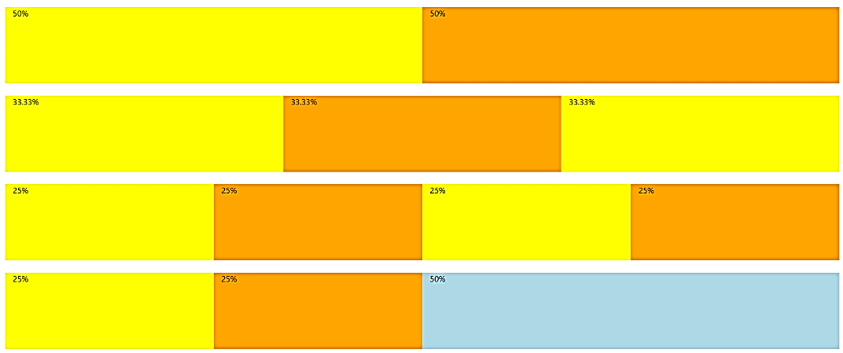

*Smartphone view*

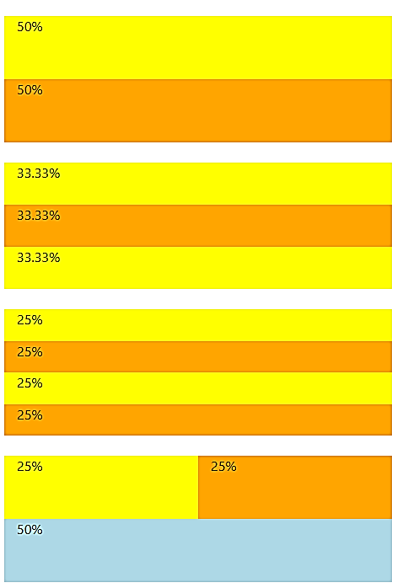

<div class="container-fluid">

<!-- Control the column width, and how they should appear on different devices -->

<div class="row">

<div class="col-sm-6" style="background-color:yellow;">50%</div>

<div class="col-sm-6" style="background-color:orange;">50%</div>

</div>

<br>

<div class="row">

<div class="col-sm-4" style="background-color:yellow;">33.33%</div>

<div class="col-sm-4" style="background-color:orange;">33.33%</div>

<div class="col-sm-4" style="background-color:yellow;">33.33%</div>

</div>

<br>

<!-- Or let Bootstrap automatically handle the layout -->

<div class="row">

<div class="col-sm" style="background-color:yellow;">25%</div>

<div class="col-sm" style="background-color:orange;">25%</div>

<div class="col-sm" style="background-color:yellow;">25%</div>

<div class="col-sm" style="background-color:orange;">25%</div>

</div>

<br>

<div class="row">

<div class="col" style="background-color:yellow;">25%</div>

<div class="col" style="background-color:orange;">25%</div>

<div class="col-sm-6" style="background-color:blue;">50%</div>

</div>

</div>

</div>

HTML

To take full advantage of the 12 column grid, you have to master the use of columns.

***Multiple columns***

The grid in Bootstrap is powerful because of the many ways that we can use it. One thing we can do is specify multiple-column breakpoints for each of our grid elements.

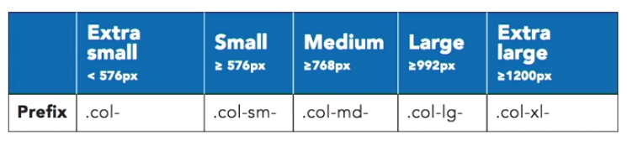

***Offsetting columns***

Another way to control the grid is to offset columns in order to move their position on the grid. For example, a grid without offset looks as the following:



<div class="row" style="background: lightgray;">

<section class="col-md-3" >

<img src="images/image.jpg" alt="sample image" style="width:100%;" >

<h4>Exotic Pets</h4>

<p>We offer <strong>specialized</strong> care for <em>reptiles, rodents, birds,</em> and other exotic pets.</p>

</section>

<section class="col-md-3">

<img src="images/image.jpg" alt="sample image" style="width:100%;" >

<h4>Grooming</h4>

<p>Our therapeutic <span class="font-weight-bold">grooming</span> treatments help battle fleas, allergic dermatitis, and other challenging skin conditions.</p>

</section>

</div><!-- end of row -->

HTML

**offset** class in columns is used to shift but the number of columns over. From the previous example, if we add offset to **<section class="col-md-3 offset-sm-1">** the webpage will look as the following:



I

***Nested column***

You can easily put a whole new grade of columns inside an existing column. Now, that's called nesting. So, let's take a look at how that works. To nest columns, you simply create a new row inside an existing column. Now, this will create a new regular 12-column grid inside that existing column. And inside that column, you can use the same set of classes that you've been using so far. For example, we can create one main image with six sub-images as the following:

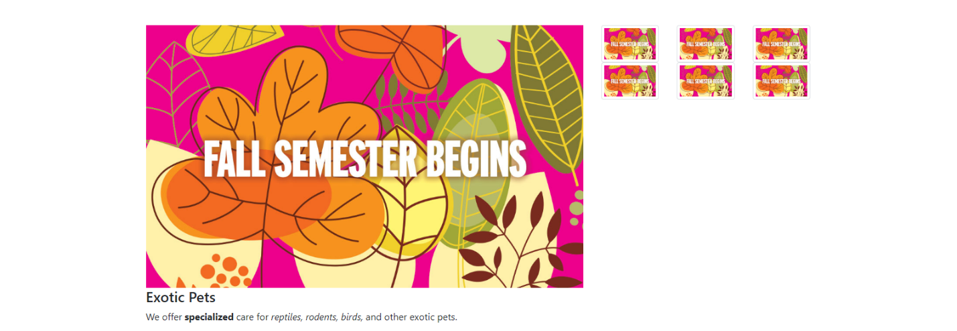

<div class="row">

<section class="col-sm-8">

<img src="images/image.jpg" alt="sample image">

<h4>Exotic Pets</h4>

<p>We offer <strong>specialized</strong> care for <em>reptiles, rodents, birds,</em> and other exotic pets.</p>

</section>

<section class="col-sm-4">

<div class="row">

<div class="col-2 col-sm-4">

<img src="images/image.jpg" class="img-thumbnail"></div>

<div class="col-2 col-sm-4">

<img src="images/image.jpg" class="img-thumbnail"></div>

<div class="col-2 col-sm-4">

<img src="images/image.jpg" class="img-thumbnail"></div>

<div class="col-2 col-sm-4">

<img src="images/image.jpg" class="img-thumbnail"></div>

<div class="col-2 col-sm-4">

<img src="images/image.jpg" class="img-thumbnail"></div>

<div class="col-2 col-sm-4">

<img src="images/image.jpg" class="img-thumbnail"></div>

</div> <!-- end of subnets row -->

</section>

</div><!—end of row -->

HTML

We can also set one main image with six sub-images below the main image:

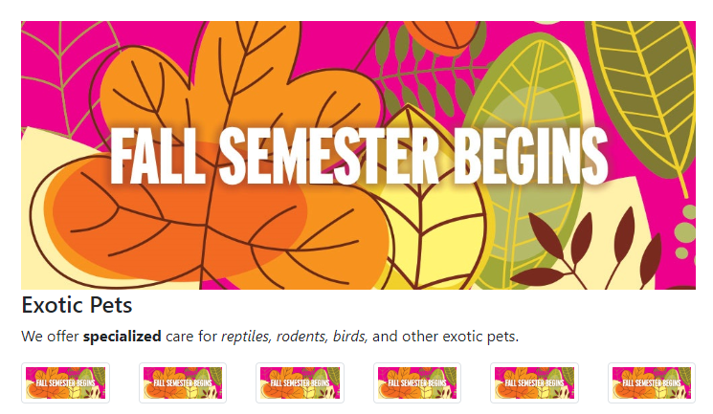

## ***Custom order***

One of the more advanced ways that you can control layouts is to customize the order of elements. It helps you to reorder the way that columns appear and you can do this at different screen widths. Class **col order-2**change the order of the element in a row.

For example, if we have a session with **col**

**<section class="col">**

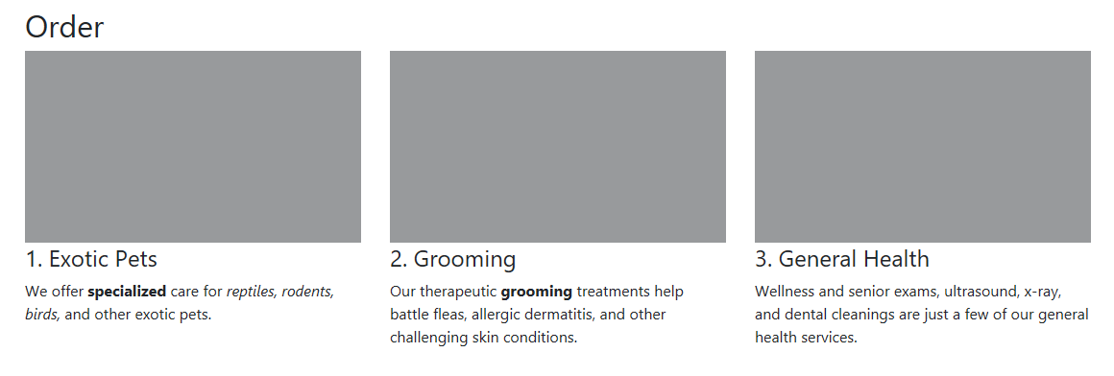

If we add order-3 to the first session, that session will be moved to the third position

**<section class="col order-3">**

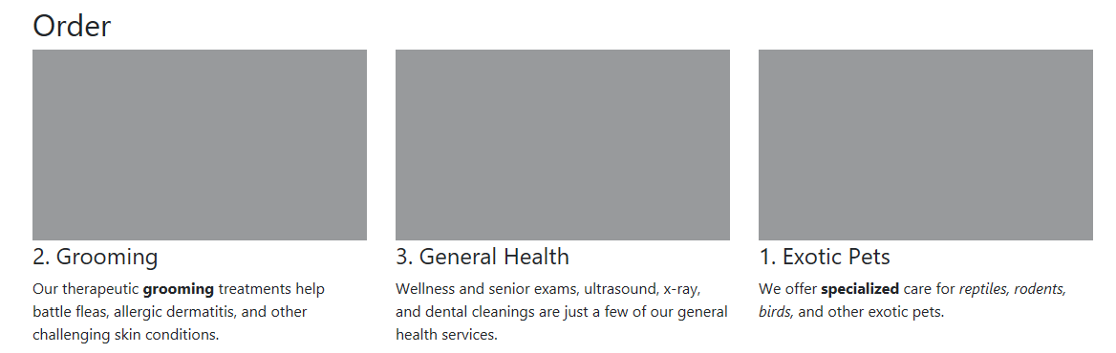

# **14. Navigation bar**

Every web project needs great navigation. Next to the grid, this is the most important component in Bootstrap. The different types of navigation components are navs, tabs, pills, and navbars. Navs are parents to all the other navigation. Tabs and pills are the same type of component and help you create content within a page that changes when clicked. Navbars, on the other hand, are typically used for main navigation between pages. Now, although you'll end up using navbars more often, it's easier to learn about navs first.

## **Creating Navigation Bar using *nav***

There's a group of components called **nav**. Now, this component had a lot of changes in this new version of Bootstrap due to the implementation of Flexbox and, thankfully, became a lot simpler to use. Now to create navs you can use either the unordered lists or use nav and regular divs.

Using unordered list, you will need to call the nav class in the <ul>, nav-item in each list <li>, and nav-link in each link.

<ul class="nav">

<li class="nav-item"><a href="#" class="nav-link">Home</a></li>

<li class="nav-item"><a href="#" class="nav-link">Services</a></li>

<li class="nav-item"><a href="#" class="nav-link">Mission</a></li>

<li class="nav-item"><a href="#" class="nav-link">Staff</a></li>

<liclass="nav-item"><a href="#" class="nav-link">Testimonials</a></li>

</ul>

HTML

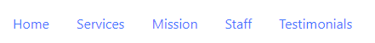

If you want to you can add a couple of styles to these. You can add an **active** style. This style with shows when you use pills or nav style.

<li class="nav-item"><a href="#" class="nav-link active">Home</a></li>

The other additional look that you can have for the links is **disabled**. Disabled basically disable the hyperlink

<li class="nav-item"><a href="#" class="nav-link disabled">Home</a></li>

### ***Nav-pills***

We have nav-pills class looks like sort of buttons.

<ul class="nav nav-pills">

<ul class="nav nav-pills">

<li class="nav-item"><a href="#" class="nav-link ">Home</a></li>

<li class="nav-item"><a href="#" class="nav-link">Services</a></li>

<li class="nav-item"><a href="#" class="nav-link active">Mission</a></li>

<li class="nav-item"><a href="#" class="nav-link">Staff</a></li>

<li class="nav-item"><a href="#" class="nav-link">Testimonials</a></li>

</ul>

HTML

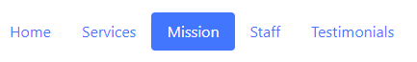

### ***Nav-tabs***

Nav-tabs class makes the link look like tabs

<ul class="nav nav-tabs">

<ul class="nav nav-tabs ">

<li class="nav-item"><a href="#" class="nav-link active ">Home</a></li>

<li class="nav-item"><a href="#" class="nav-link">Services</a></li>

<li class="nav-item"><a href="#" class="nav-link ">Mission</a></li>

<li class="nav-item"><a href="#" class="nav-link">Staff</a></li>

<li class="nav-item"><a href="#" class="nav-link">Testimonials</a></li>

</ul>

HTML



There's a couple of classes related to that. We can use justify-content-center to center the tabs, or justify-content-end to shift the tabs to the right side.

<div class="nav nav-pills justify-content-center">

<ul class="nav nav-tabs justify-content-center">

<li class="nav-item"><a href="#" class="nav-link ">Home</a></li>

<li class="nav-item"><a href="#" class="nav-link">Services</a></li>

<li class="nav-item"><a href="#" class="nav-link ">Mission</a></li>

<li class="nav-item"><a href="#" class="nav-link">Staff</a></li>

<li class="nav-item"><a href="#" class="nav-link active">Testimonials</a></li>

</ul>

HTML



<div class="nav nav-pills justify-content-end">

<ul class="nav nav-tabs justify-content-endr">

<li class="nav-item"><a href="#" class="nav-link ">Home</a></li>

<li class="nav-item"><a href="#" class="nav-link">Services</a></li>

<li class="nav-item"><a href="#" class="nav-link ">Mission</a></li>

<li class="nav-item"><a href="#" class="nav-link active ">Staff</a></li>

<li class="nav-item"><a href="#" class="nav-link ">Testimonials</a></li>

</ul>

HTML



You can also try **nav-justified** to make all the links of the same size.



**nav-fills** makes all the links to fill into one line



***Flex-column***

flex-column makes all the links to automatically stack on top of one another.

<ul class="nav flex-column nav-pills nav-fills">

<li class="nav-item"><a href="#" class="nav-link active ">Home</a></li>

<li class="nav-item"><a href="#" class="nav-link">Services</a></li>

<li class="nav-item"><a href="#" class="nav-link ">Mission</a></li>

<li class="nav-item"><a href="#" class="nav-link">Staff</a></li>

<li class="nav-item"><a href="#" class="nav-link ">Testimonials</a></li>

</ul>

HTML

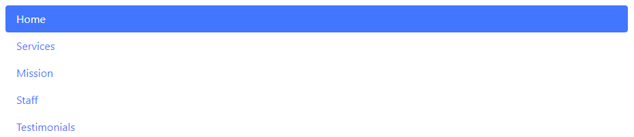

You can actually specify a breakpoint at which these get converted back to rows. For example, stack all the links in medium size window.

<ul class="nav flex-column nav-pills nav-fills">

<li class="nav-item"><a href="#" class="nav-link active ">Home</a></li>

<li class="nav-item"><a href="#" class="nav-link">Services</a></li>

<li class="nav-item"><a href="#" class="nav-link ">Mission</a></li>

<li class="nav-item"><a href="#" class="nav-link">Staff</a></li>

<li class="nav-item"><a href="#" class="nav-link ">Testimonials</a></li>

</ul>

HTML



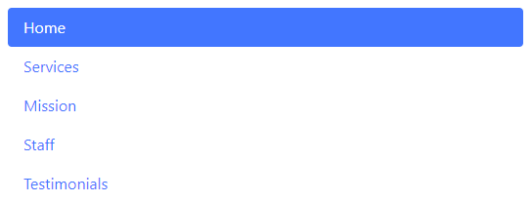

## **Using navbar classes**

The **navbar** component is related to the **nav** component, so if you're familiar with navs, then creating navbars will be simple. the **navbar** class is the class that goes on the main container, and it can have a number of other elements inside it. Now, by default, **navbar** components will stack, so we need to add a **navbar-expand**, with optional breakpoints to control when the **navbar** is going to expand.

<nav class="navbar bg-dark navbar-dark">

<div class='navbar-nav'> <!--div to store all the link -->

<a href="#" class="nav-item nav-link active">Home</a>

<a href="#" class="nav-item nav-link">Services</a>

<a href="#" class="nav-item nav-link">Mission Impossible</a>

<a href="#" class=" nav-item nav-link">Staff</a>

<a href="#" class="nav-item nav-link">Testimonials</a>

</div>

</nav>

HTML

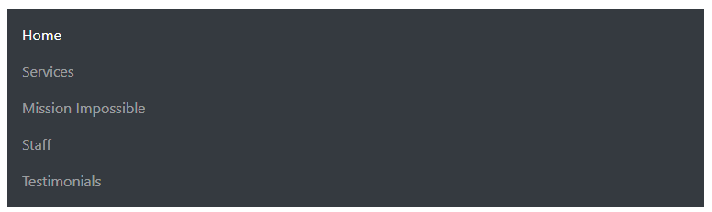

By default, the navigation will always stack. Bootstrap is designed as a mobile first framework, so the default is to always do what would happen on a mobile device. So, we have an extra class that we need to add here, and it's called **navbar-expand** with a specific breakpoint.

**<nav class="navbar bg-dark navbar-dark navbar-expand-sm">**

### **Navbar brand and text**

In addition to the **navbar nav** you can add other components to your navigation. The simplest to use is called the **navbar** brand and it's used for text or logos and will get an enhanced look. Another simple component is the **navbar** text component and you can add inline text that works well with the rest of the navigation. So, both of these are going to go right next to the **navbar nav** component. **navbar-brand** is the class that you add when you want to add a logo or some text.

HTML

<nav class="navbar bg-dark navbar-dark navbar-expand-sm">

<a class=navbar-brand href='#'> APPLE

<img src="apple1.jpg" style="width: 40px;" alt="wisdow pet logo"/>

</a>

<!-- nav list-->

<div class='navbar-nav'>

<a href="#" class="nav-item nav-link active">Home</a>

<a href="#" class="nav-item nav-link">Services</a>

<a href="#" class="nav-item nav-link">Mission Impossible</a>

<a href="#" class=" nav-item nav-link">Staff</a>

<a href="#" class="nav-item nav-link">Testimonials</a>

</div>

</nav>

<div class='container'>

<nav class="navbar bg-dark navbar-dark navbar-expand-sm">

<!-- Create a div for navbar-brand -->

<a class=navbar-brand href='#'>

The navbar-brand can also work with link and/or image

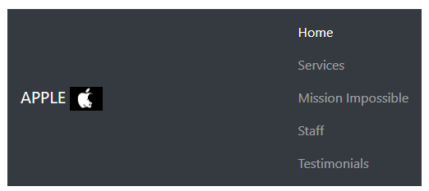

## **Dropdown**

Although dropdowns are technically a separate component, they are used very often in menus. A dropdown requires a container, just like a lot of other elements to work. Therefore, you'll need to create something that has a class of dropdown. This is usually a div, or it could be on a list item if you're using a navigation that uses list items.

<nav class="navbar bg-dark navbar-dark navbar-expand-sm">

<a class=navbar-brand href='#'>

<img src='apple1.jpg' style="width: 40px;" alt="wisdow pet logo"/>

</a>

<div class='navbar-nav'>

<a href="#" class="nav-item nav-link active">Home</a>

<!-- specify that the dropdown list will be at Services-->

<div class='dropdown'>

<a class='nav-item nav-link dropdown-toggle' data-toggle='dropdown' aria-haspopup='true' aria-expanded='false' id="serviceDropdown"href='#'>Services</a>

<!-- create a dropdown list for services-->

<div class='dropdown-menu' aria-labelledby-'serviceDropdown'>

<a class="dropdown-item" href="#" >Advisor</a>

<a class="dropdown-item" href="#" >Technical</a>

</div> <!--end of drowdown list -->

</div> <!-- end of service dropdown -->

<a href="#" class="nav-item nav-link">Mission Impossible</a>

<a href="#" class=" nav-item nav-link">Staff</a>

<a href="#" class="nav-item nav-link">Testimonials</a>

</div>

</nav>

HTML

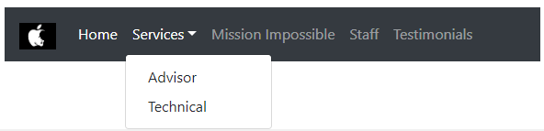

## **Create collapsible content**

Every so often, we need to create a navigation that collapses when the width of the device or the window is really small. That's because navigation can take up a lot of room vertically on a small device and often, we want to make sure that that room isn't taken over unless the user wants it. So in order to do that, we create these collapsible sections of content and to do that in Bootstrap, you essentially need two parts, the thing that you want to collapse and some element that will control that content.

So we need to work on two different parts. For the collapsible content, you're going to need a couple of classes, the first one is the generic collapse class that goes on the content that you of course want to collapse. And in addition to that, you're also going to use another class called **navbar** collapse because most of the time when you're using this feature, you're going to be collapsing a **navbar**. Now there are some other things that you need to do and we need to tie the element that we are collapsing which would be this element with the thing that is collapsing this element which will be a little button that's known as the hamburger menu button.

<nav class="navbar bg-dark navbar-dark navbar-expand-sm">

<!-- Create a div for navbar-brand -->

<a class=navbar-brand href='#'>

<img src='apple1.jpg' style="width: 40px;" alt="wisdow pet logo"/>

</a>

<!-- Create a hamburger button to control the collapseTab-->

<button class='navbar-toggler' type='button' data-toggle='collapse' data-target='#collapseTab' aria-controls="collapseTab" aria-expanded='false' aria-label='Toggle naviagation'>

<span class='navbar-toggler-icon'></span>

</button> <!--end of collapse button -->

<!-- Create a div to specified the collapse session -->

<div class='collapse navbar-collapse' id='collapseTab'>

<!-- nav list-->

<div class='navbar-nav'>

<a href="#" class="nav-item nav-link active">Home</a>

<a href="#" class="nav-item nav-link">Services</a>

<a href="#" class="nav-item nav-link">Mission Impossible</a>

<a href="#" class=" nav-item nav-link">Staff</a>

<a href="#" class="nav-item nav-link">Testimonials</a>

</div>

</div> <!-- end of collapse-->

</nav>

HTML



# **15. Styling elements**

In this section, we're going to be working with some styles that can make your life easier but you probably won't need all the time. One of the most popular components are buttons. You use them primarily in forms and form components but there are so many options that they deserve their own study. Bootstrap styles are so well-made that even when I build a non-Bootstrap project, I'll often borrow CSS from Bootstrap projects. Bootstrap 4 adds something called tags which are a simple style for organizing content.

Progress bars are a good example of a style that might be really useful for some developers building interfaces that need to show progress. List groups are mobile friendly layouts to group content within list elements. That's something you're going to need often but especially useful for mobile projects. Finally, breadcrumbs are a common pattern for displaying channels within websites. So, before we get into more complex Bootstrap CSS.

## **Creating buttons**

Now there are a number of classes that help you create buttons:

**btn** 🡺 basic class

**btn-sm, btn-lg** 🡺 small and large button size

**<link>, <button>,** and **<input>** elements are also used to create buttons.

***Button Colors***

Now you do have to specify at least one of the contextual color classes. So you would say **btn** and then hyphen and then one of these colors that you see right here

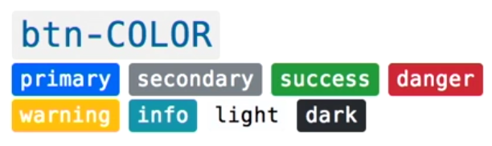

There is an alternative for outlines which looks like this, you say **btn** and then outline and then one of the contextual color classes that you see right here.

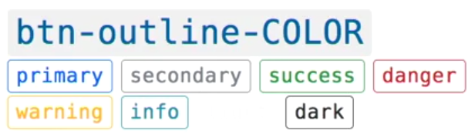

In addition to that there's a special style called **btn-block** that you can add if you want a button to occupy the entire width of the container, and in addition to that you have the traditional active, as well as disable classes that you can use.

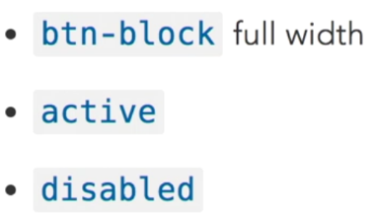

<nav class="navbar bg-dark navbar-dark navbar-expand-sm">

<!-- Create a div for navbar-brand -->

<a class=navbar-brand href='#'>

<img src='apple1.jpg' style="width: 40px;" alt="wisdow pet logo"/>

</a>

<!-- Create a hamburger button to control the collapseTab-->

<button class='navbar-toggler' type='button' data-toggle='collapse' data-target='#collapseTab' aria-controls="collapseTab" aria-expanded='false' aria-label='Toggle naviagation'>

<span class='navbar-toggler-icon'></span>

</button> <!--end of collapse button -->

<!-- Create a div to specified the collapse session -->

<div class='collapse navbar-collapse' id='collapseTab'>

<!-- nav list-->

<div class='navbar-nav'>

<a href="#" class="nav-item nav-link active">Home</a>

<a href="#" class="nav-item nav-link">Services</a>

<a href="#" class="nav-item nav-link">Mission Impossible</a>

<a href="#" class=" nav-item nav-link">Staff</a>

<a href="#" class="nav-item nav-link">Testimonials</a>

</div>

</div> <!-- end of collapse-->

</nav>

HTML

### *Grouping buttons*

There are a few classes that help you create button groups. To group simple buttons together you can use the **btn-group** class. There's also a vertical option for button groups that stack on top of one another. Those are traditionally used for mobile devices but you can use them for whatever you want. Finally, there is a toolbar option that let's you create groups of button groups. Now when you're creating button groups it's a good idea to use the aria label property to add a little bit of context to your button groups.

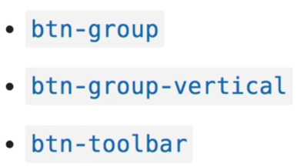

**Example)**

<h1>Our Mission</h1>

<div class='btn-group'>

<button type="button" class="btn btn-primary active">Cat</button>

<button type="button" class="btn btn-primary">Dog</button>

<button type="button" class="btn btn-primary">Fish</button>

<button type="button" class="btn btn-primary">Bird</button>

</div>

<div class='btn-group'>

<button type="button" class="btn btn-primary active">Amphibian</button>

<button type="button" class="btn btn-primary">Reptile</button>

<button type="button" class="btn btn-primary">Other</button>

</div>

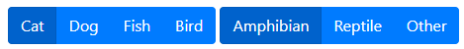

<div class='btn-group-vertical'>

<button type="button" class="btn btn-primary active">Amphibian</button>

<button type="button" class="btn btn-primary">Reptile</button>

<button type="button" class="btn btn-primary">Other</button>

</div>

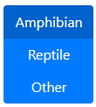

You can also add button sizes:

<div class='btn-group btn-group-lg'>

<div class='btn-group-vertical btn-group-sm'>

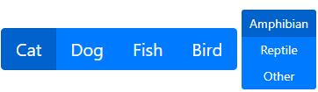

## **Badges**

Badges are usually created using the element <span>, the main class for badges is called **badge**, and then, in addition to that, you have a slightly different shape for the badges, called **badge-pill**. You can also use the traditional contextual classes. One thing about badges is that they are contextual, so they will resize according to the container.

**Example)**

<h3>Grooming **<span class='badge badge-danger'**>New</span></h3>

<p>Our therapeutic <span>grooming</span> treatments help battle fleas, allergic dermatitis, and other challenging skin conditions.</p>

<h4>General Health **<span class='badge badge-warning badge-pill'**>Coming Soon!</span></h4>

<p>Wellness and senior exams, ultrasound, x-ray, and dental cleanings are just a few of our general health services**.<span class='badge badge-info'>**Available Next Summer</span></p>



# **16. Predesign layout components**

Some styles in Bootstrap are designed to help you quickly create elements for certain types of content. These are sometimes called design patterns and Bootstrap has some really useful patterns for common layout tasks. Design patterns are predefined through various components. A jumbotron, for example, is a popular way to display some content at the top of a website. Table styles are extremely useful because they make elements that are challenging to style look great without a lot of work. Card layouts are a new design pattern that is available in this version of Bootstrap.

They let you create designs that are boxed into items that look like cards. Another really useful design pattern is media elements. They're great for creating lists of items that need to have photos on one side and headlines and texts in another.

## **Jumbotron**

The jumbotron is a component for a highlighted section of content and it's commonly used at the top of many websites. It's really easy to do with Bootstrap and this current version has a couple of options for you.

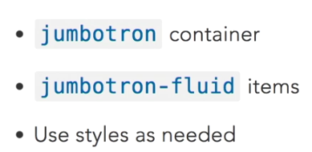

**Example)** Use Boostrap to create the following header:

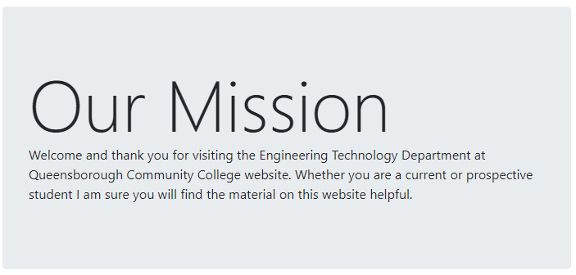

<div class='jumbotron'>

<div class="display-2">Our Mission</div>

<p class="display-5">Welcome and thank you for visiting the Engineering Technology Department at Queensborough Community College website. Whether you are a current or prospective student I am sure you will find the material on this website helpful.</p>

</div>

HTML

## **Cards**

Cards are a new design element in Bootstrap 4 and it can help you lay out your content into card-like containers that look great and have as a small outline around them. There are a ton of options in terms of the classes that you can use.

You can modify the card content:

* card-text
* card-title
* card-subtitle
* card-link
* card-img

**Example)** Use Boostrap to create the following card:

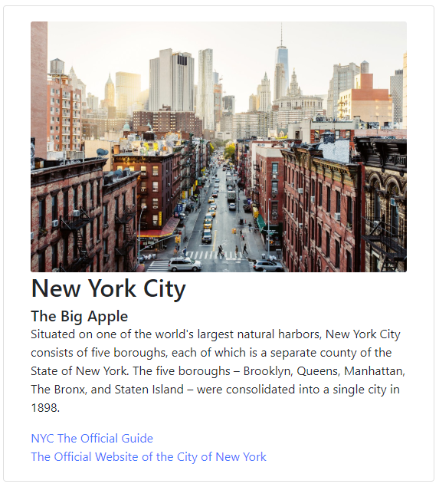

<div class="card col-md-6">

<div class='card-body'> <!-- add a container to card elements -->

<img class="card-img img-fluid" src="nyc.jpg" alt="New York City" title="New York City">

<h2 class='card-title'>New York City</h2>

<h5 class='card-subtitle'>The Big Apple</h5>

<p class='card-text'>Situated on one of the world's largest natural harbors, New York City consists of five boroughs, each of which is a separate county of the State of New York. The five boroughs – Brooklyn, Queens, Manhattan, The Bronx, and Staten Island – were consolidated into a single city in 1898.</p>

<a class='card-link' href="https://www.nycgo.com/">NYC The Official Guide</a>

<br>

<a class='card-link' href="https://www1.nyc.gov/">The Official Website of the City of New York</a>

</div>

</div>

HTML

You can also add colors

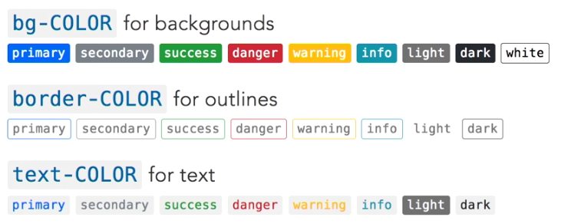

### **Card content classes**

The basic container should have a card class, and we should at least have an element that has a card body as a container of some of the content in your cards.

You can create a card header and footer by using classes card-header and card-footer.

**Example)** Add the card-header and card-footer to the previous card

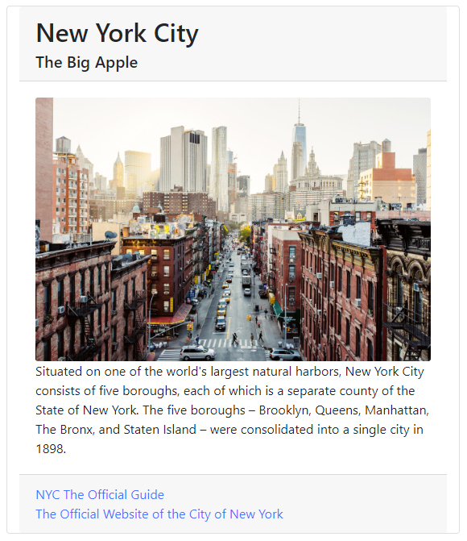

<div class="card col-md-6">

<div class="card-header"> <!-- card header-->

<h2 class='card-title'>New York City</h2>

<h5 class='card-subtitle'>The Big Apple</h5>

</div>

<div class='card-body'> <!-- add a container to card elements -->

<img class="card-img img-fluid" src="nyc.jpg" alt="New York City" title="New York City">

<p class='card-text'>Situated on one of the world's largest natural harbors, New York City consists of five boroughs, each of which is a separate county of the State of New York. The five boroughs – Brooklyn, Queens, Manhattan, The Bronx, and Staten Island – were consolidated into a single city in 1898.</p>

</div>

<div class="card-footer">

<a class='card-link' href="https://www.nycgo.com/">NYC The Official Guide</a>

<br>

<a class='card-link' href="https://www1.nyc.gov/">The Official Website of the City of New York</a>

</div>

</div>

HTML

### **List in a card**

Normal **list-group** container class that will go around the elements, and then inside that, each of the items that is part of the list gets a **list-group-item**. Finally there is a class called **list-group-flush**. It allows you to take the content that is in the list group, and extend it to the edge of the card.

**Example)** Using the previous card, add a list to the hyperlinks.

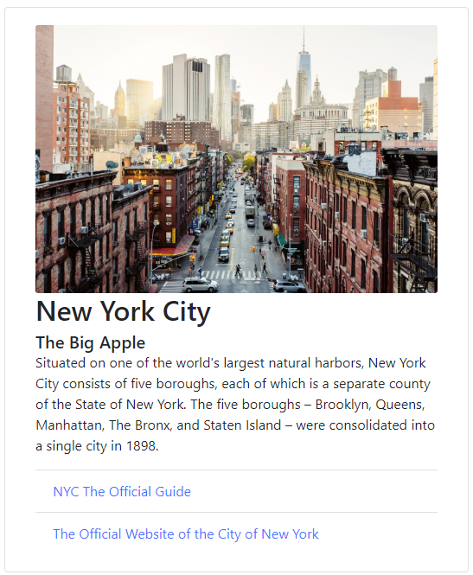

<div class="card col-md-6">

<div class='card-body'>

<img class="card-img img-fluid" src="nyc.jpg" alt="New York City" title="New York City">

<h2 class='card-title'>New York City</h2>

<h5 class='card-subtitle'>The Big Apple</h5>

<p class='card-text'>Situated on one of the world's largest natural harbors, New York City consists of five boroughs, each of which is a separate county of the State of New York. The five boroughs – Brooklyn, Queens, Manhattan, The Bronx, and Staten Island – were consolidated into a single city in 1898.</p>

<div class=**'list-group list-group-flush'**>

<a class=**'list-group-item'** href="https://www.nycgo.com/">NYC The Official Guide</a>

<a class=**'list-group-item'** href="https://www1.nyc.gov/">The Official Website of the City of New York</a>

</div>

</div>

</div>

HTML

### **Card layout**

So, let's take a look at how we control the layout of different cards. And what you do in Bootstrap is you create a container that is going to have a number of cards in it and that container should get some classes. And the first one I'll talk about is called **card-group**. **card-group** will place the cards side by side, and they will have a shared order.

**Example**) Group two of the previous cards into one row using **card-group**

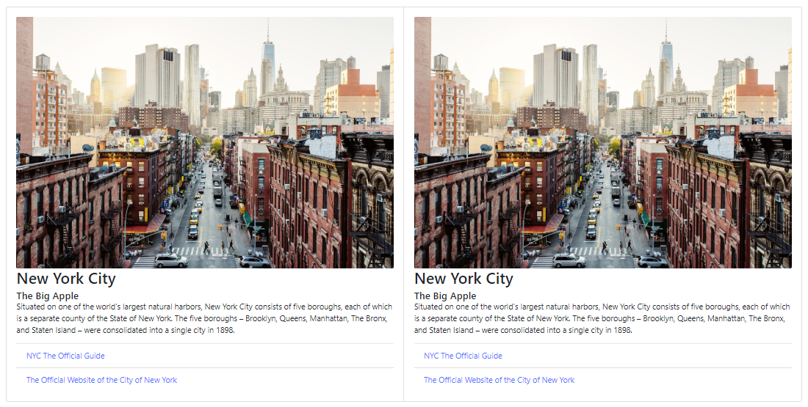

**<div class="card-group">**

<div class='card card-body'>

<img class="card-img img-fluid" src="nyc.jpg" title="New York City">

<h2 class='card-title'>New York City</h2>

<h5 class='card-subtitle'>The Big Apple</h5>

<p class='card-text'>Situated on one of the world's largest natural harbors, New York City consists of five boroughs, each of which is a separate county of the State of New York. The five boroughs – Brooklyn, Queens, Manhattan, The Bronx, and Staten Island – were consolidated into a single city in 1898.</p>

<div class='list-group list-group-flush'>

<a class='list-group-item' href="https://www.nycgo.com/">NYC The Official Guide</a>

<a class='list-group-item' href="https://www1.nyc.gov/">The Official Website of the City of New York</a>

</div>

</div><!-- end of card-->

<div class='card card-body'>

<img class="card-img img-fluid" src="nyc.jpg" title="New York City">

<h2 class='card-title'>New York City</h2>

<h5 class='card-subtitle'>The Big Apple</h5>

<p class='card-text'>Situated on one of the world's largest natural harbors, New York City consists of five boroughs, each of which is a separate county of the State of New York. The five boroughs – Brooklyn, Queens, Manhattan, The Bronx, and Staten Island – were consolidated into a single city in 1898.</p>

<div class='list-group list-group-flush'>

<a class='list-group-item' href="https://www.nycgo.com/">NYC The Official Guide</a>

<a class='list-group-item' href="https://www1.nyc.gov/">The Official Website of the City of New York</a>

</div>

</div><!-- end of card-->

</div><!-- end-card-group -->

HTML

If you don't want a shared order, you can use **card-deck**. It's pretty much the same thing as **card-group**, puts everything side by side, but it does have a little of a spacing in between the cards.

**Example**) Group two of the previous cards into one row using **card-deck**

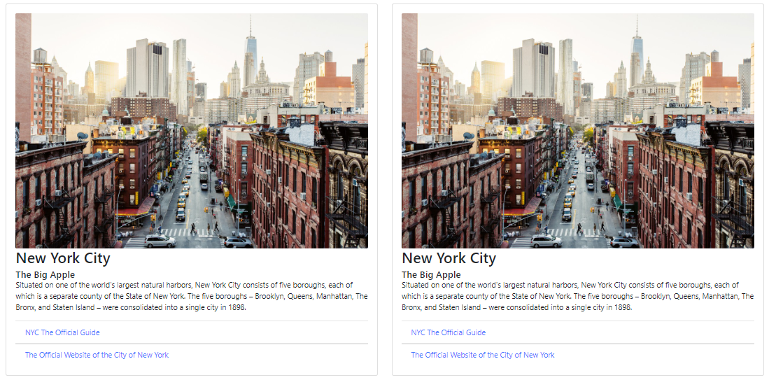

**<div class="card-deck">**

<div class='card card-body'>

<img class="card-img img-fluid" src="nyc.jpg" title="New York City">

<h2 class='card-title'>New York City</h2>

<h5 class='card-subtitle'>The Big Apple</h5>

<p class='card-text'>Situated on one of the world's largest natural harbors, New York City consists of five boroughs, each of which is a separate county of the State of New York. The five boroughs – Brooklyn, Queens, Manhattan, The Bronx, and Staten Island – were consolidated into a single city in 1898.</p>

<div class='list-group list-group-flush'>

<a class='list-group-item' href="https://www.nycgo.com/">NYC The Official Guide</a>

<a class='list-group-item' href="https://www1.nyc.gov/">The Official Website of the City of New York</a>

</div>

</div><!-- end of card-->

<div class='card card-body'>

<img class="card-img img-fluid" src="nyc.jpg" title="New York City">

<h2 class='card-title'>New York City</h2>

<h5 class='card-subtitle'>The Big Apple</h5>

<p class='card-text'>Situated on one of the world's largest natural harbors, New York City consists of five boroughs, each of which is a separate county of the State of New York. The five boroughs – Brooklyn, Queens, Manhattan, The Bronx, and Staten Island – were consolidated into a single city in 1898.</p>

<div class='list-group list-group-flush'>

<a class='list-group-item' href="https://www.nycgo.com/">NYC The Official Guide</a>

<a class='list-group-item' href="https://www1.nyc.gov/">The Official Website of the City of New York</a>

</div>

</div><!-- end of card-->

</div><!-- end-card-deck -->

HTML

Use can also use traditional **row** and **col**

**Example**) Group three of the previous cards into one row using **row** and **col**

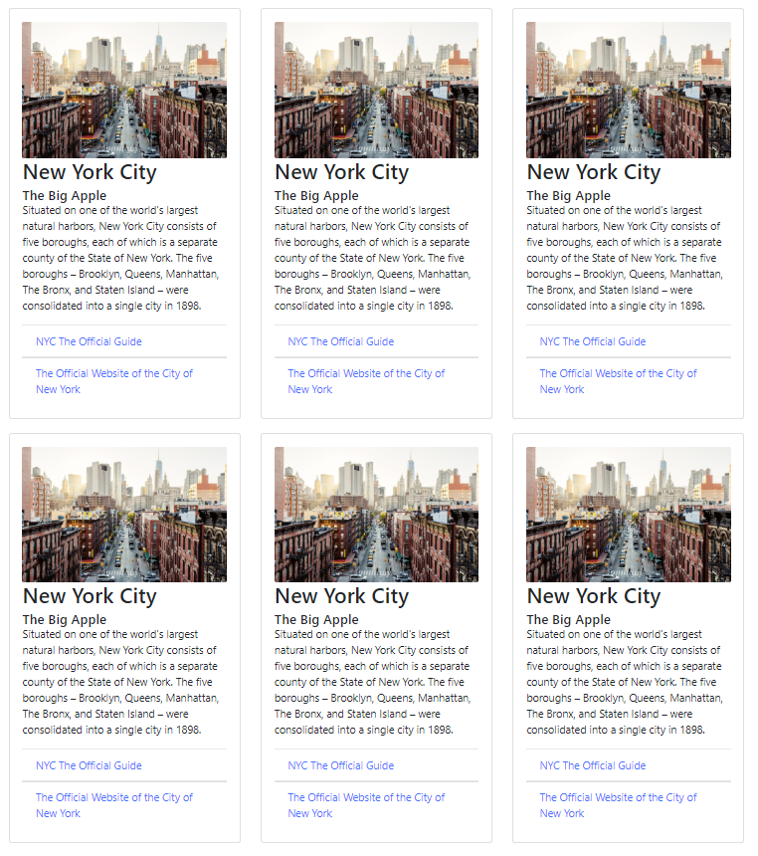

<div class="container">

<div class="row rowCard"><!-- FIRST ROW-->

<div class="col-md-4">

<div class='card card-body'>

<img class="card-img img-fluid" src="nyc.jpg" title="New York City">

<h2 class='card-title'>New York City</h2>

<h5 class='card-subtitle'>The Big Apple</h5>

<p class='card-text'>Situated on one of the world's largest natural harbors, New York City consists of five boroughs, each of which is a separate county of the State of New York. The five boroughs – Brooklyn, Queens, Manhattan, The Bronx, and Staten Island – were consolidated into a single city in 1898.</p>

<div class='list-group list-group-flush'>

<a class='list-group-item' href="https://www.nycgo.com/">NYC The Official Guide</a>

<a class='list-group-item' href="https://www1.nyc.gov/">The Official Website of the City of New York</a>

</div>

</div><!-- end of card-->

</div><!-- end of col-->

<div class="col-md-4">

<div class='card card-body'>

<img class="card-img img-fluid" src="nyc.jpg" title="New York City">

<h2 class='card-title'>New York City</h2>

<h5 class='card-subtitle'>The Big Apple</h5>

<p class='card-text'>Situated on one of the world's largest natural harbors, New York City consists of five boroughs, each of which is a separate county of the State of New York. The five boroughs – Brooklyn, Queens, Manhattan, The Bronx, and Staten Island – were consolidated into a single city in 1898.</p>

<div class='list-group list-group-flush'>

<a class='list-group-item' href="https://www.nycgo.com/">NYC The Official Guide</a>

<a class='list-group-item' href="https://www1.nyc.gov/">The Official Website of the City of New York</a>

</div>

</div><!-- end of card-->

</div><!-- end of col-->

<div class="col-md-4">

<div class='card card-body'>

<img class="card-img img-fluid" src="nyc.jpg" title="New York City">

<h2 class='card-title'>New York City</h2>

<h5 class='card-subtitle'>The Big Apple</h5>

<p class='card-text'>Situated on one of the world's largest natural harbors, New York City consists of five boroughs, each of which is a separate county of the State of New York. The five boroughs – Brooklyn, Queens, Manhattan, The Bronx, and Staten Island – were consolidated into a single city in 1898.</p>

<div class='list-group list-group-flush'>

<a class='list-group-item' href="https://www.nycgo.com/">NYC The Official Guide</a>

<a class='list-group-item' href="https://www1.nyc.gov/">The Official Website of the City of New York</a>

</div>

</div><!-- end of card-->

</div><!-- end of col-->

</div><!-- end FIRST ROW -->

<div class="row rowCard"><!-- SECOND ROW-->

<div class="col-md-4">

<div class='card card-body'>

<img class="card-img img-fluid" src="nyc.jpg" alt="New York City" title="New York City">

<h2 class='card-title'>New York City</h2>

<h5 class='card-subtitle'>The Big Apple</h5>

<p class='card-text'>Situated on one of the world's largest natural harbors, New York City consists of five boroughs, each of which is a separate county of the State of New York. The five boroughs – Brooklyn, Queens, Manhattan, The Bronx, and Staten Island – were consolidated into a single city in 1898.</p>

<div class='list-group list-group-flush'>

<a class='list-group-item' href="https://www.nycgo.com/">NYC The Official Guide</a>

<a class='list-group-item' href="https://www1.nyc.gov/">The Official Website of the City of New York</a>

</div>

</div><!-- end of card-->

</div><!-- end of col-->

<div class="col-md-4">

<div class='card card-body'>

<img class="card-img img-fluid" src="nyc.jpg" alt="New York City" title="New York City">

<h2 class='card-title'>New York City</h2>

<h5 class='card-subtitle'>The Big Apple</h5>

<p class='card-text'>Situated on one of the world's largest natural harbors, New York City consists of five boroughs, each of which is a separate county of the State of New York. The five boroughs – Brooklyn, Queens, Manhattan, The Bronx, and Staten Island – were consolidated into a single city in 1898.</p>

<div class='list-group list-group-flush'>

<a class='list-group-item' href="https://www.nycgo.com/">NYC The Official Guide</a>

<a class='list-group-item' href="https://www1.nyc.gov/">The Official Website of the City of New York</a>

</div>

</div><!-- end of card-->

</div><!-- end of col-->

<div class="col-md-4">

<div class='card card-body'>

<img class="card-img img-fluid" src="nyc.jpg" alt="New York City" title="New York City">

<h2 class='card-title'>New York City</h2>

<h5 class='card-subtitle'>The Big Apple</h5>

<p class='card-text'>Situated on one of the world's largest natural harbors, New York City consists of five boroughs, each of which is a separate county of the State of New York. The five boroughs – Brooklyn, Queens, Manhattan, The Bronx, and Staten Island – were consolidated into a single city in 1898.</p>

<div class='list-group list-group-flush'>

<a class='list-group-item' href="https://www.nycgo.com/">NYC The Official Guide</a>

<a class='list-group-item' href="https://www1.nyc.gov/">The Official Website of the City of New York</a>

</div>

</div><!-- end of card-->

</div><!-- end of col-->

</div><!-- end SECOND ROW -->

</div><!--end of container -->

HTML

# **17. Working with interactive components**

## **Setting alerts**

Alerts are messages with special contextual styles that are designed to display in great looking boxes. They're optionally dismissed and can have any sort of markup so let's take a look at them. Now setting up alerts is pretty simply. You start out with the basic alert class on a container. There's a few contextual classes that you can use for color. So for example, success, info, warning, and danger. A few classes are available for internal content, like headings as well as links.

Although you can fit just about any HTML content inside an alert. Now just be aware that it is really meant for very simple content, so don't try too many crazy HTML tags in there. You can choose to dismiss the alerts so that the user can get rid of message. This is how you do that. You add a class of **alert-dismissible** and then if you want some animation you can also add the fade and show classes. So when you dismiss the alert, it'll have a little animation that fades out.

When you do this, you should also add a close button to the alert to close the alert when the click on the close button.

**Example**) Create an alert message as the following

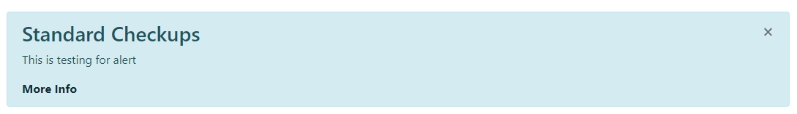

<div class='alert alert-info'>

<button type='button' class='close' data-dismiss='alert'><span>&times;</span>

</button>

<h3 class='alert-heading'>Standard Checkups</h3>

<p> This is testing for alert</p>

<a class='alert-link' href="#">More Info</a>

</div>

HTML

## **Dropdown**

Dropdowns are a common design patterns in Bootstrap. You can create them easily for different components, so let's take a look. You can use **dropdown** in a bunch of different components including navs, tabs, and buttons. Dropdowns can be created in two parts. First, you create a button to trigger the **dropdown** and then create the **menu** itself. They're tied under our dropdown container that toggles the dropdown menu.

For the menu, you can either use anchor tag links or buttons. The classes for a basic dropdown are the **dropdown** class on the container of both the trigger and the menu element, the **dropdown-toggle** class on the button that triggers the menu, and then the **dropdown-menu** class which is the container for the menu. You also add a **dropdown-item** on each individual menu item which is either a link or a button.

**Example)** Create a dropdown list for **Services**

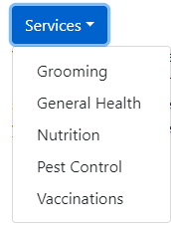

<div class='dropdown text-dark'>

<button type="button" class='btn btn-primary dropdown-toggle ' data-toggle='dropdown'>Services</button>

<div class='dropdown-menu'>

<a class='dropdown-item' href="#">Grooming</a>

<a class='dropdown-item' href="#">General Health</a>

<a class='dropdown-item' href="#">Nutrition</a>

<a class='dropdown-item' href="#">Pest Control</a>

<a class='dropdown-item' href="#">Vaccinations</a>

</div>

</div>

HTML

Inside the dropdown, you can add a few elements including **dropdown-header** that's a nice title to a group of elements in the dropdown, you can also you use **dropdown-divider** that lets you create a horizontal line to divide groups of elements, any menu item can also be tagged as disabled to prevent people from clicking on it.

**Example)** Create a dropdown list for **Services** with header and divider within the list

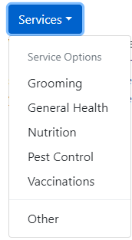

<div class='dropdown text-dark'>

<button type="button" class='btn btn-primary dropdown-toggle ' data-toggle='dropdown'>Services</button>

<div class='dropdown-menu' aria-labelledby='dropdownMenuButton'>

<div class='dropdown-header'>Service Options</div>

<a class='dropdown-item' href="#">Grooming</a>

<a class='dropdown-item' href="#">General Health</a>

<a class='dropdown-item' href="#">Nutrition</a>

<a class='dropdown-item' href="#">Pest Control</a>

<a class='dropdown-item' href="#">Vaccinations</a>

<div class='dropdown-divider'></div>

<a class='dropdown-item' href='#'>Other</a>

</div>

</div>

HTML

There's a few options that control how things look and work. For example, you can control the size of the buttons using the **btn-sm** for a smaller button and the **btn-lg** for a bigger button that goes in the trigger of the dropdown menu. You can also cause the button to drop upwards instead of downwards with the **dropup** class. If you want to align the menu to the right instead of to the left which is a default, you can add a **dropdown-menu-right** class. Finally, you can create a menu elements where the dropdown and button are split, **btn-group dropdown-toggle-split**. That's a little bit more flexible than just having a dropdown since it allows you to choose an option before you submit the button.

## **Scrollspy**

Scrollspy is a really cool component that allows you to keep track of the scroll of the page and modifies classes according to the position of your elements. So the way that you use it is by creating a data attribute called **scroll**, and you do that on the container of the element that you want to track the scrolling in. Now that element also needs to have a position of relative, and you also need to target that element with a data target attribute, and then an **id**. Data target is usually how we put together what we are doing with the object that we're targeting.

<body data-spy='scroll' data-target='#navbar-site' data-offset='80'>

<nav id="navbar-site" class="fixed-bottom navbar navbar-dark bg-dark navbar-expand-sm">

<div class="container">

<ul class="navbar-nav">

<li class="nav-item"><a class="nav-link" href="#cards">Cards</a></li>

<li class="nav-item"><a class="nav-link" href="#drop">Dropdown</a></li>

<li class="nav-item"><a class="nav-link" href="#NYCAccordion">Accordion</a></li>

<li class="nav-item"><a class="nav-link" href="#slideshow">Slideshow</a></li>

</div><!-- navbar-nav -->

</ul><!-- container -->

</nav>

HTML

# **18. Collapse Accordions**

Collapse and accordions are a set of related components that allow you to show or hide HTML content. Collapse is the simplest, and lets you show or hide content on a click. Accordions are similar but part of a bigger group. When one item shows, another hides, so accordions are essentially group of collapses. To set up a collapse, you create a link or a button that activates the collapse element. To that element, you add a **data-toggle="collapse"** and to target the element, you can use either an **id** if it's an anchor tag or link, or you can use a **data-target** attribute if it's a button.

The element that's going to show or hide has the collapse class. Now, accordions are essentially a group of collapses put together. It does require an additional container, and one of the elements should be showing so you add the show class on that element, and you'll need to add the class of **dropdown-menu**, and it's common to put these in a card style.

**Example)** Create a button to show hidden information

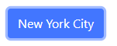

When click on the button



<button class='btn btn-primary' data-toggle='collapse' data-target='#nyc'>

New York City</button>

<div id='nyc' class="collapse">

Situated on one of the world's largest natural harbors, New York City consists of five boroughs, each of which is a separate county of the State of New York. The five boroughs – Brooklyn, Queens, Manhattan, The Bronx, and Staten Island – were consolidated into a single city in 1898.

</div>

HTML

You can also you a collapse accordion by using cards. For this, the HTML structure is as the following:

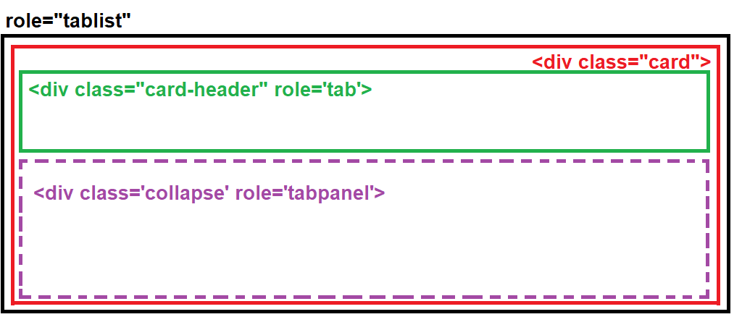

**Example)** Create a collapsible accordion using cards



When click on the button

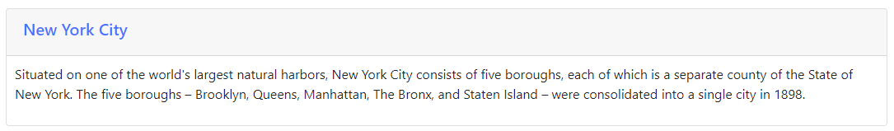

<div id='NYCAccordion'>

<div class="card">

<div class="card-header">

<h5><a data-toggle='collapse' data-parent='NYCAccordion' href="#NYCContent">New York City</a></h5>

</div><!-- card header -->

<div class='collapse' id="NYCContent" >

<div class="card-block" style="padding:10px;">

<p>Situated on one of the world's largest natural harbors, New York City consists of five boroughs, each of which is a separate county of the State of New York. The five boroughs – Brooklyn, Queens, Manhattan, The Bronx, and Staten Island – were consolidated into a single city in 1898.</p>

</div>

</div><!-- collapse -->

</div><!-- card -->

</div>

HTML

If you want the accordion start showing the hidden content, you can add the word **show** after the class **collapse**:

**<div class='collapse show' id="NYCContent" >**

# **19. Carousels**

Carousels are the most popular Bootstrap component. It essentially allows you to create a slideshow that auto-advances and it gives you some controls to let you advance through the images. Now there's a ton of classes for the carousel so let's take a look at all of them. So the first thing you need to do is have a main component that has a class of carousel. That component needs to have at least a data-ride attribute with the word carousel. This will automatically activate the advancing of the carousel when the page loads. Now in addition to that, there will be another container that has a class of **carousel-inner**. This is what's going to have all your photos. Now each of the photos should have a **div** wrapping the photos with a class of **carousel-item.**

In addition to that, we have a few options. The first element that you want to show up when the carousel starts should have a class of **active**. That would go in the **div**, and you do want to crop and size the photos. Otherwise, the carousel will jump up and down.

**Example)** Create a simple carousels of two images

<div **class='carousel'** data-ride='carousel' style="width:700px; height:600px;">

<div **class='carousel-item active'** style="width:100%; height:80%;">

<img src="nyc.jpg" alt="Lifestyle Photo" style="width:100%; height:100%;">

</div>

<div **class='carousel-item'** style="width:100%; height:80%;">

<img src="apple.jpg" alt="Mission" style="width:100%; height:100%;">

</div>

<div>

<h3>New York City <small>"The Big Apple"</small></h3>

<p>Situated on one of the world's largest natural harbors, New York City consists of five boroughs, each of which is a separate county of the State of New York.</p>

</div>

</div> <!--end of carousel-->

HTML

In addition to that, we can add captions to a carousel with the **carousel-caption** class. So you would put another **div**, add this class to it, and that will go inside the **div** that has the image.

<div class='carousel' data-ride='carousel' style="width:700px; height:600px;">

<!--1st image-->

<div class='carousel-item active' style="width:100%; height:80%;">

<img class="img-fluid" src="nyc.jpg" alt="New York City" style="width:100%; height:100%;">

**<div class="carousel-caption"** style="background-color: rgba(0,0,0,0.5);">

<h3>New York City <small>"The Big Apple"</small></h3>

<p>Situated on one of the world's largest natural harbors, New York City consists of five boroughs, each of which is a separate county of the State of New York.</p>

**</div>**

</div>

<div class='carousel-item' style="width:100%; height:80%;"><!-- 2nd image-->

<img class="img-fluid" src="timesSquare.jpg" alt="Times Square" style="width:100%; height:100%;">

**<div class="carousel-caption"** style="background-color: rgba(0,0,0,0.5);">

<h3>Times Square <small>"The Heart of New York City"</small></h3>

<p>Times Square is a major commercial intersection, tourist destination, entertainment center and neighborhood in the Midtown Manhattan section of New York City at the junction of Broadway and Seventh Avenue.</p>

**</div>**

</div>

</div> <!--end of carousel-->

HTML

So in addition to that, there's a number of navigation options so you can add these little arrows that will let you advance to the previous and next slide. The way you do that is by tying the carousel to the navigation with a **data-target** attribute. Whenever you use navigation, you need to make sure that you have that, and then you have two buttons that you can add. One with a class of **carousel-control-prev** and then you add an icon inside. And then also, you add a **carousel-control-next** with its icon as well.

<div class='carousel' data-ride='carousel' style="width:700px; height:600px;">

<!--1st image-->

<div class='carousel-item active' style="width:100%; height:80%;">

<img class="img-fluid" src="nyc.jpg" alt="New York City" style="width:100%; height:100%;">

<div class="carousel-caption" style="background-color: rgba(0,0,0,0.5);">

<h3>New York City <small>"The Big Apple"</small></h3>

<p>Situated on one of the world's largest natural harbors, New York City consists of five boroughs, each of which is a separate county of the State of New York.</p>

</div>

</div>

<div class='carousel-item' style="width:100%; height:80%;"><!-- 2nd image-->

<img class="img-fluid" src="timesSquare.jpg" alt="Times Square" style="width:100%; height:100%;">

<div class="carousel-caption" style="background-color: rgba(0,0,0,0.5);">

<h3>Times Square <small>"The Heart of New York City"</small></h3>

<p>Times Square is a major commercial intersection, tourist destination, entertainment center and neighborhood in the Midtown Manhattan section of New York City at the junction of Broadway and Seventh Avenue.</p>

</div>

</div>

<!-- Left and right controls -->

<a **class="carousel-control-prev"** href="#demo" data-slide="prev">

<span class="carousel-control-prev-icon"></span>

</a>

<a **class="carousel-control-next"** href="#demo" data-slide="next">

<span class="carousel-control-next-icon"></span>

</a>

</div> <!--end of carousel-->

HTML

**Reference**

Window size, margin, and padding

Bootstrap has a wide range of responsive margin and padding utility classes. They work for all breakpoints:

**xs** (<=576px), **sm** (>=576px), **md** (>=768px), **lg** (>=992px) or **xl** (>=1200px))

The classes are used in the format:

**{property}{sides}-{size}** for xs & **{property}{sides}-{breakpoint}-{size}** for sm, md, lg, and xl.

**m** - sets margin

**p** - sets padding

**t** - sets margin-top or padding-top

**b** - sets margin-bottom or padding-bottom

**l** - sets margin-left or padding-left

**r** - sets margin-right or padding-right

**x** - sets both padding-left and padding-right or margin-left and margin-right

**y** - sets both padding-top and padding-bottom or margin-top and margin-bottom

**blank** - sets a margin or padding on all 4 sides of the element

**0** - sets **margin** or **padding** to 0

**1** - sets **margin** or **padding** to .25rem (4px if font-size is 16px)

**2** - sets **margin** or **padding** to .5rem (8px if font-size is 16px)

**3** - sets **margin** or **padding** to 1rem (16px if font-size is 16px)

**4** - sets **margin** or **padding** to 1.5rem (24px if font-size is 16px)

**5** - sets **margin** or **padding** to 3rem (48px if font-size is 16px)

**auto** - sets margin to auto

**Bibliography**

Duckett, J. (2016). *HTML and CSS Design and build websites.* Indianapolis: John Wiley and Sons Inc.

Duckett, J. (2016). *JavaScript and JQuery: interactive front-end developer.* Indianapolis: John Wiley and Sons Inc.

*HTML, CSS, JavaScript, JQuery, and Bootstrap*. (2017, June). Retrieved from w3schools: www.w3schools.com

**IMPORTANT NOTE**

The materials used in this manual have the author's rights and are for educational use only.

**Important note:** The materials used in this manual have the author's rights and are for educational use only. Material compiled from [www.lynda.com](http://www.lynda.com) (May 2018)